AASHTO Technology Implementation Group
Nomination of Technology Ready for Implementation
2010 Nominations Due by Friday, September 11, 2009

Sponsor | Nominations must be submitted by an AASHTO member DOT willing to help promote the technology. | 1. Sponsoring State DOT: Missouri
Sponsor |  | 2. Name: Timothy M. Chojnacki
Sponsor |  | Title: Maintenance Liaision Engineer
Sponsor |  | Mailing Address: 2211 St. Mary's Boulevard
Sponsor |  | City: Jefferson City |  | State: Missouri |  |  | Zip Code: 65102
Sponsor |  | E-mail: tim.chojnacki@modot.mo.gov |  |  | Phone: .573.751.1040 |  |  | Fax: 573.526.4868
Sponsor |  | 3. Date Submitted: 09/09/2009
Sponsor |  | 4. Is the Sponsoring State DOT willing to promote this technology to other states by participating on a Lead States Team supported by the AASHTO Technology Implementation Group?  Please check one: Yes No
Technology Description (10 points) | The term “technology” may include processes, products, techniques, procedures, and practices. | 5. Name the technology: TowPLow
Technology Description (10 points) |  | 6. Please describe the technology:  The TowPLow integrates a trailer plow by pulling it behind a snowplow truck. While most snowplow trucks clear only ten to 11 feet, and special wing plows clear up to 16 feet, the TowPLow technology has enabled one truck and operator to clear more than 24 feet. Because of the vast increase in clearance area, one TowPLow combination can actually replace about 2.5 conventional snowplow trucks in gang plowing and improves safety when compared to special snowplow trucks with wing plows in gangs. Additionally, the TowPLow has an expected life cycle of 30 years or more compared to the typical expected life of 15 to 17 years for snowplow trucks.
Technology Description (10 points) |  | 7. If appropriate, please attach photographs, diagrams, or other images illustrating the appearance or functionality of the technology. (If electronic, please provide a separate file.)  Please check one: Yes, images are attached. No images are attached.
State of Development (30 points) | Technologies must be successfully deployed in at least one State DOT. The TIG selection process will favor technologies that have advanced beyond the research stage, at least to the pilot deployment stage, and preferably into routine use. | - Please describe the history of the technology’s development.  MoDOT technical staff identified a potential need for technological improvement in 1996 when viewing photographs of gang plowing. MoDOT was using six to ten trucks to plow multi-lane interstate routes in St. Louis. In 2004, a partnership between MoDOT and Viking Cives identified methods to plow more snow with a single truck. The implementation of TowPLows, began as an idea of one of MoDOT's technical experts. Based on his farming experience and knowledge of newer farming equipment technologies, he questioned why the concepts of wide farming equipment could not be used to dramatically improve snowplowing on Missouri highways. The first TowPLow was placed into service January 2005 in Kansas City. The innovation proved itself in November 2006, when two Kansas City units cleared Interstate 70 from shoulder to shoulder.
State of Development (30 points) |  | - For how long and in approximately how many applications has your State DOT used this technology?  The first TowPLow was placed into service in January of 2005. Since that time, the TowPLow has proved its usefullness as a time-saving, safe alternative to conventional snowplowing trucks while providing a higher-level of service to the roadway users. For the winter of 2009-2010, MoDOT will have 47 TowPLows in its fleet statewide.
State of Development (30 points) |  | - What additional development is necessary to enable routine deployment of the technology?  None. This technology is ready for use. MoDOT operators and managers are continually identifying specific snow plowing operations and processes in which the TowPLow can be used.
State of Development (30 points) |  | 11. Have other organizations used this technology? Please check one: Yes No  If so, please list organizations and contacts.
State of Development (30 points) |  | Organization | Name |  |  | Phone | E-mail
State of Development (30 points) |  | Minnesota DOT | Norm Ashfeld  Mark Fischbach  Randy Reznicek |  |  | 651-234-7942  651-437-2109  320-223-6568 | Norm.Ashfeld@dot.state.mn.us  Mark.Fischbach@dot.state.mn.us
State of Development (30 points) |  | Utah DOT | Steve McCarthy |  |  | 801-965-4122 | smccarthy@utah.gov
State of Development (30 points) |  | Maine DOT | Stephen Colson  Dale Peabody |  |  | 207-941-4529  207-624-3305 | stephen.colson@maine.gov  dale.peabody@maine.gov
State of Development (30 points) |  | Brun-Way Highway Operations Inc. New Brunswick, CA | Robin Hathoway |  |  | 506-325-8663
State of Development (30 points) |  | MRDC Operations Corp. New Brunswick, CA | Mark Kenny or Terry Thornton |  |  | 506-357-1240
 |  | 407 ETR Ontario, CA | Craig White |  |  | 416-989-3182
 |  | Carillion Canada Inc. Ontario, CA | Richard Burno |  |  | 800-390-2242
Payoff Potential (30 points) | Payoff is defined as the combination of broad applicability and significant benefit or advantage over other currently available technologies. | 12. How does the technology meet customer or stakeholder needs in your State DOT or other organizations that have used it?  The TowPLow technology directly impacts two customer needs: prudent stewardship of taxpayers funding and safety on Missouri roadways. By creating a method to increase performance of our snowplows, production more than doubled for the same manpower. One snowplow truck and TowPLow can replace about 2.5 conventional snowplow trucks. Safety of the roadway users is improved when compared to special snowplow trucks with wing plows in gangs. The snowplow truck with a TowPLow allows for faster plowing, which can reduce rear end accidents with snowplow tucks. Fewer snowplow trucks, traveling faster, will reduce the likelihood of traffic accidents.
Payoff Potential (30 points) |  | 13. What type and scale of benefits has your DOT realized from using this technology? Include cost savings, safety improvements, transportation efficiency or effectiveness, environmental benefits, or any other advantages over other existing technologies.  The benefits that MoDOT has realized with the implementation of the TowPLow have all been extremely positive. However, the true realization of benefits varies dependent on the use of the innovation. In urban gang plowing operations, such as in St. Louis and Kansas City, two trucks with TowPLows can directly replace four snowplow trucks. In this configuration, the use of two TowPLows eliminates the need for two trucks and two operators, resulting in a 28.6 percent reduction in labor and fuel costs.  An even more substantial impact is made on snowplowing operations on rural divided four-lane highways. With the TowPLow, the four-lane highway can be cleared with two trucks, one pass each - one truck with the lefthand TowPLow can clear the passing lane and inside shoulder, while the other truck can clear the driving lane and outside shoulder. Similar to the gang-plowing example, the same amount of clearing can be done with half the truck operators, saving 50 percent on labor and fuel costs on this operation.
Payoff Potential (30 points) |  | 14. Please describe the potential extent of implementation in terms of geography, organization type (including other branches of government and private industry) and size, or other relevant factors. How broadly might the technology be deployed?  Due to the precise purpose of the TowPLow, the extent of implementation would be limited to businesses and organizations that are in charge of large area snow removal. More specifically, transportation departments - both state-based and internationally - could replicate the TowPLow model and experience similar reductions in labor and fuel costs. Those responsible for clearing snow from airports and large parking areas could also benefit from this technology.

Market Readiness (30 points) | The TIG selection process will favor technologies that can be adopted with a reasonable amount of effort and cost, commensurate with the payoff potential. | 15. What actions would another organization need to take to adopt this technology?  Procuring the equipment and training operators is all that is required. Some slight modification of the snowplow truck hydraulic system may be required to operate the TowPLow.
Market Readiness (30 points) |  | 16. What is the estimated cost, effort, and length of time required to deploy the technology in another organization?  Costs of the TowPLow vary depending on what options are ordered. The TowPLow can be equiped with either a material spreader or a liquid dispensing tank. The TowPLow can also be made to deploy either to the passenger or driver's side of the towing vehicle. The TowPLows purchased this year by Missouri DOT have ranged in cost from $67,000 to $82,000. Length of time to deploy can also vary. Some agencies may choose to proceed slowly, as Missouri has, starting with a few TowPLows to gain confidence. Others may look at a broader initial implementation. Missouri has expanded our TowPLow fleet from two in 2005 to 47 by the end of 2009.
Market Readiness (30 points) |  | 17. What resources—such as technical specifications, training materials, and user guides—are already available to assist deployment?  Viking Cives designed and manufactures the TowPLows and therefore has current specifications. TowPLows are furnished with operator and parts manual. Viking Cives provides initial training for operators and mechanics. MoDOT has developed operator training and field exercises for MoDOT’s applications in the Kansas City district. Modot training maybe updated next winter for other districts.
Market Readiness (30 points) |  | 18. What organizations currently supply and provide technical support for the technology?  There are three Viking Cives sites which bid and furnish TowPLows across the USA and Canada. Viking Cives contact information can be found at http://www.vikingcives.com/. Shops are in New York, Missouri and Ontario, CA. Technical information, product design, expected applications and field performance can also be found by contacting the inventor, Bob Lannert at MoSnowKing@aol.com or going through the site www.TowPLow.com.
Market Readiness (30 points) |  | 19. Please describe any legal, environmental, social, intellectual property, or other barriers that might affect ease of implementation.  None
Submit Completed form to |  | http://transportation1.org/tig_solicitation/Submit.aspx

Attachment A

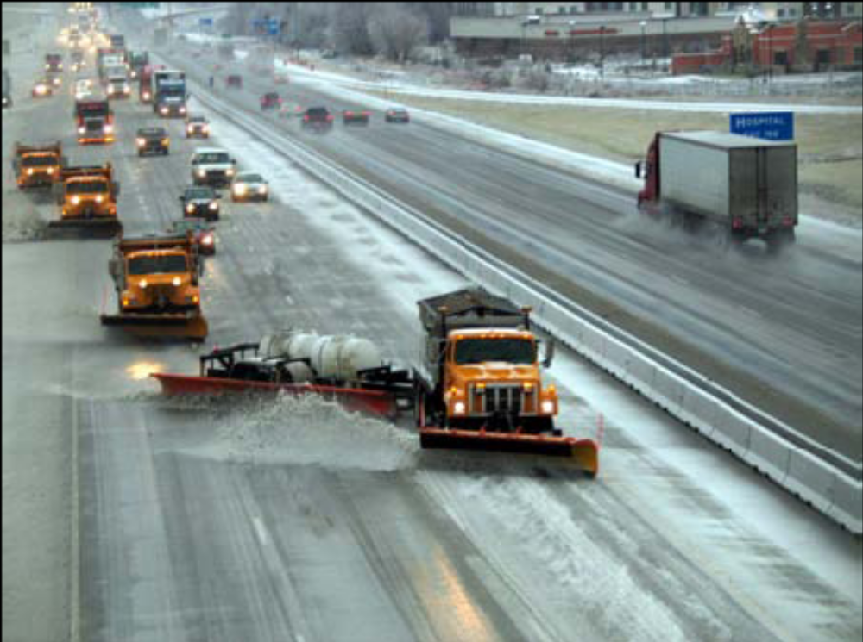
Figure 1: Tow Plow in Use

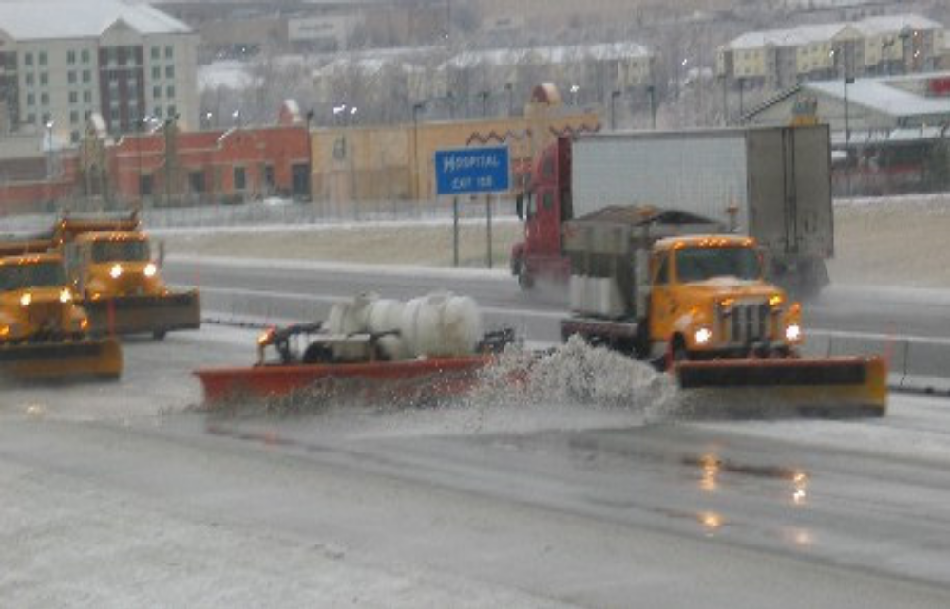
Figure 2: TowPlow in Use

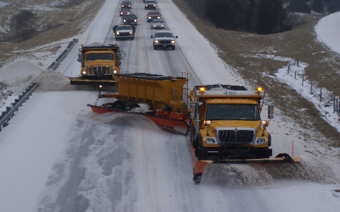
Figure 3: TowPlow Equipt with Material Spreader

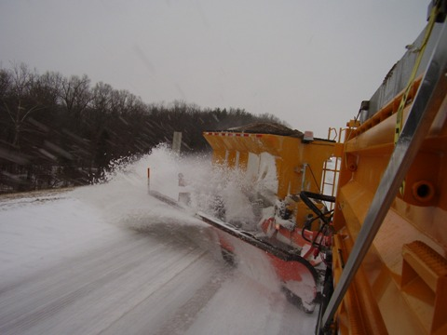
Figure 4: TowPlow Equipped with Material Spreader

