AASHTO Technology Implementation Group
Nomination of Technology Ready for Implementation
2011 Nominations Due by Friday, September 17, 2010

Sponsor | Nominations must be submitted by an AASHTO member DOT willing to help promote the technology. | 1. Sponsoring State DOT: Texas Department of Transportation
Sponsor |  | 2. Name: David Fink
Sponsor |  | Title: Manager, Traffic Management Systems
Sponsor |  | Mailing Address: Houston TranStar, 6922 Katy Road
Sponsor |  | City: Houston |  | State: TX |  | Zip Code: 77024
Sponsor |  | E-mail: David.Fink@houstontranstar.org |  | Phone: 713-881-3063 |  | Fax: 713-881-3006
Sponsor |  | 3. Date Submitted: 09/17/10
Sponsor |  | 4. Is the Sponsoring State DOT willing to promote this technology to other states by participating on a Lead States Team supported by the AASHTO Technology Implementation Group?  Please check one: Yes No
Technology Description (10 points) | The term “technology” may include processes, products, techniques, procedures, and practices. | 5. Name the technology: AWAM (Anonymous Wireless Address Matching) technology for travel time data collection
Technology Description (10 points) |  | 6. Please describe the technology:  Anonymous Wireless Address Matching (AWAM) is a cost-effective, high-quality, real-time travel time data collector that detects Bluetooth-enabled devices such as cell phones, headsets and GPS systems in vehicles to gather time and location information. This information is used to determine and broadcast roadway speeds.
Technology Description (10 points) |  | 7. If appropriate, please attach photographs, diagrams, or other images illustrating the appearance or functionality of the technology. (If electronic, please provide a separate file.)  Please check one: Yes, images are attached. No images are attached.  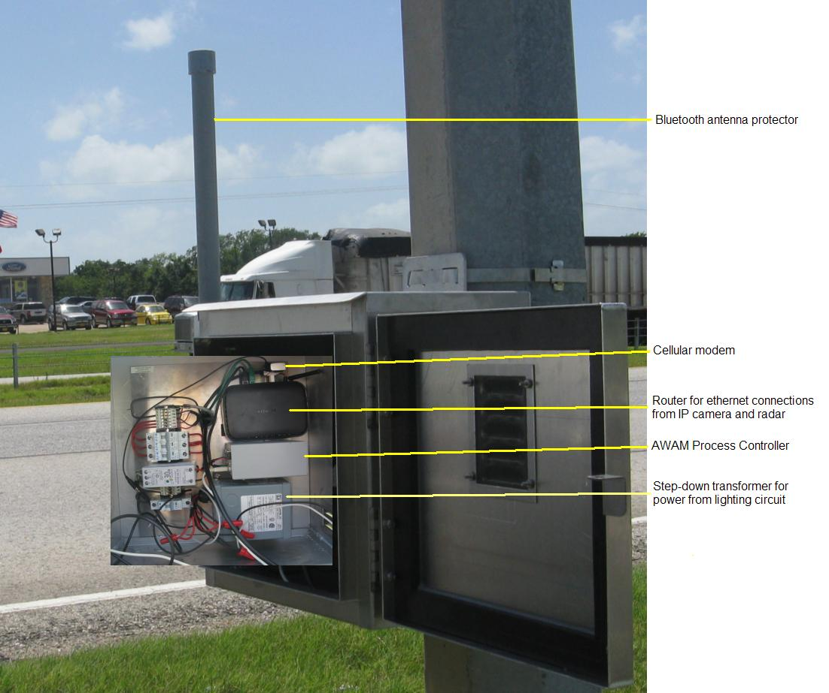
State of Development (30 points) | Technologies must be successfully deployed in at least one State DOT. The TIG selection process will favor technologies that have advanced beyond the research stage, at least to the pilot deployment stage, and preferably into routine use. | - Please describe the history of the technology’s development.  Early examinations were conducted to evaluate possible alternatives to RFID travel time collection schemes in use in the Houston area in order to reduce the cost of deployments on urban arterials. After several techniques were compared, the AWAM technology produced a very accurate and cost effective solution. The TTI developed intellectual property was than deployed for demonstration on TxDOT facilities in existing monitoring locations. The success of that demonstration led to an enhanced deployment on a major hurricane evacuation route between Houston and Dallas.
State of Development (30 points) |  | - For how long and in approximately how many applications has your State DOT used this technology?  On-site testing began in Fall 2008 on a 3.5 mile arterial segment on US 90A in Houston. The first fully functional segment was in place in March 2009. Today, 14 sensors span 262 directional miles from FM 1488 to Streetman, TX on Interstate 45 (with eventual build-out to IH-20 in Dallas), and real-time speed data are displayed on the Houston TranStar Website. AWAM data are displayed adjoining AVI information on the Website, creating a seamless view for the public.  In Houston’s city limits, 20 sensors installed in west Houston cover 48 directional miles along local arterials. Data are being collected but not released to the public.  The region’s jurisdictions plan a combined 450 installed sensors covering 487 linear miles on freeways and major arterials. Build out for this phase is first quarter 2011.
State of Development (30 points) |  | - What additional development is necessary to enable routine deployment of the technology?  Nothing further is needed. At approximately $3,500 for a sensor, the cost is low enough that there are no impediments to expansion. A jurisdiction must have a means to display speed data and have access to the right-of-way.
State of Development (30 points) |  | - Have other organizations used this technology? Please check one: Yes No  If so, please list organizations and contacts.
State of Development (30 points) |  | Organization | Name |  | Phone |  | E-mail
State of Development (30 points) |  | City of Houston | Jeffrey S. Weatherford, P.E., PTOE, Deputy Director |  | 832.395.2461 |  | jeffrey.weatherford@houstontx.gov
Payoff Potential (30 points) | Payoff is defined as the combination of broad applicability and significant benefit or advantage over other currently available technologies. | - How does the technology meet customer or stakeholder needs in your State DOT or other organizations that have used it?  The technology offers a very cost effective solution to furnish data for providing travel time information to not only the public agency that deploys the equipment, but also to travelers that might need or wish to know the status of the roadways.
Payoff Potential (30 points) |  | - What type and scale of benefits has your DOT realized from using this technology? Include cost savings, safety improvements, transportation efficiency or effectiveness, environmental benefits, or any other advantages over other existing technologies.  Day-to-day benefits are installation flexibility, reduced traffic delays for installation (thus decreasing air quality impact for lost travel time), equipment and personnel cost savings, ease of equipment replacement, decreased maintenance needs, more effective traffic information to the public. The cost of the AWAM system in comparison to traditional probe-based travel time monitoring is between 5-10% of toll-tag based methods, which have been used in the Houston area for about 20 years. For evacuations, the additional real-time travel information could save lives as congestion is managed and reduced.
Payoff Potential (30 points) |  | Please describe the potential extent of implementation in terms of geography, organization type (including other branches of government and private industry) and size, or other relevant factors. How broadly might the technology be deployed?  The product is endlessly adaptable. It can be used anywhere there is either sun or power and enough space for a signal cabinet or a pole mount. Any organization of any size can use it at virtually any location, and the cooperative use such as the Houston TranStar Website gives the public a vital ‘one-stop shop’ for travel information.
Market Readiness (30 points) | The TIG selection process will favor technologies that can be adopted with a reasonable amount of effort and cost, commensurate with the payoff potential. | - What actions would another organization need to take to adopt this technology?  Buy and install the equipment and then post-process the travel data on a Website--or use internally.
Market Readiness (30 points) |  | - What is the estimated cost, effort, and length of time required to deploy the technology in another organization?  $3,500 for an average unit installation for the AWAM field processor using existing infrastructure (cabinet, AC power, etc.). For rural location, a cost of about $8,000 might be expected for solar-powered deployment where power is unavailable). Of course, right-of-way access would be required.  Physical installation: Less than on hour per sensor with existing infrastructure.  Deployment to the Website: Within minutes.
Market Readiness (30 points) |  | - What resources—such as technical specifications, training materials, and user guides—are already available to assist deployment?  Technical specifications are available and other materials are being developed.
Market Readiness (30 points) |  | 18. What organizations currently supply and provide technical support for the technology?  The Texas Transportation Institute is currently commercializing the intellectual property which will be available before the end of calendar 2010. There are other commercial products that can perform similar functionality but have not been deployed and integrated to this extent at TxDOT.
Market Readiness (30 points) |  | 19. Please describe any legal, environmental, social, intellectual property, or other barriers that might affect ease of implementation.  The technology needs to be clearly understood as a tool for gathering anonymous information. IP addresses in cellular telephones, GPS devices and ear pieces are generated by computer and are not known by the device owner or manufacturer. Privacy concerns must be addressed to avoid confusion about the truly anonymous nature of the technology.
Submit Completed form to |  | http://transportation1.org/tig_solicitation/Submit.aspx

AWAM Sensor Field Installations
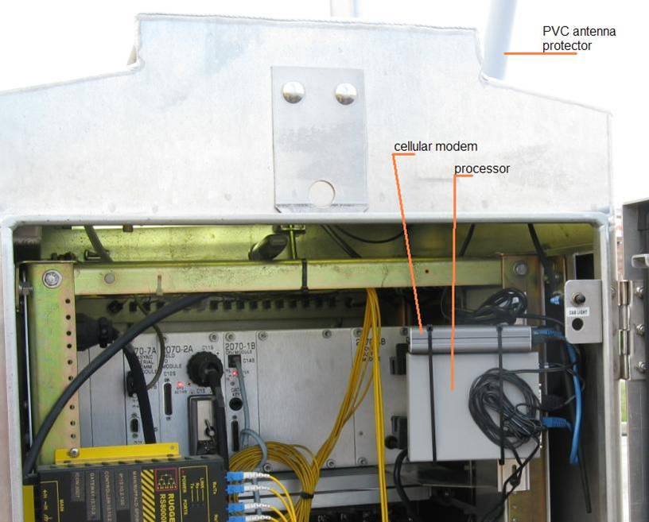

Joint Installation of AVI and AWAM Sensors
for Data Comparison

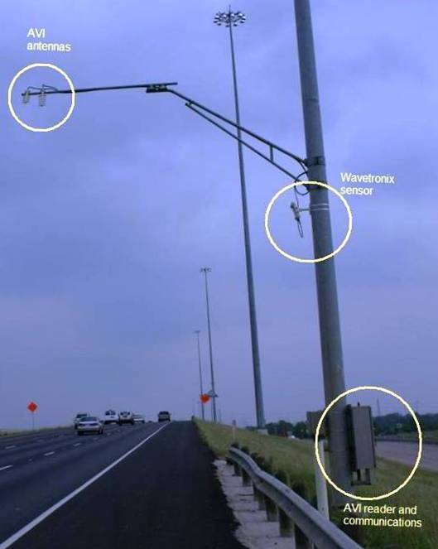
Comparison of Data from
AVI and AWAM Sensors

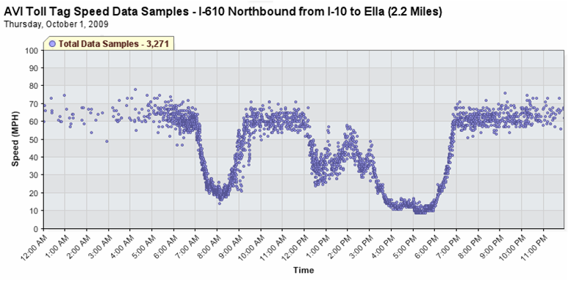

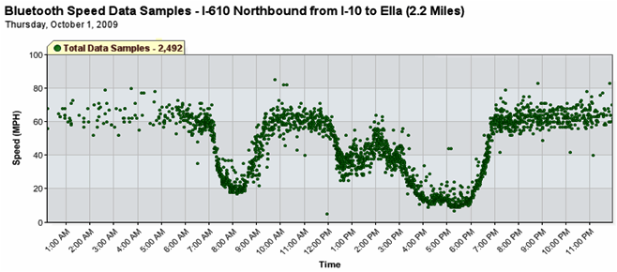
AWAM Data Displayed on
Houston TranStar Website
(262 directional miles)



