AASHTO Technology Implementation Group
Nomination of Technology Ready for Implementation

Sponsor | Nominations must be submitted by an AASHTO member DOT willing to help promote the technology. | - Sponsoring State DOT: Connecticut
Sponsor |  | - Name: Robbin Cabelus
Sponsor |  | Title: Transportation Planning Director
Sponsor |  | Mailing Address: 2800 Berlin Turnpike
Sponsor |  | City: Newington | State: CT |  | Zip Code: 06111
Sponsor |  | E-mail: robbin.cabelus@ct.gov | Phone: (860)594-2051 |  | Fax: (860) 594-2056
Sponsor |  | - Date Submitted: 10/03/2016
Sponsor |  | - Is the Sponsoring State DOT willing to promote this technology to other states by participating on a Lead States Team supported by the AASHTO Technology Implementation Group?  Please check one: Yes No
Technology Description (10 points) | The term “technology” may include processes, products, techniques, procedures, and practices. | - Name the technology: MMUCC Compliant Electronic Crash Reporting and Analysis System
Technology Description (10 points) |  | - Please Describe the Technology:  The Connecticut Department of Transportation (CTDOT) and UConn collaborated to develop the new MMUCC (Model Minimum Uniform Crash Criteria) Version 4 crash data collection system that was implemented in Connecticut on January 1, 2015.  MMUCC Compliant Fillable PDF With Electronic Features:  A universal, low-cost, electronic, field based, MMUCC data collection tool was needed to develop a “safety net” for departments without participating vendors or whose vendors were not ready. This “smart” form included the following features: 1) Auto population and page generation capabilities 2) Ability to import crash diagrams 3) Added pages and appendices for more complex crashes 4) Electronic file transmission to the CTDOT FTP site and ability to backfill local RMS systems via XML files and 5) Incorporated all of CTDOT edit rules and warnings; includes validation button to take users to exact fields that need correction.  The following is a link to the fillable PDF:  http://ctsrc.uconn.edu/wp-content/uploads/sites/1630/2016/07/Blank-Fillable_PR1_Rev_Sept_15_2015.pdf  MMUCC Compliant IT Management Package :  In order to facilitate upgrading of Record Management System (RMS) vendor software, the fillable PDF, uploading of crash data to the FTP site, management of data at the FTP site, and back end processing; the CTDOT had to develop a full suite of IT management tools from scratch. These included: 1) A MMUCC xml schema (10,000 lines of code) which set the formatting requirements for data transmission; all vendors/fillable PDF user had to submit crash data the same way, 2) Development of MMUCC validation and edit rules. These were incorporated into the fillable PDF, vendor software, applied at the FTP site, and used to QC data, 3) A CTDOT Specifications Guide to define data element/attributes and their values as well as edit and validation rules, 4) A Testing and Certification Guide with crash scenarios (from CTDOT’s data base) to test RMS vendor software, 5) A Crash Report Reader tool to apply validations and edits at the FTP site and to test vendor software, and 6) A Crash Uploader Tool to ease transmission of the fillable PDF and purchase of software licenses for crash diagrams.  The following is a link to the DOT Specifications document:  http://www.ct.gov/dot/cwp/view.asp?a=2094&q=533114  MMUCC Compliant UConn Crash Data Repository:  As a result of the Crash Data Improvement Program (CDIP) project, the UConn Crash Data Repository (CDR) serves as the primary source of MMUCC crash data in CT; it is web based and accessible to any public user, offering timely, accurate, and complete crash data. Users may view summaries, run and save queries, view data from individual reports and diagrams, map crashes, generate summary tables, and download raw crash data for further analysis.  Key features of the CDR are as follows: 1) Basic and advance query tools for individual departments containing 20 years’ worth of pre MMUCC data (1995 to 2014), 2) Basic report tools that can create summary fatality, injury, and property damage only (PDO) tables for key crash types for individual departments, counties, Metropolitan Planning Organizations, Councils of Governments, and DOT districts including State rankings, 3) An advanced query tool that provides options to select date ranges, locations, contributing factors by specific routes and for specific communities, 4) Prepopulated crash data templates that have been established to assist law enforcement agencies with highway safety grant applications, 5) 2015 to current MMUCC crash data-summary tables of individual crash reports which can query and add tables for any data field and attribute in the crash providing direct access to Easy Street Draw diagrams for every crash, and 6) Mapping capability: heat and pin maps, Google map street view.  The following is a link to UConn’s Crash Data Repository and training videos:  Link: http://www.ctcrash.uconn.edu/ www.Youtube.com/ctsrc www.vimeo.com/ctsrc
Technology Description (10 points) |  | - If appropriate, please attach photographs, diagrams, or other images illustrating the appearance or functionality of the technology. (If electronic, please provide a separate file.)  Please check one: Yes, images are attached. No images are attached.
State of Development (30 points) | Technologies must be successfully deployed in at least one State DOT. The TIG selection process will favor technologies that have advanced beyond the research stage, at least to the pilot deployment stage, and preferably into routine use. | - Please describe the history of the technology’s development.  Based on a CDIP Assessment in May, 2012 the CTDOT Crash Data and Analysis and Highway Safety Offices approached UConn to partner on a new initiative to overhaul their crash data collection system. The result was a collaborative effort to improve the quality and accessibility of the State’s crash data. Knowing that the existing paper based crash reporting system was no longer sustainable, the CDIP focused on building crash data collection and management tools. The CDIP resulted in a Statewide MMUCC based fully electronic reporting system that now provides real time, accurate and complete crash data to all highway safety users. In addition, the CTDOT decided to adopt the latest version of MMUCC, which on its own can be an intimidating process for even the most progressive States. While most of these efforts are typically funded independently and developed incrementally, Connecticut took a different approach.  The CDIP plan process identified the following problems: 1) A paper crash report (PR-1) with overlays that had not been changed since 1994, limiting the State’s ability to analyze new behavioral and engineering trends on State and local roadways, 2) Paper based submission of 70 percent of the state’s approximately 100,000 annual crash reports, 3) A business process that captured only one third of crash data and discarded the rest, 4) A data entry paper backlog of 16 months and growing, 5) A law enforcement culture of “just filling out reports for insurance companies”, 6) The absence of CTDOT authorized xml schema and edit rules to facilitate expanded electronic reporting, 7) The absence of a default electronic crash reporting tool to assist low technology agencies, and 8) The need for timely and complete crash data to support the Highway Safety Plan, Strategic Highway Safety Plan, and Highway Safety Improvement Plan (HSIP) program which was currently not being met.  The Connecticut CDIP experience produced a “toolbox” which serves as a roadmap for other states to follow. The CDIP “toolbox” includes all of the following tools which are easily transferable to other States: 1) electronic MMUCC compliant fillable PDF, 2) creation of MMUCC validation and edit rules, 3) MMUCC xml schema, 4) Records Management System (RMS) vendor certification protocol, 5) comprehensive six hour accredited MMUCC training curriculum for law enforcement and DOT staff, and 6) expanded Crash Data Repository (CDR) capable of mapping, visualizing and analyzing MMUCC data.  The new MMUCC crash reporting system went fully operational on January 1, 2015.
State of Development (30 points) |  | - For how long and in approximately how many applications has your State DOT used this technology?  This is the statewide crash data collection and analysis system for Connecticut. As of September 29, 2016 there have been 181,439 crashes reported using this system, involving 342,374 vehicles and 433,803 people. The CT State police and over 90 local police departments use this system to submit data to the CTDOT. There are over 900 registered users that use this system for crash data summaries and analysis.
State of Development (30 points) |  | - What additional development is necessary to enable routine deployment of the technology?  Routine deployment would be difficult since each state collects different data on their crash report form. Our system has an XML schema and follows the MMUCC guideline on what should be collected at the scene of the crash. Therefore, if a state is MMUCC compliant then it should be minimal effort to implement the tools necessary for a state to duplicate what has been done in Connecticut.
State of Development (30 points) |  | - Have other organizations used this technology? Please check one: Yes No  If so, please list organizations and contacts.
State of Development (30 points) |  | Organization | Name | Phone | E-mail
Payoff Potential (30 points) | Payoff is defined as the combination of broad applicability and significant benefit or advantage over other currently available technologies. | - How does the technology meet customer or stakeholder needs in your State DOT or other organizations that have used it?  The E-crash and CTCrash systems work in tandem and are the official crash data collection system and crash data repository for the state of Connecticut. There are over 900 registered users that run over 100 queries each day and perform over 50 data downloads a week. Connecticut Safety professionals are very happy with the system developed and use the system on a daily basis.
Payoff Potential (30 points) |  | - What type and scale of benefits has your DOT realized from using this technology? Include cost savings, safety improvements, transportation efficiency or effectiveness, environmental benefits, or any other advantages over other existing technologies.  Timeliness: Crash report processing times have been reduced from 16 months to two weeks (Prior to CDIP implementation, crash data to support the Highway Safety Plan, the Strategic Highway Safety Plan, and the Highway Safety Improvement Plan was at least two years old)  Accessibility: Availability of MMUCC data at the UConn CDR is virtually in “real time” (within one day of final crash processing at the CTDOT)  Completeness and Uniformity: Achieved 99.3 percent overall MMUCC compliance for elements collected at the crash scene resulting in an increase in crash report fields in the CTDOT data base by almost three fold  Accuracy: As a result of the application of new validation and edit rules, errors which had to be manually corrected on virtually every pre MMUCC report have dropped to just 1 per cent of all MMUCC reports received  Integration: Within the Crash Data Repository, pre MMUCC crash data already has been linked to selected attributes in the State’s roadway inventory file; capacity has been created to link to CTDOT’s new GIS based LRS system when completed; fatal and surviving driver impairment data now being collected for future linkage  Accessibility: Web based access to all MMUCC crash data collected including ability to run advanced queries, map crashes on road segments, intersections, and by community, view crash diagrams, and through Google maps to view crash locations  Long Term Impacts:  Changed the crash reporting dynamic between CTDOT and the law enforcement community forever. Developed state of the art MMUCC training materials. Developed cutting edge IT tools to facilitate electronic crash reporting including a fillable PDF. Established sustainable relationships with the RMS vendor community in collaborating on data quality.  Proof of the benefit of University Based Research and Technical Support:  The Connecticut MMUCC PR-1 project through a Memorandum of Understanding (MOU) with UConn was able to establish a Transportation Safety Research Center (TSRC) to provide a range of crash management and technical support services to expedite the conversion to MMUCC and full electronic reporting. More importantly, the MOU expanded the capacity of the existing CDR to adopt, query, display, and analyze MMUCC crash data. The TSRC now seeks to become a center of excellence with the integration of crash, roadway, and other safety files and expanded analytical tools and staff. The ability to identify and address the State’s highway safety problems both from a behavioral and engineering perspective has been greatly enhanced.
Payoff Potential (30 points) |  | - Please describe the potential extent of implementation in terms of geography, organization type (including other branches of government and private industry) and size, or other relevant factors. How broadly might the technology be deployed?  This technology would be of interest to every state DOT for the collection and analysis of crash data. Streamlining, standardizing, and removing the duplication effort required to process paper crash reports is a substantial savings to state DOTs. The collection of accurate field validated data is also a substantial savings of effort to correct reports as well as a tool to greatly increase data quality. Lastly using a web-based approach to data analysis and distribution encourages safety research and analysis with little effort on formatting and data collection. Every state could implement this type of system. Connecticut has developed the toolkit to do so with this technology.
Market Readiness (30 points) | The TIG selection process will favor technologies that can be adopted with a reasonable amount of effort and cost, commensurate with the payoff potential. | - What actions would another organization need to take to adopt this technology?  Each state would need to evaluate their current system and then follow the steps and procedures outlined in the Connecticut toolbox to deploy this system. We would recommend they appoint or hire a full time data champion to serve as the project manager and implement the system as described.
Market Readiness (30 points) |  | - What is the estimated cost, effort, and length of time required to deploy the technology in another organization?  For Connecticut this was a 3 year project. Other states would need to invest a similar timeframe to train and educate the entire state on the new system. The cost for Connecticut was roughly $6 million dollars. Other states can take the software, toolbox, and materials developed and implement a similar system for much less. The total cost would depend on the size of the state, the number of officers that need to be trained, software vendors in the state and the extent to which they deviate from the Connecticut model. A full implementation in the $3 million range would not be unreasonable for a medium size state.
Market Readiness (30 points) |  | - What resources—such as technical specifications, training materials, and user guides—are already available to assist deployment?  We have established a web site with a Tool Kit for other states to follow. The links are below.  http://www.ct.gov/dot/cwp/view.asp?a=2094&q=533114  http://ctsrc.uconn.edu/
Market Readiness (30 points) |  | - What organizations currently supply and provide technical support for the technology?  The Connecticut Transportation Safety Research Center (CTSRC) developed the crash data repository system known as “CTCrash,” which was launched in June of 2011. The CTSRC was also a major partner in the implementation of the Connecticut Crash Data Improvement Program (CDIP) and the E-crash software. The Connecticut Department of Transportation (CTDOT) maintains the new MMUCC (Model Minimum Uniform Crash Criteria) Version 4 crash data collection system that was implemented in Connecticut on January 1, 2015.
Market Readiness (30 points) |  | - Please describe any legal, environmental, social, intellectual property, or other barriers that might affect ease of implementation.  Funding for the majority of the software development effort was derived from Section 154 transfer funds under SAFETEA-LU and MAP-21. Those funds are typically split in the CTDOT between the Highway Safety Office and the Office of Engineering. Therefore, the software was developed with federal funds and the software is public property. States are welcome to the software but will need assistance implementing the system.

Software Images and Descriptions attached.

Crash Editor
The crash editor allows the CTDOT and UConn staff to open each crash individually and then validate the report against the CTDOT edit rules. Furthermore the coder reviewing the crash will add the route and milepost information while also updating the Latitude and Longitude of the crash. Geolocation to the state’s Linear Referencing System is the primary objective of this process. However coders also investigate warnings and modify the case if deemed necessary. This process should take less than 5 minutes per crash. CTDOT coders are expected to process at least 10 crashes an hour. All crashes that are reviewed have passed the CTDOT edits and validations and therefore should already be of a high quality. If the submitted crash does not pass the edit check in the automated import process it is rejected and automatically sent back to the police department to fix and resubmit. These rejections and submissions are tracked using the Crash system described below. The screen shots below detail what the CTDOT coders see when they edit crashes. The software was designed to look exactly like the crash report for ease of data entry and validation. If a warning is noted in the report the coders can click on the warning and it will take them directly to the data element that needs to be corrected.
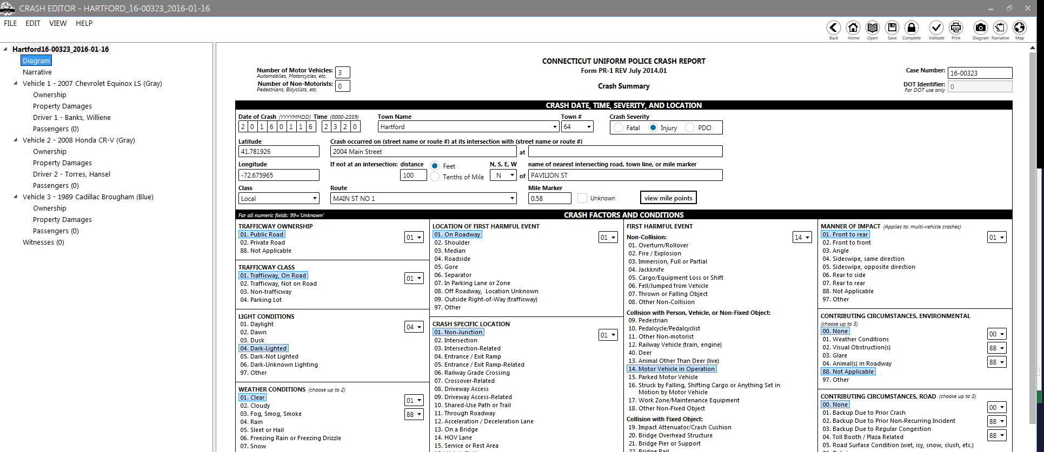
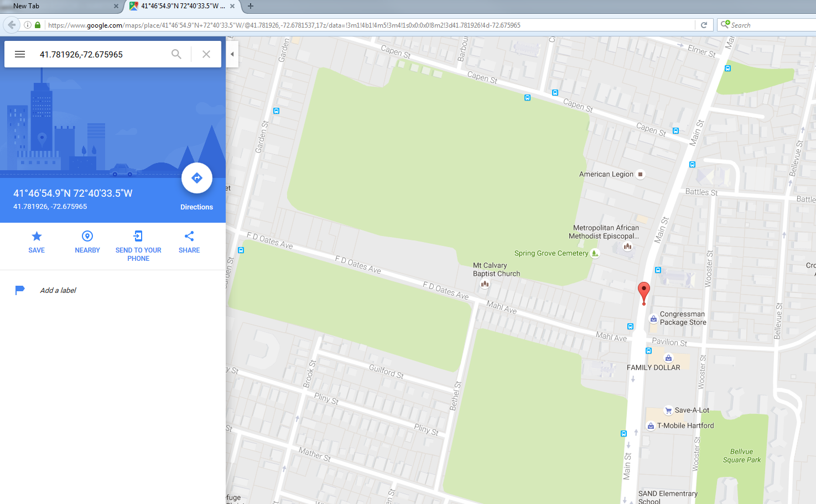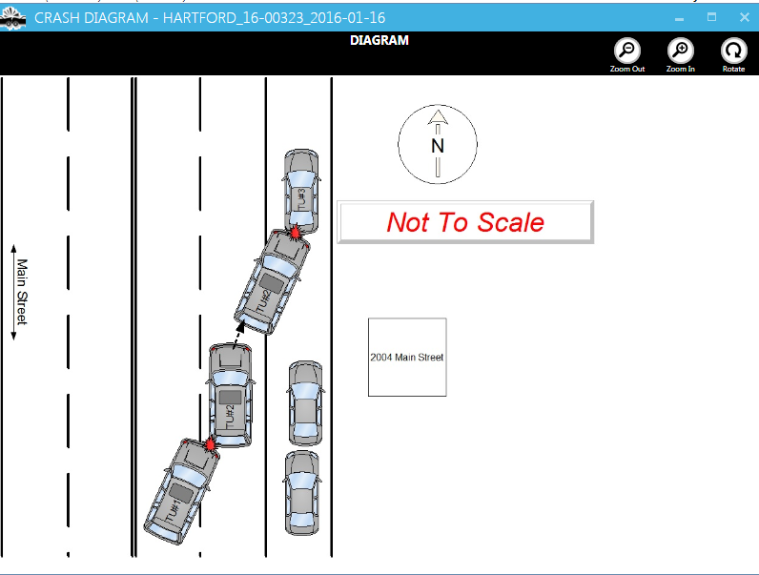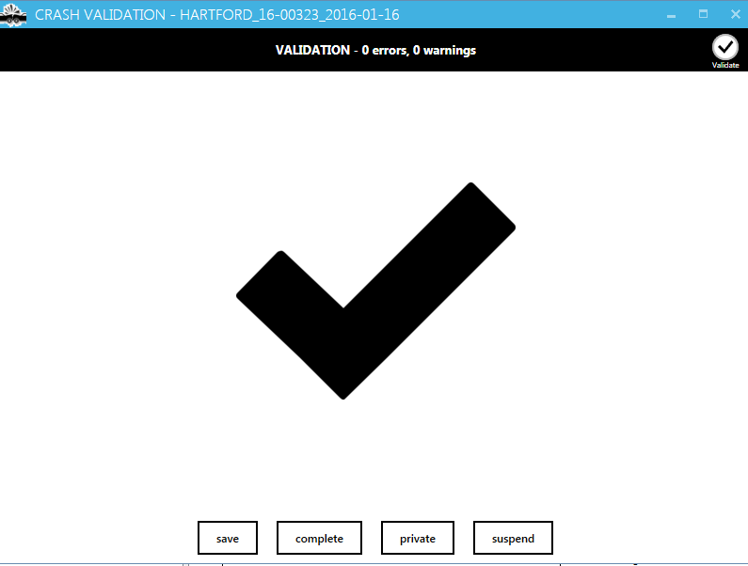

Crash Import Report
The following report displays information about the crash reports imported for a queried period of time by particular law enforcement agency(s). The color of the cells indicates if the report was accepted (no fill), has warnings (yellow fill), or was rejected (red fill). This allows the DOT to quickly review agencies or time periods where for example a vendor makes an upgrade to a client’s system. Details are retained concerning timeliness (crash date vs. upload date), RMS vendor, law enforcement agency, and the version of the vendor’s software being used. 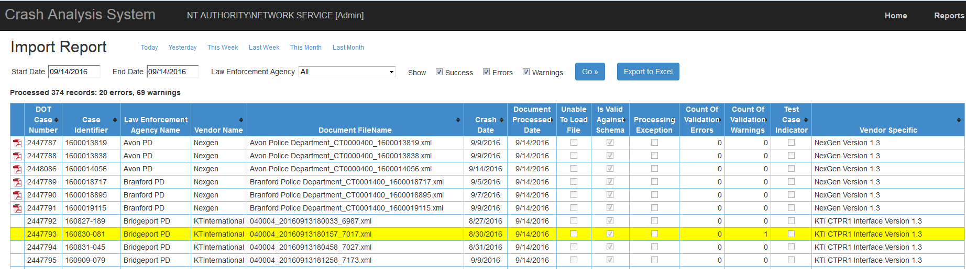

Daily Summary Report
CTDOT also tracks how each agency is performing. The report below shows the number of cases submitted to the DOT for a given date range, number of cases rejected, and number of cases that were rejected and never resubmitted. Our crash data liaisons use this report to make calls to police departments that are not submitting, have a large number of rejected reports or do not resubmit crashes that were rejected. This tool allows our team to target training or outreach to police departments that need extra help in getting crash reports into the CTDOT.
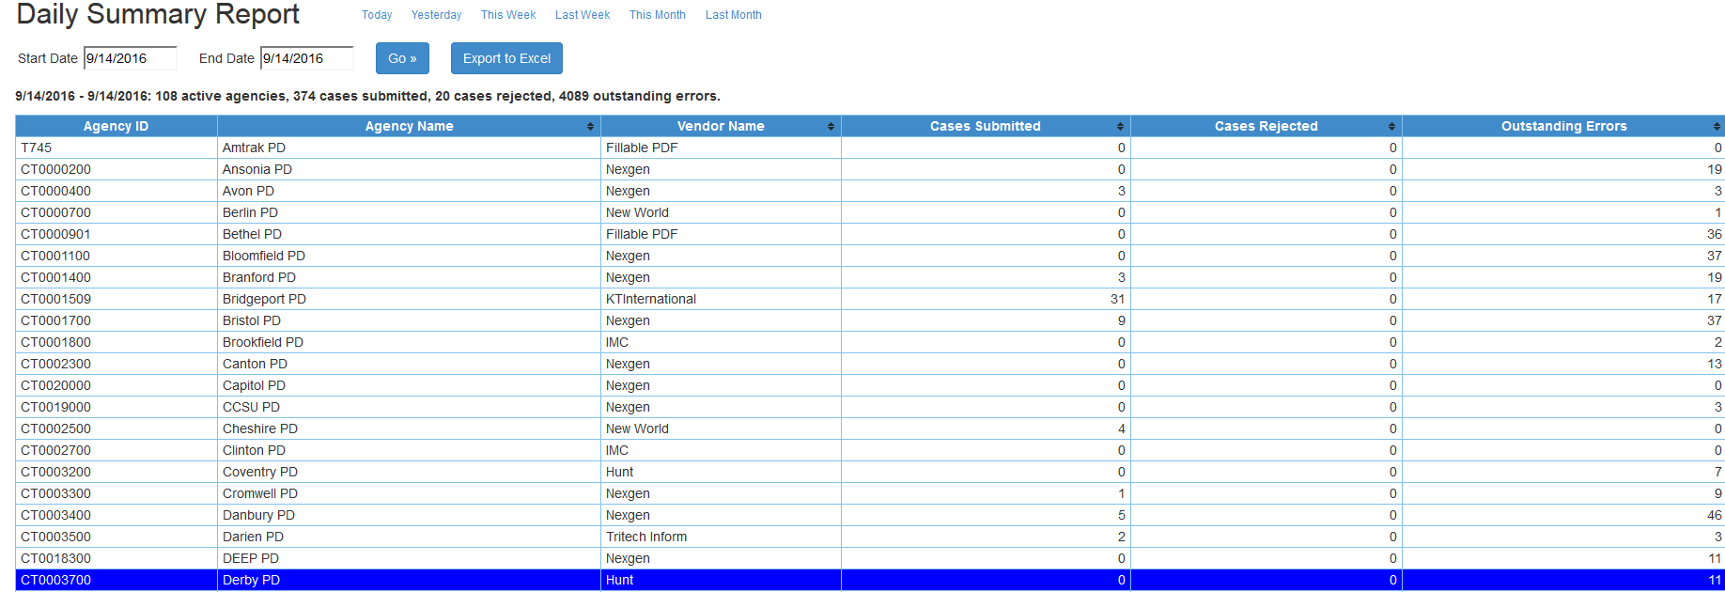

Agency Status report
The purpose of this report is to track historical reporting rates with current reporting rates. By selecting a month and a year the system will report on the number received in the current year and then compare that number to the previous year. If there are a dramatic number of fewer reports the team may reach out to the department to see if they have issues or a backlog of data. This report also shows the last date a case was received from an agency and the software version that was used to submit that report.
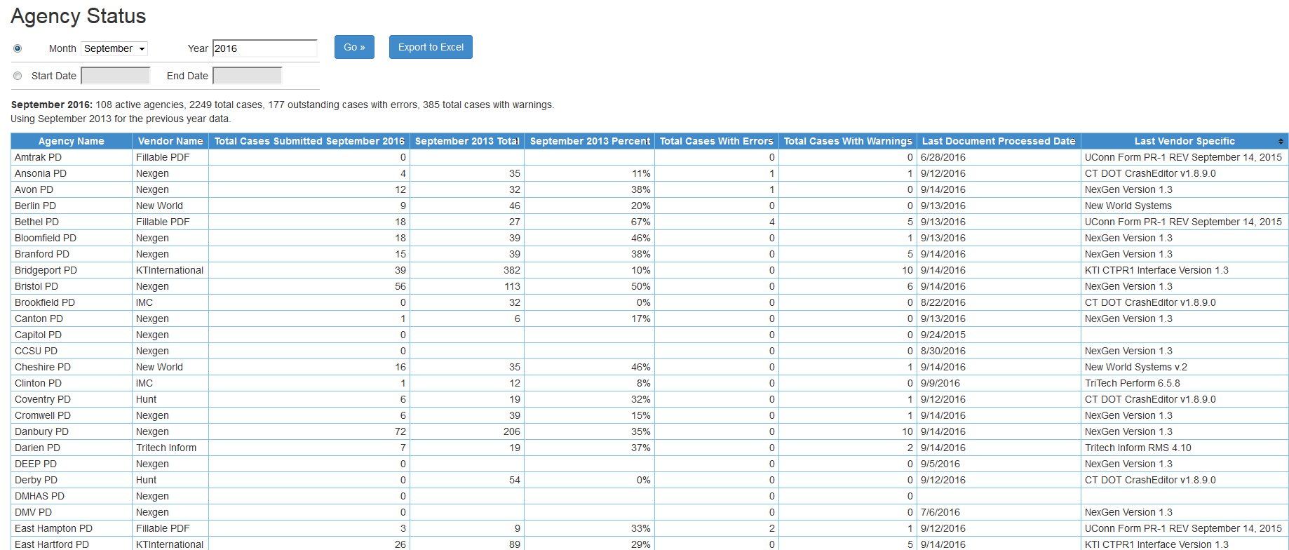

Backlog Report
The CTDOT uses the backlog report to monitor the current number of crashes in the queue to be processed. This report displays the queue in a graph. The table below the graph contains the number of crashes processed by their coding staff on a daily basis, the number of reports submitted to the CTDOT, the change in the backlog, and the total number of reports received since the start of the MMUCC switchover. This report is critical to timeliness. If the backlog begins to grow the CTDOT can evaluate the need for more coders, overtime, or assistance from UConn in processing crash reports. It will also let the CTDOT determine if their day-to-day operations are sufficient to eliminate or prevent a backlog of crashes.
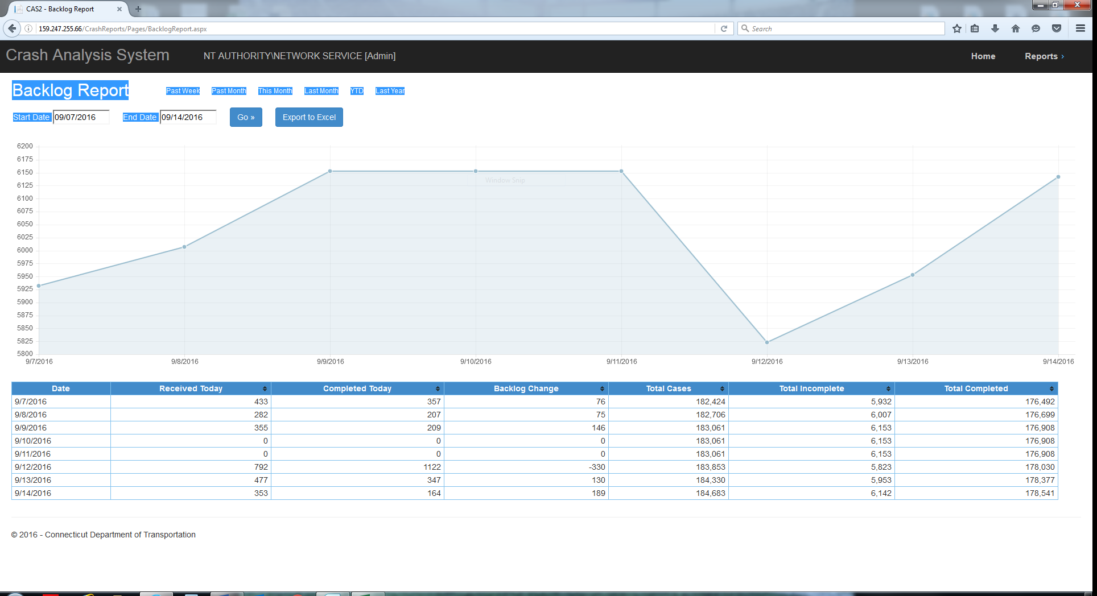

Coder Performance
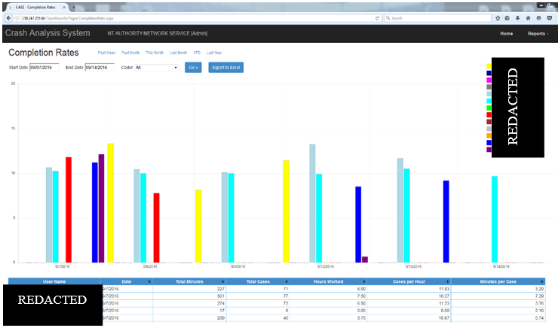
The completion rates report provides a more detailed look at how each coder is performing and the average number of crashes they are coding per hour (graph) and per day (table). This report is used to monitor how efficient each coder is and if there are issues that need to be resolved. Coding is not the only assignment for many of the CTDOT coders so a low production day is not an indication of poor performance but can be used to help manage workload with the goal of timely and accurate crash data.

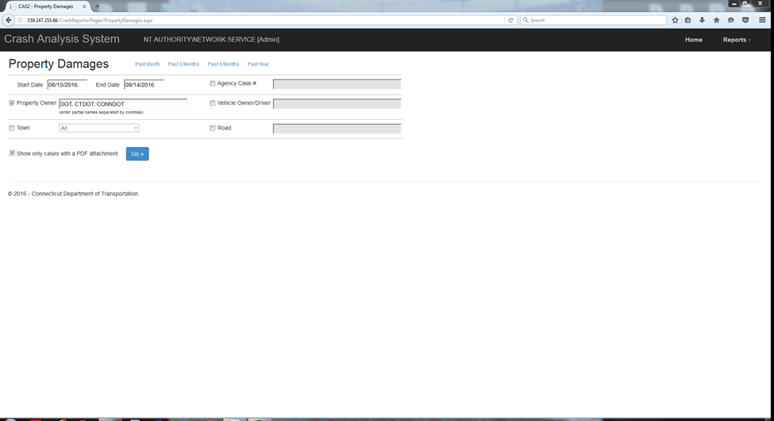

CTDOT Property Damage Report
This report was generated to allow the CTDOT to quickly identify crashes where CTDOT property was damaged, and then display those reports. The CTDOT uses this application to track down responsible drivers and an associated insurance company when they are looking to charge parties for damage to state infrastructure.

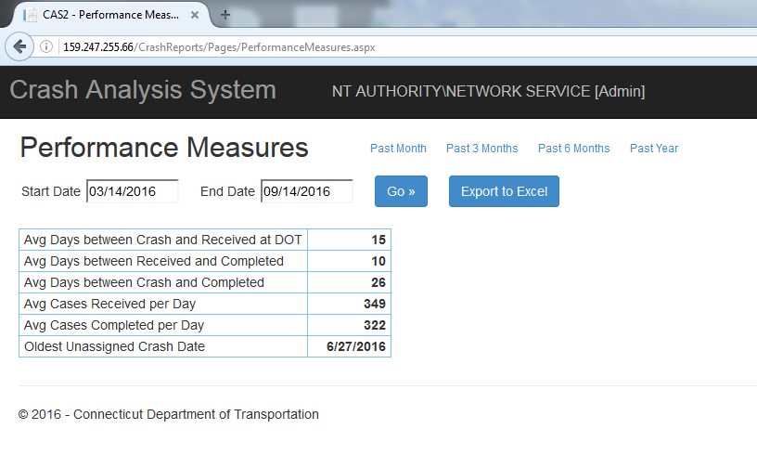
Performance Measures
The performance measures report is used to track how the overall system is performing with respect to timeliness.

Errors and Warnings
The errors and warnings report displays how frequently a warning or error is being triggered upon import of crash reports. This information can then be used to tailor newsletter articles or custom trainings to police departments. Furthermore, this report can be used to establish or strengthen edit and validation rules provided to software vendors.
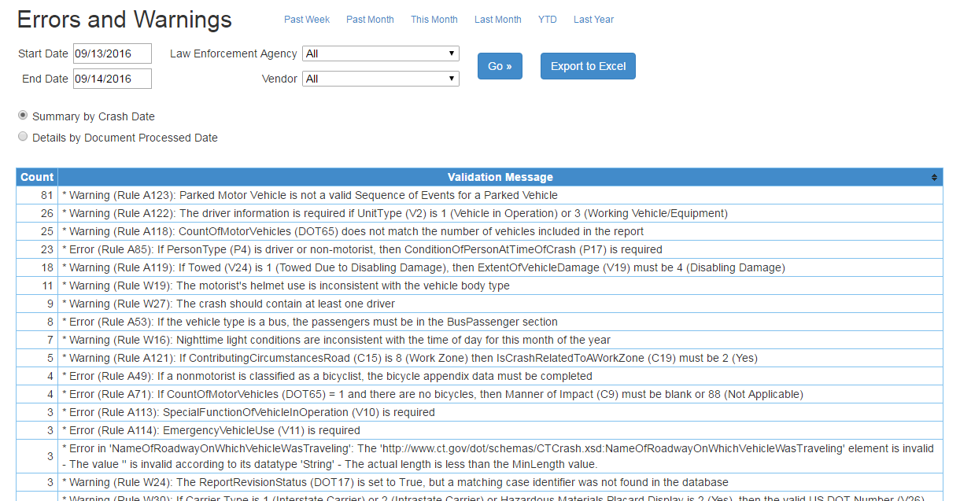

MMUCC Compliant Crash Data Repository
As a result of the CDIP project, the UConn Crash Data Repository (CDR) serves as the primary source of MMUCC crash data in CT. The CDR is web based and accessible to any public user, offering timely, accurate, and complete crash data. Users may view summaries, run and save queries, view data from individual reports and diagrams, map crashes, generate summary tables, and download raw crash data for further analysis.
Key features of the CDR are as follows:
- Current Features:
  - Basic and advanced query tools containing 20 years’ worth of pre MMUCC data (1995 to 2014)
  - Basic report tool can create summary fatality, injury, and PDO tables for key crash types for individual departments, counties, Transportation Planning regions, and DOT districts including State rankings
  - Advanced query tool provides options to select date ranges, locations, contributing factors by specific routes and for specific communities
  - Prepopulated crash data templates have been established to assist law enforcement agencies with grant applications
  - 2015- current MMUCC crash data-summary tables of individual crash reports; can query and add tables for any data field and attribute in the crash; direct access to EasyStreetDrawTM diagrams for every crash
  - Mapping capability: heat and pin maps, Google Street ViewTM
  - Data dashboard capabilities

- New Features in Planning Stage:
  - Merging of common fields for old PR-1 and MMUCC data for trend analysis
  - Integration of infraction and citation data
  - Integration of toxicology databases containing alcohol and drug impairment information for DUI stops and all crashes
  - Integration of census and demographic information
  - Integration of EMS and Trauma registry information

Below are some screen shots and more detailed information about the Connecticut Crash Data Repository.

Data Analysis Tools: CTCrash.uconn.edu
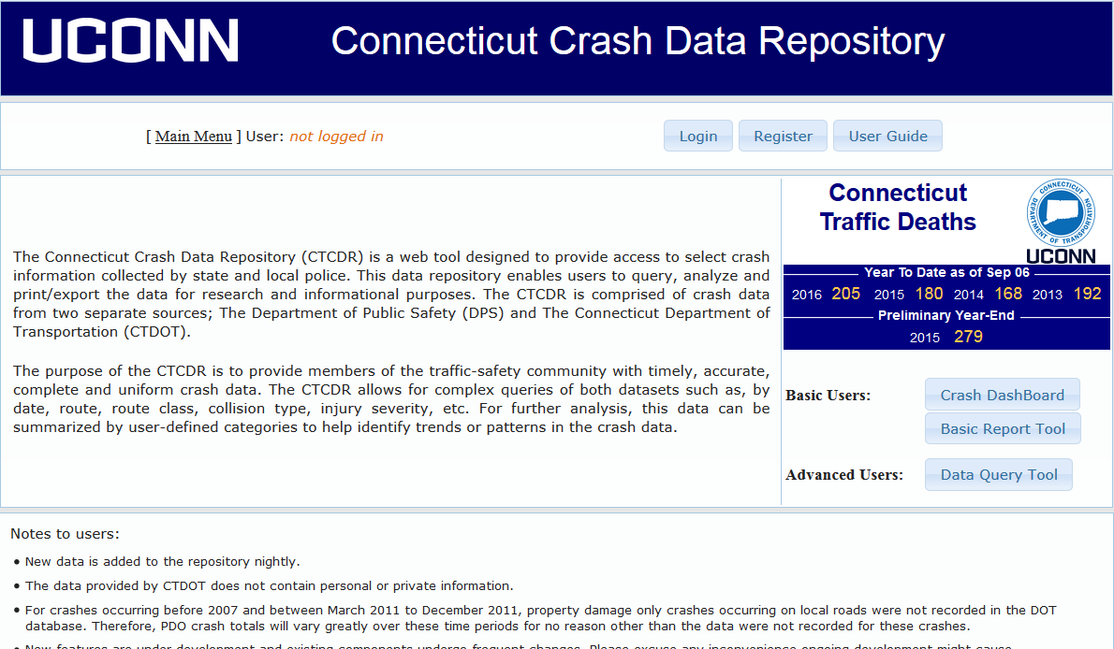
This section will describe some of the data analysis tools that are part of the Connecticut crash data repository. The opening screen of CTCrash.uconn.edu allows the user to quickly identify the number of fatal crashes that have occurred year to date. The “Connecticut Traffic Deaths” box displays the previous 4 years of fatalities, year to date with a preliminary year end fatality number for the previous year. This allows fatal crash numbers to be quickly and easily tracked and compared from year-to-year.
Users can register for the system instantly and then have access to all the tools provided.

Crash Dashboards
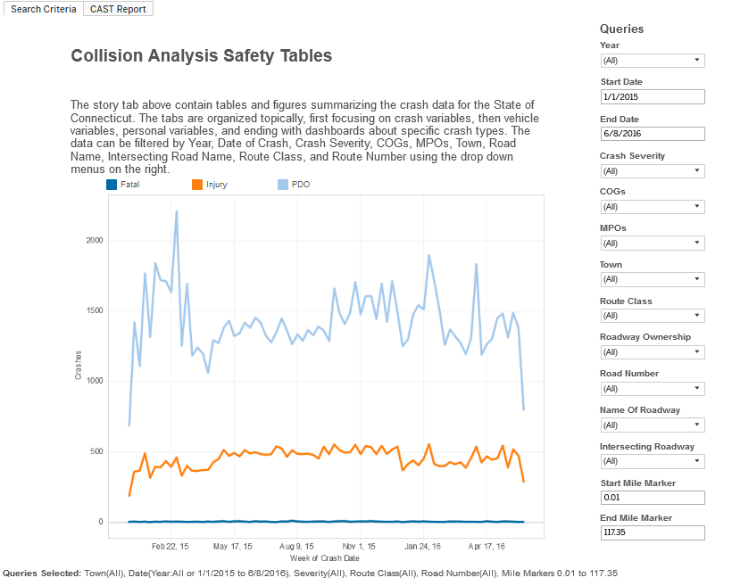
The crash dashboards provide a fast way to perform a query on the crash data and return a large number of statistics, facts and figures for analysis of crash trends in the state. Users make their selections using the drop downs on the left, and the graphic in the middle of the screen adjusts the numbers accordingly.
Once all selections are made, the user then clicks on the CAST report tab at the top of the screen. The information contained in the next tab is composed of a series of data charts and tables based on commonly requested data queries. There are 26 pages of facts and figures in all, and over 80 different figures. This example shows heat maps of date and time of crashes. This can be done for individual towns, roads or even intersections.
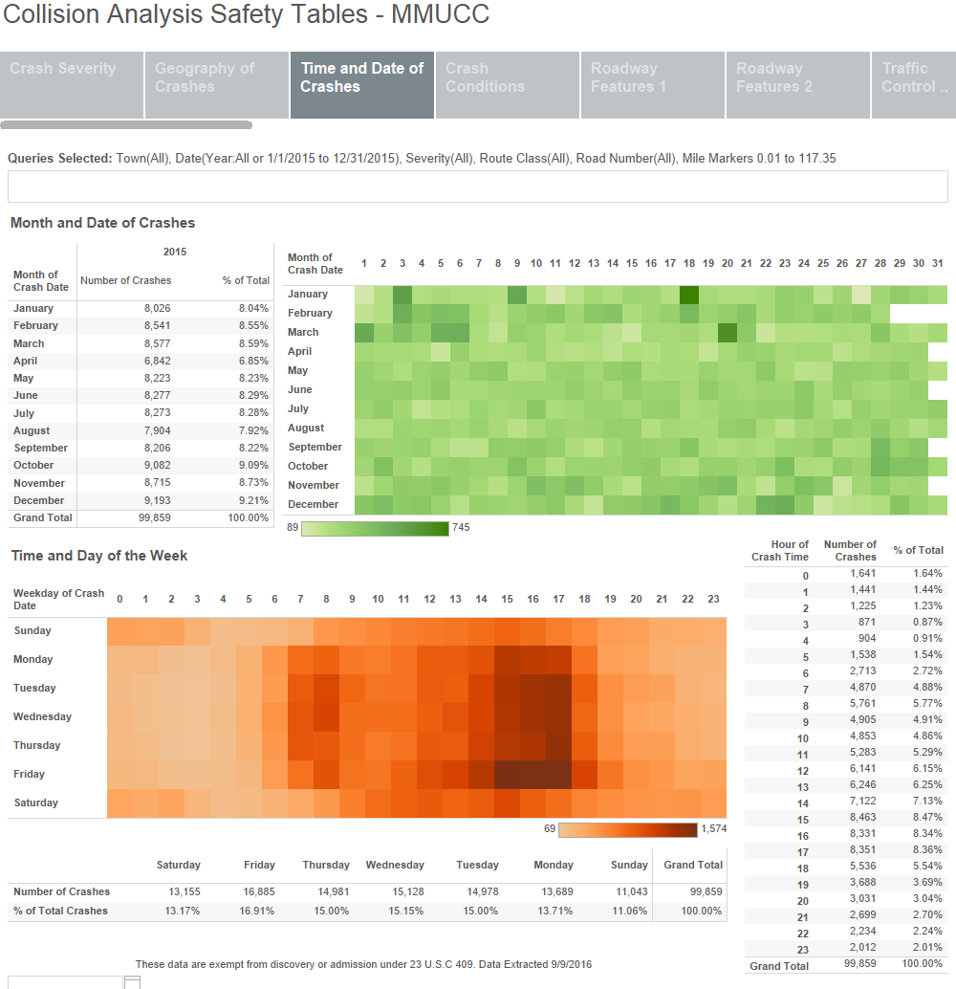

Basic Report Tools
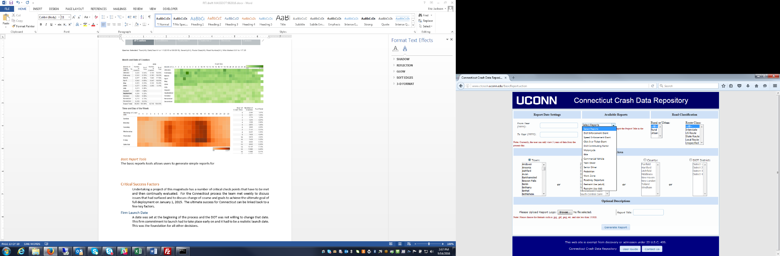
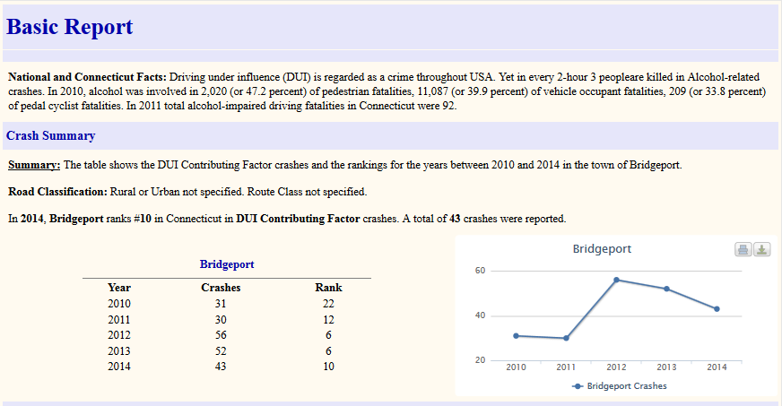
The basic report tool allows users to generate simple reports for the previous 5 years by individual towns. The reports indicate where the requested town ranks within the state based on the query in question (DUI, speed, seatbelt use, etc.). Furthermore the basic report tool allows police departments to generate the data for the crash statistics page of a grant application. This reduces work for each police department and provides a uniform database and tool to generate crash data for grant applications.

Advanced User tools
The advanced user tools provide full query and analysis capabilities for crash data. Users must register on the site to have access to these tools. Once registered and logged in, the user can make query selections via a simple user interface. The options on this interface mirror all the options on the Connecticut crash report. After submitting for results the user can perform a number of analyses. Cross tabulations, route histograms, mapping and crash density mapping are products that can be obtained with an analysis. The user is also provided with the ability to view the crash location in Google Street View and to view an image of the crash diagram. These are just a few of the features of the Crash Data Repository, and we are currently expanding the functionality to include a full Highway Safety Manual (HSM) Analysis as part of another grant from the CTDOT.


