Region 1 - Lone Tree Residency
7328 S Revere Parkway, Suite 204A
Centennial, CO 80112

AASHTO Nomination

Innovation Initiation Submittal
Problem Statement:
For every single Engineering and Local Agency construction project that CDOT creates, the designer must create and prepare a specifications package. Within this specifications package, there are Project Special Provisions (PSP) and Standard Special Provisions (SSP). Currently, the PSP is comprised of individual Word documents that the designer must select, open, copy and paste into a master file. There are hundreds of specifications that a project may need. It is up to the designer to work through each one and decide on its applicability and intent. Depending upon the size and complexity of the project, the PSP could be as small as 25 special provisions or as much as 100+. The designer must also step through a similar process when selecting the applicable SSP as well.
In addition to building a specifications package, the designer will create a title sheet, which indexes all the applicable specifications listed, with the specific specifications listed and the corresponding sheet numbers. This is another manual process where the designer will either manually type in the name of the specification or will copy and paste the title. Either way, it is time consuming and very inefficient. Through some rough calculations of the time needed to create a complete specifications package for a project, that includes the PSP, SSP and title sheet, it takes approximately 8 man hours per 25 specifications.
Because a project’s specification package can be hundreds and hundreds of pages long, for convenience, a designer will often use specifications from previous projects and include them in new projects. This creates potential specification issues because the old specifications may not contain applicable content and could possibly be in conflict with new requirements.
Discussion of Solution:
To help automate and speed up the specifications creation process, the Project Specification Assembly Tool (PSAT) was created. PSAT is an Excel based tool that automates the assembly of the PSPs and the SSPs into a complete Specification Package. This tool offers the opportunity for increased efficiency and accuracy when preparing and creating project specifications. Depending upon the number of specifications, this tool can reduce the amount of time needed to assemble the specifications from 1 to 3 staff-days of work per project to just a few minutes. If fully utilized, this tool has the opportunity to save between $70,000 and $200,000 per year in CDOT staff time. Additionally, considering the numerous Local Agency’s that use CDOT specifications, the amount of savings could increase significantly across the state.
Since PSAT always references the most current specifications, the risk of building a specifications package with conflicts or outdated content is minimized and reduced.
The How:
PSAT uses two programs: “SpecialSpecs” and “Standard Special Provisions Index”, which are both Excel based, and can be downloaded at the Project Specification Assembly Tool Website. Once all the necessary specifications are selected, the designer clicks on ‘create’ and the program generates a new Word document that includes all the selected specifications and the index. Detailed operating instructions provided in the Project Specification Assembly Tool Website are available.
The designer enters applicable project information into PSAT and it uses the information to create the applicable headers. This saves additional time and improves the consistency of the specifications package.
The majority of Local Agency’s in Colorado that perform transportation related projects, rely heavily on CDOT’s specifications and standards. When CDOT revises or updates any aspect of the design and construction requirements of project delivery, it has a ripple effect across the state.
Key Benefits:
The development of this tool employs several Lean principles, including 1) using automation to speed up repetitive tasks, 2) reducing delays and confusion caused by errors, and 3) standardizing work. Using this tool, project designers reduce errors that often arise from copying, pasting and editing old project worksheets and reduce the time needed to create the specifications package. PSAT will be updated and hosted by the CDOT Standards and Specifications Group, which will ensure the most current specifications are always being referenced.

Idea/Innovation developed by: Jack Thorpe (EIT II), and Dole Grebenik (PE II), Lone Tree Residency, Region 1.

Submitted by:
Dole Grebenik, P.E.
Resident Engineer – Region 1
Dole.Grebenik@state.co.us
303-365-7234

This is a complete list of all the Standard Project Provisions to select from: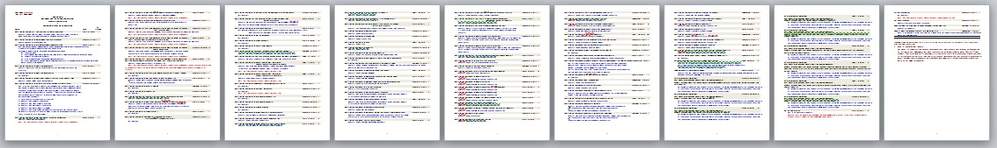
This is a complete list of all the Project Special Provisions to select from: 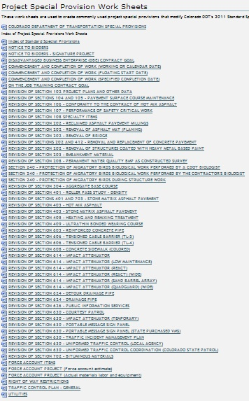
To create your specifications package: 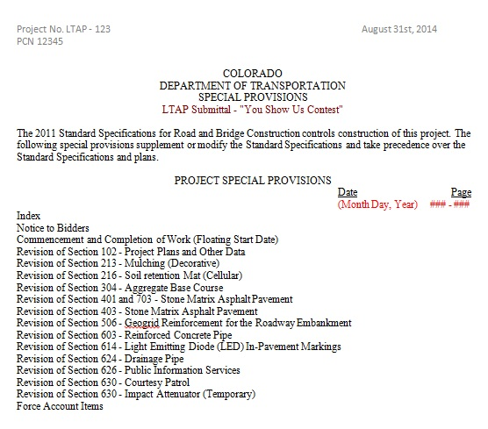
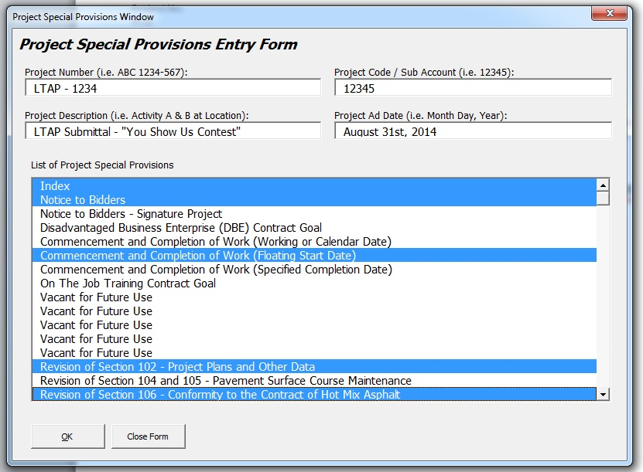
So, you can either go and select each individual Word document, then copy and paste into a master file, or use:

Old way = 8 to 24 hours of staff time.
New way = 5 minutes.

