Sponsor | Nominations must be submitted by an AASHTO member DOT willing to help promote the technology | - Sponsoring DOT (State): California
 |  | - Name and Title: Nick Compin Chief, Office of Strategic Development
 |  | Organization: California Department of Transportation
 |  | Street Address: 1120 N. Street
 |  | City: Sacramento |  | State: CA |  |  | Zipcode: 95814
 |  | E-mail: Nicholas.compin@dot.ca.gov |  | Phone: 916 653-4575 |  |  | Fax:
 |  | 3. Is the sponsoring State DOT willing to promote this technology to other states by participating on a Lead States Team supported by the AASHTO Innovation Initiative? Yes or No: Yes
Technology Description (10 points) | The term “technology” may include processes, products, techniques, procedures, and practices. | 4. Name of Technology:  Intelligent Transportation Systems System Builder (ITS-SB)
- Please describe the technology.
- The Intelligent Transportation Systems System Builder (ITS-SB) tool is an interactive database that contains a library of both Caltrans and regional ITS architectures built using the Federal Highway Administrations’ (FHWA) Turbo Architecture, context diagrams and other helpful related documents.
- Stakeholders now have the ability to access the ITS-SB database to upload, modify and maintain individual regional architectures
- All users have the ability to not only search their own ITS plans and elements of uploaded information, but they can also search any architecture that has been uploaded into the database.
6. If appropriate, please attach photographs, diagrams, or other images illustrating the appearance or functionality of the technology. (If electronic, please provide a separate file.) Please list your attachments here.
- Home Page - http://149.136.20.175/NetApps/Systembuilder/Default.aspx
- Search Architectures Page - http://149.136.20.175/NetApps/Systembuilder/SearchText.aspx
State of Development  (30 points) | Technologies must be successfully deployed in at least one State DOT. The AII selection process will favor technologies that have advanced beyond the research stage, at least to the pilot deployment stage, and preferably into routine use. | - Briefly describe the history of its development.  - In 2004, the California Statewide ITS Architecture and System Plan was created which laid the ground work for planning, programming and deploying future generations of ITS.  - The result was a graphical and textual representation of regional architectures within and across Caltrans Districts and boundaries.  - In 2011, ITS-SB was created to provide a clearinghouse of ITS transportation technology and provide the ability for stakeholders to upload, modify and maintain individual ITS architectures.  - The database sat dormant for a period of time until a final location was located within Caltrans  - In 2016, the database was revised, enhanced and permanently housed within the Caltrans Network with an external internet link.
- For how long and in approximately how many applications has your State DOT used this technology?
- ITS-SB was only recently revised and enhanced, therefore Caltrans and Regional stakeholders are just now becoming more familiar with the functionality of the ITS-SB tool.
- What additional development is necessary to enable routine deployment of the technology?
- ITS-SB requires ongoing effort to enable the inclusion of additional ITS architectures and the latest version of the FHWA Turbo Architecture database.
- Ongoing maintenance is also necessary to ensure that ITS-SB remains functional during any necessary security patch installations and/or other minor fixes as needed.
- Have other organizations used this technology? Yes or No: No If so, please list organization names and contacts.
- To our knowledge, no other state has this ITS database tool, functionality or capability
 |  | Organization | Name |  | Phone | E-mail
Potential Payoff  (30 points) | Payoff is defined as the combination of broad applicability and significant benefit or advantage over other currently available technologies. | - How does the technology meet customer or stakeholder needs in your State DOT or other organizations that have used it?  ITS-SB enables stakeholders to efficiently and effectively;  - Comply with Federal Regulations (23 CFR 655 and 940) by ensuring ITS projects conform to the National ITS Architecture  - Share both existing and planned ITS deployments with partner agencies  - Develop regional ITS Architectures that are consistent with the National ITS Architecture  - Develop regional ITS Architectures that are consistent with the Statewide or Metropolitan planning process  - Develop Regional Transportation Plans (RTP)s and a host of valuable plans  - Develop required programs: State Highway Operations and Protection Program (SHOPP), Regional Transportation Improvement Program (RTIP), Transportation Improvement Program (TIP), Regional Transportation Improvement Program (RTIP), and State Transportation Improvement Program (STIP)  - Develop asset management plans that include ITS elements
12. What type and scale of benefits has your DOT realized from using this technology? Include cost savings, safety improvements, transportation efficiency or effectiveness, environmental benefits, or any other advantages over other existing technologies.
The ITS-SB and the Statewide ITS Architecture (SWITSA) will play an important role in all phases of ITS life-cycle including the planning, design, procurement, deployment, and management phases as follows:
- Planning: An ITS project’s inclusion in the ITS-SB displays commitment and readiness for funding.
- Design: Each step of the regional architecture process results in guidelines for design.
- Procurement: Functional requirements can be extracted directly from ITS-SB and inserted into a Request for Proposal (RFP).
- Deployment: Results in improved ITS projects as the process of developing the regional architecture requires projects to be designed using the Systems Engineering process
- Management: Results in more efficient system integration and management as data exchange requirements that reflect stakeholder consensus are included.
- Please describe the potential extent of implementation in terms of geography, organization type (including other branches of government and private industry) and size, or other relevant factors. How broadly might the technology be deployed?
ITS-SB has the potential to be implemented at regional, state, and national levels across the US given that is uses the FHWA ITS Turbo Architecture as the platform.
Market Readiness (30 points) | The AII selection process will favor technologies that can be adopted with a reasonable amount of effort and cost, commensurate with the payoff potential. | - What actions would another organization need to take to adopt this technology?  They could either obtain a copy of ITS-SB from Caltrans and stand the tool up locally or load their architecture into the version at Caltrans. The organization would also need to be able to modify ITS-SB to accept their architecture. No matter where ITS-SB is housed, the most likely action would be for the organization to pursue a consultant contract to modify ITS-SB to accept their architecture.
 |  | - What is the estimated cost, effort, and length of time required to deploy the technology in another organization?
- What resources—such as technical specifications, training materials, and user guides—are already available to assist deployment?
Caltrans has created the technical, training and user documents necessary to provide ITS-SB across Calfiornia. has training material available and training via webinar is to be provided within 2016
- What organizations currently supply and provide technical support for the technology?
Caltrans statewide and the majority of Metropolitan Planning Organizations statewide
- Please describe any legal, environmental, social, intellectual property, or other barriers that might affect ease of implementation.
None that we are aware of.
Submit Completed form to |  | http://web.transportation.org/tig_solicitation/Submit.aspx

http://149.136.20.175/NetApps/Systembuilder/Default.aspx

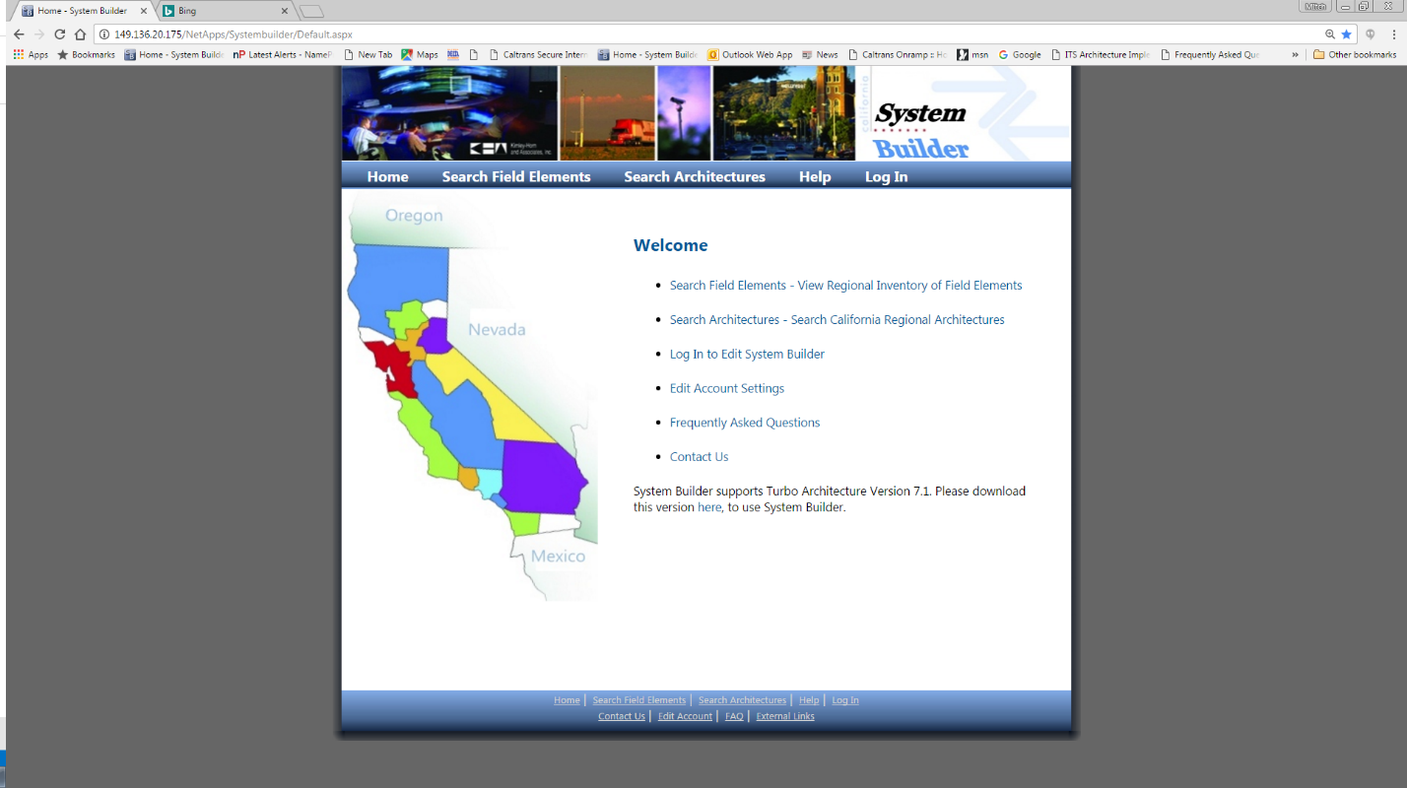

http://149.136.20.175/NetApps/Systembuilder/SearchText.aspx

