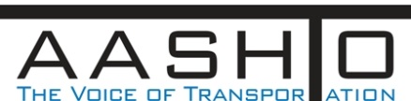 

**TC3**

**National Council Agenda**

**February 23, 2014 – February 26, 2013**

**Chair: Tom Byron Vice Chair: Mark Chaput**

**Sunday, February 24, 2014**

***Travel Day***

**Registration 4:00 PM – 6:00 PM**

**Welcome Reception 6:00 PM – 8:00 PM**

**Monday, February 24, 2014 8:00 AM – 5:00 PM**

**Group Orientation**

**Sub-Committee Updates**

**and Accomplishments**

**Regional Training Group Updates**

**AASHTO Subcommittee Updates**

**TC3 Survey Results**

**TC3 Mobile App**

**TC3 Website**

**FHWA Update**

**AASHTO Update**

**Tuesday, February 25, 2014 8:00 AM – 5:00 PM**

**Group Round Table**

**Expectations and Brain Storming for TC3 Committees**

**New Committee Structure**

**Committee Task and Work Items**

**Committee Member Assignments**

**Break-Out Sessions and Committee Assignments**

**Afternoon Committee work sessions**

**Wednesday, February 26, 2014 8:00 AM – 12:00 PM**

* **New Committee Reports**
* **Discussion regarding broadened awareness and engagement within the AASHTO Subcomittees**
* **TC3 Learning Management System**
  + **Fees**
  + **Hosting**

***The Executive Board will meet in the afternoon***