Sponsor | Nominations must  be submitted by an AASHTO member DOT willing to help promote the technology | 1. Sponsoring DOT (State): MO
 |  | 2. Name and Title: Mark Croarkin, St. Louis District Bridge Engineer
 |  | Organization: Missouri Department of Transportation (MoDOT)
 |  | Street Address: 1590 Woodlake Drive
 |  | City: Chesterfield | State: MO | Zip code: 63017
 |  | E-mail: mark.croarkin@modot.mo.gov | Phone: 573-619-6935 | Fax: n/a
3. Is the sponsoring State DOT willing to promote this technology to other states by participating on a
Lead States Team supported by the AASHTO Technology Implementation Group? Yes or No: Yes
Technology  Description  (10 points) | The term  “technology” may  include processes, products, techniques, procedures, and practices. | 4. Name of Technology:  BEJS (Bridge Expansion Joint System) by EMSEAL JOINT SYSTEMS
5. Please describe the technology.
BEJS is an innovative traffic-durable expansion joint that has proven to provide water tightness in our structures. It has successfully filled a much needed cost effective mid-range repair option of failed joints on our bridges. BEJS has been used for over 3 years now in MO. It exhibits greater movement capability than
had been available. I was quite impressed after initially emphasizing how important the sizing of
maintenance joints is, the manufacturer developed and provided us with aids such as bridge checklists to gather pertinent information, and is now producing a sizing chart with enough details to ensure that the material is sized and installed correctly. Another area of difficulty for all maintenance joints is the corners,
and BEJS listened and started Factory-fabricating 90 degree transition pieces to solve the continual problem of leaks at curbs. The product is cellular polyurethane foam impregnated with a water-based acrylic. The traffic grade silicone facing is applied and cured in the factory. The material is then compressed to smaller than the joint size, which is a great advantage over field applied liquid sealant and backer rod systems which are cured in the field and typically fail quickly. Due to the bellows that are created when the BEJS foam is compressed in the factory all thermal movement occurs at the bellows and therefore there is no stress in the silicone at the bond line which is where we observe most systems fail. The foam acts as a resilient backing to the silicone coating as well as provides 2 to 3 inches of depth for the epoxy adhesive to bond to substrate. This depth of foam also permits the system to resist reasonable transient point loads. We have found BEJS easier to install than any other maintenance type joints we have used. The amount of movement
compression seals and EVA-foams or closed cell foams can handle is dependent on the stored strain energy of the material that the crew was able to squeeze into the joint gap. They also can fail when not enough material was calculated for the colder temps or water migrates into the closed cells when the joint is
damaged making the joint material so heavy it falls out. BEJS does not suffer compression set as is typical with closed cell foams. The preformed silicone V shape systems are the primary competitor of this system, but they collect more debris and can be more difficult to install in tight joints. BEJS is being used by many other DOTS’ around the country. Iowa DOT has used BEJS to replace failed neoprene seals in strip seals, MA DOT uses BEJS buried under poured asphaltic plug joints in place of caulk and backer rod, and NY DOT has used BEJS to replace failed rubber seals in modular joints.
6. If appropriate, please attach photographs, diagrams, or other images illustrating the appearance or
functionality of the technology. (If electronic, please provide a separate file.) Please list your attachments here.
See attached below the TIG submittal form.
State of  Development  (30 points) | Technologies must  be successfully deployed in at least one State DOT.  The TIG selection process will favor technologies that have advanced beyond the research stage, at least to the pilot deployment stage, and preferably into routine use. | 7. Briefly describe the history of its development.  Impregnation into open cell foam has been around for over 30 years. This product evolved from an asphalt impregnation to its current 100% acrylic. Some other manufacturers use a wax emulsion or other variations into an open cell foam that have not proven to be as successful as 100% acrylic due to bleeding during warm weather and brittleness at cold temperatures which can result in the material not expanding fully in colder temps. Closed cell foams have traditionally absorbed water and fallen out due to weight or improper sizing. BEJS has already been adopted by several DOTs in the country.
8. For how long and in approximately how many applications has your State DOT used this technology?
The first installs occurred in 2010 after reviewing numerous applications in parking garage expansion joints. There are many installations throughout Missouri now.

Page 1

9. What additional development is necessary to enable routine deployment of the technology?
Become familiar with the sizing and installation instructions, which is not difficult. National exposure via AASHTO to DOT’s who are not familiar with this technology would go a long way toward spreading the word about this technology. Currently the manufacturer is attempting to educate the national market state by state by offering free material for testing. This is a slow process. This technology’s excellent track record should be shared in order to more quickly put it in the hands of states so that they can use it with confidence knowing that other states have found it a successful tool for preserving critical bridge components. EMSEAL also offers a training session that they have brought into several DOT facilities such as CT, NY, and MA during the winter to train crews and engineers.
 |  |  | 10. Have other organizations used this technology? Yes or No: Yes If so, please list organization names and contacts. See attachment below with names from EMSEAL..
 |  |  | Organization | Name | Phone | E-mail
Potential  Payoff  (30 points) | Payoff is defined  as the combination of broad applicability and  significant benefit  or advantage over other currently available technologies. | 11. How does the technology meet customer or stakeholder needs in your State DOT or other  organizations that have used it?  Leaking expansion joints are one of the main culprits contributing to the deterioration of our bridges. BEJS will help to decrease maintenance costs to deteriorating bridge bearings and concrete support structures that would be exposed to de-icing salts if not otherwise protected. It is critical that bearings such as PTFE’s stay dry and free of debris or detrimental damage occurs. This system allows for a maintenance fix with reasonable life to avoid or significantly delay a complete joint replacement, which is much more disruptive and expensive. The outcome results in substantial savings to the state for a minimal maintenance cost.
12. What type and scale of benefits has your DOT realized from using this technology? Include cost savings, safety improvements, transportation efficiency or effectiveness, environmental benefits, or any
other advantages over other existing technologies.
It is very hard to measure less deterioration, but I’m confident that is a result at the locations this system has been used. BEJS is one of the few technologies that are actually successfully keeping water on the bridge deck and away from the bearing pads and support components. We had such poor results with silicone
joints we quit trying to repair leaks. BEJS was one material on a very short list that returned our confidence
to address much needed maintenance on leaking joints and preserving our structures for the long run. It fills a maintenance gap for us. Most joints will need one or maybe two of these maintenance type glands in their life cycle before you completely replace the joint and armor. This system is the easiest to install of the options that are currently available in Missouri.
13. Please describe the potential extent of implementation in terms of geography, organization type
(including other branches of government and private industry) and size, or other relevant factors. How broadly might the technology be deployed?
BEJS is currently approved for Maintenance use only by internal crews in Missouri. As we continue to gain
experience I would expect this material to make its way into contract applications and this technology to be shared with our local municipalities when we are inspecting their structures.
Market  Readiness  (30 points) | The TIG selection  process will favor technologies that can be adopted with a reasonable amount of effort | 14. What actions would another organization need to take to adopt this technology?  Become familiar with sizing and install – this is not difficult. Be familiar with standard joint installation prep – mixing epoxy and sandblasting. As previously mentioned, EMSEAL also offers a ½ day training session that they have brought into several DOT facilities such as CT, NY, and MA to train crews and engineers. This should not be a difficult process to learn for a construction crew. A few keys, such as making sure you  install the system deep enough are important, but I’m confident they are stressed in the class.

Page 2

 | and cost,  commensurate with the payoff  potential. | 15. What is the estimated cost, effort, and length of time required to deploy the technology in another  organization?  Product information is readily available. The company’s website has many product details which includes useful information, including states currently using the product with project profiles. Cost might include AASHTO’s vetting of the product by following up with the attached list of engineering contacts from DOTs  using BEJS. The best test of this type of product (and how it functions) is observations from installations  over 1 year old, i.e. those that have gone through a full year or two of thermal cycling. Testing in a laboratory situation cannot accurately simulate weather, thermal cycling, and traffic conditions to determine how the joint material will perform.
16. What resources—such as technical specifications, training materials, and user guides—are already available to assist deployment?
Good technical literature, well-trained bridge technicians available for training, and sizing guides exist.
17. What organizations currently supply and provide technical support for the technology?
The manufacturer and some distributors.
18. Please describe any legal, environmental, social, intellectual property, or other barriers that might affect ease of implementation.
None that I know of.
Submit Completed form to |  | http://transportation1.org/tig_solicitation/Submit.aspx

Page 3

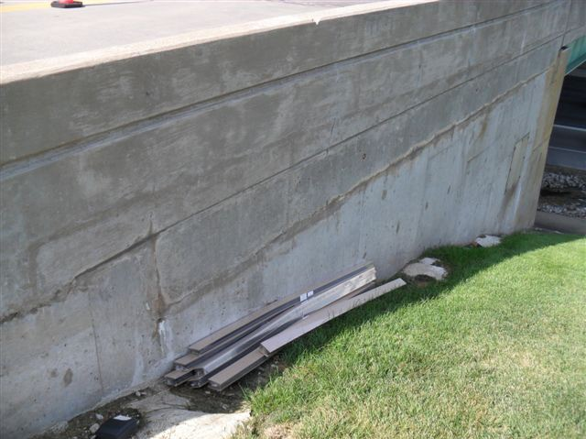8:00am

Joint size and temperature compared to ensure proper sized joint material on site.

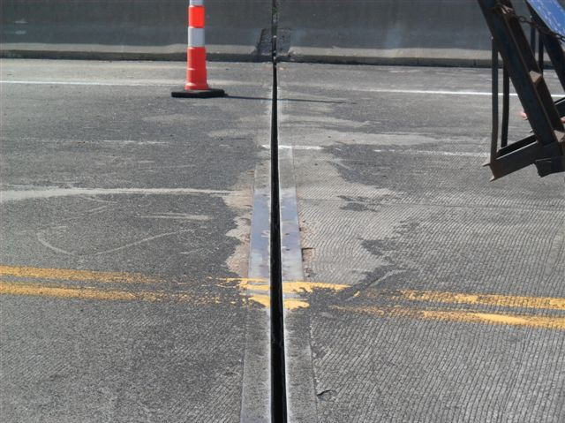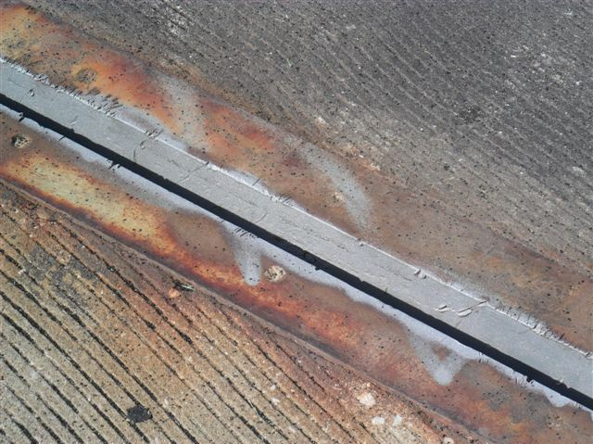BEJS material stored in shade to increase working time on hot day.

Failed rubber seal removed and joint faces sandblasted to white metal.

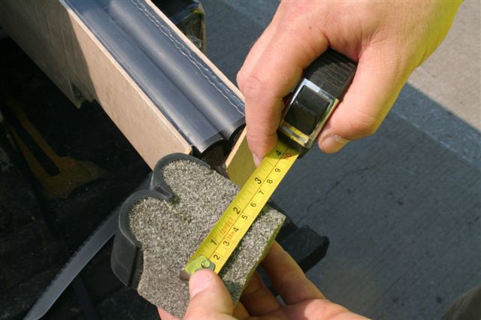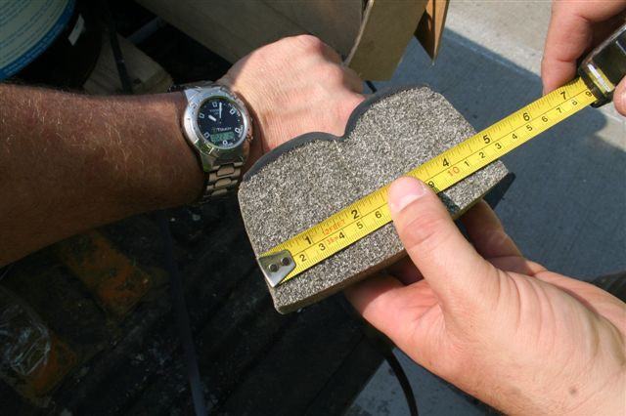10:00am

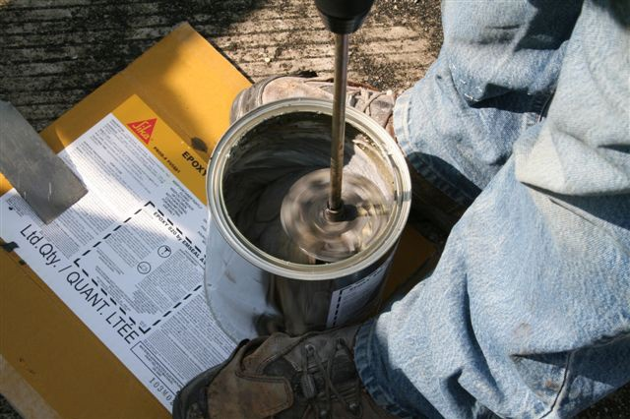Checking the expansion rate of a small piece of BEJS foam to determine working time.

Mixing the BEJS epoxy adhesive.

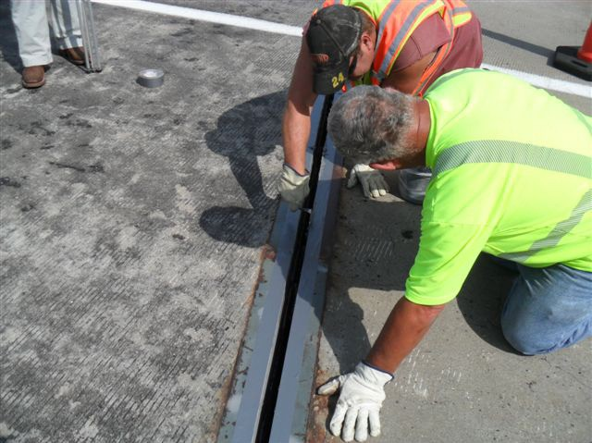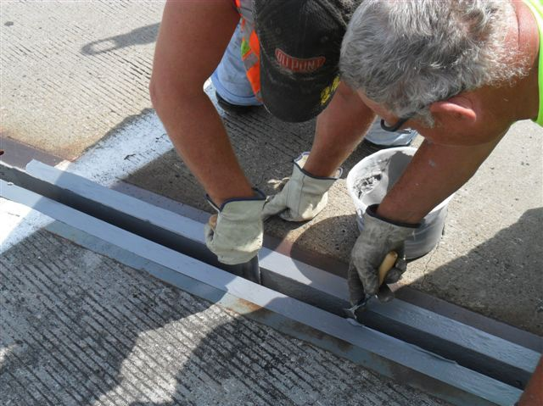10:30am

Unwrapping the BEJS and removing it from its hardboard and shrink-wrap packaging.

Inserting BEJS into wet epoxy on joint faces. Set to 1/2" from top of metal angles.

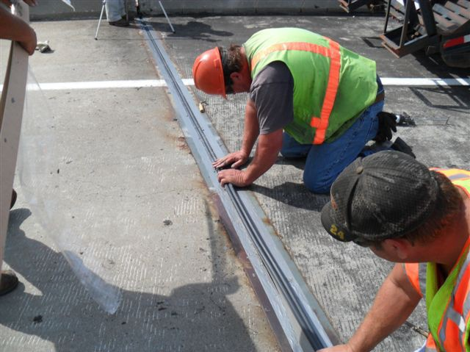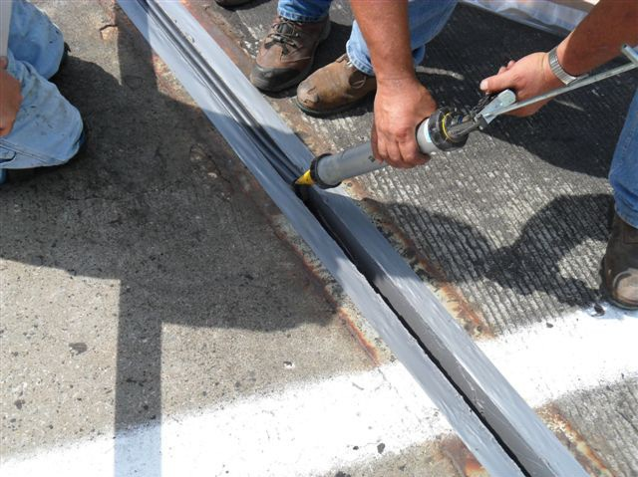Applying the joining silicone to seal the butt joins and inserting remaining sticks of BEJS material.

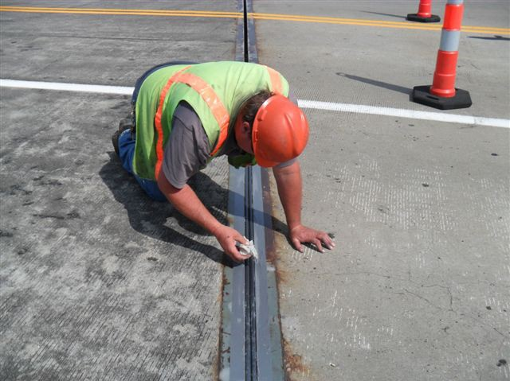10:45am

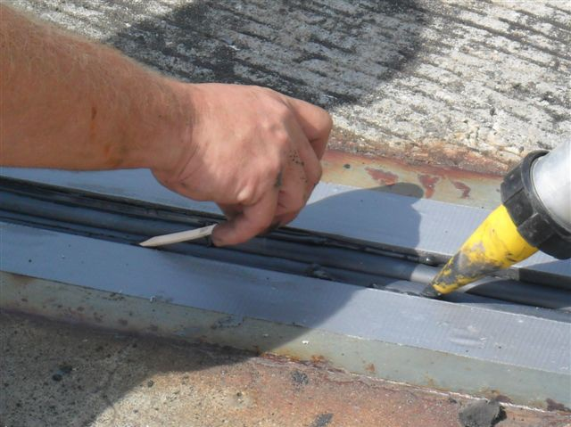Cleaning the silicone top surface with solvent to remove excess epoxy.

Injecting and tooling silicone sealant bands between the bellows and the epoxy-coated joint face.

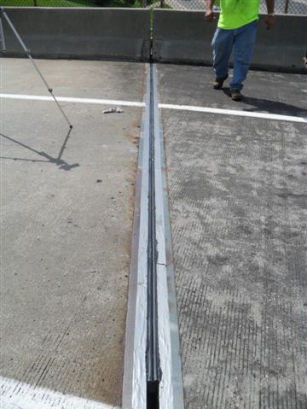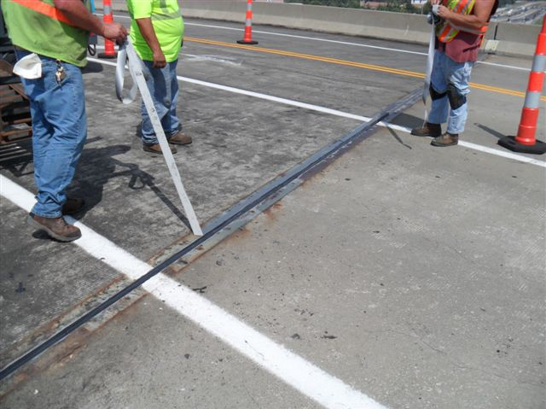Page 3 of 3

11:00am

Removing duct tape from top of metal angles.

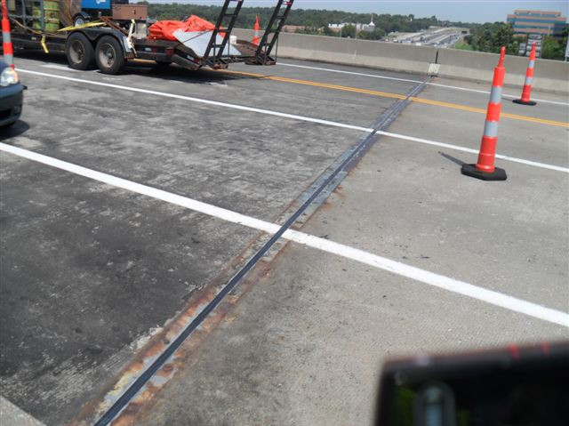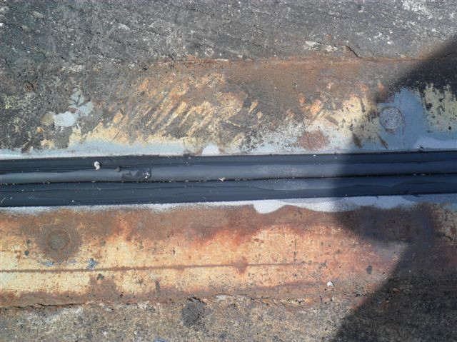Complete BEJS
joint installation.

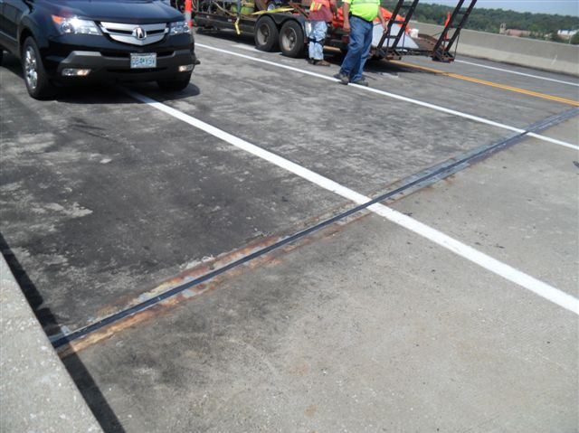11:15am

Taking traffic.

Test Installations and some orders of BEJS with DOT

EMSEAL JOINT SYSTEMS

Agency Contact Email & Phone No. Location Install Date

AK DOT | Rod Blohm | rod.blohm@alaska.gov | Little Willow Creek Bridge, Willow, AK Aug 2012
AL DOT | Eric Christie | 907-338-1481  christiee@dot.state.al.us | Orders pending for Fall 2013  Test selection in progress

AR DOT | Mike Hill | mike.hill@arkansashighways.com  501-569-2113 | Bingham Interchange, Pulaski Cty Nov 2012
CT DOT | Richard Van Allen | Richard.vanallen@ct.gov  David.Hiscox@ct.gov  860-594-2626 | 2 test bridges installed July 2013
FL DOT | Dennis Fernandez | dennis.fernandez@dot.state.fl.us | Test location chosen Winter 2014
 |  | 305-470-5182

GA DOT Clayton Bennett cbennett@dot.ga.gov Test location being chosen Winter 2014
404-635-2889

ID DOT | Dan Gorley | dan.gorley@itd.idaho.gov | I-84, Middletown Road, Nampa | May 2013
 | Barbara Bates | 208-334-8519  Barbara.bates@itd.idaho.gov  208-239-3345 |  | Fall 2013

IL DOT Dave Copenbarger dave.copenbarger@illinois.gov
217-785-2914 Sugar Creek Bridge #054-0073 Lincoln/Hartsburg, IL Oct 2011

Tim Krumm timothy.Krumm@illinois.gov Centralia Illinois 2nd test install Aug 2013
618-346-325

IA DOT Gordon Port Gordon.port@dot.iowa.gov
515-233-7823 S Dakota Ave over US 30, Northbound, Ames Oct 2011
Purchased 2013: 3 bridges 5098.3R065, 3703.2S030,
2525.1S006
Strip Seal Install Highway 28 SB over Raccoon River Oct 2013

IN DOT Drew Storey DStorey@indot.IN.gov I-70 East Bound (RP 126 and 34). New Castle Oct 2012
812-569-4060

KYTC David Steele david.steele@ky.gov
502-564-4556
David Tipton David.Tipton@ky.gov
502-564-9900 X3966

Betsy Layne RR Bridge, Justel April 2011
KY-704 / Harrod’s Fork Creek, Cumberland June 2012

Approved QPL 2012 Contact EMSEAL for additional installations
KS DOT  MA DOT | Calvin Weber  Mohammed Nabulsi | Scheduling test install Spring 2014 (Listed in Provisional Spec – Dec 2013)  mohammed.nabulsi@state.ma.us
Dale Morse  Vona Pellegrino  Dan Crovo |  | 508-929-3849 Mass Turnpike I 90@ Auburn, MA Marsh Ave over I 290, Worcester, MA  dale.morse@state.ma.us Many locations contact Dale  508-721-4010  Pellegrino.vona@state.ma.us Bridge No B-3-52- Beckett, MA - Main St over B.& A.R.R.
Daniel.s.crovo@state.ma.us Accelerated Bridge Program Fairhaven June 2013
508-884-4222

413-637-5764

Provisional Approval
Contact EMSEAL for additional bridge locations

MD DOT Bob Rubinson brubinson@sha.state.md.us 1207500 132 over Amtrak Nov 2014

ME DOT Doug Gayne doug.gayne@maine.gov Topsham, ME Fall 2012
207-624-3268
William Doukas William.doukas@maine.gov RT-95 Kittery, ME June 2013
207-624-3424
MI DOT Jason Deruyver deruyverj@michigan.gov I-196 Ramp to M-21 over CSX RR
517-242-2988

MN DOT | Duane Piepho | duane.Piepho@state.mn.us Owatonna Bridge, Faribault, MN  507-456-5312 | Aug 2013
MO DOT | Scott Stolemeyer Pat Martens Mark Croarkin | scott.stotlemeyer@modot.mo.gov  573-522-8752 Bent 7 (MO 51/IL 150), Chester, MO  pat.martens@modot.mo.gov  573-522-8752 Highway I 55, Fruitlands, MO  mark.croarkin@modot.mo.gov  314-453-1763 | Oct 2011  May 2011

Dave O’Connor 417-818-4169

Bridge A4154 Cole County, Route D over US 50,
West of Jefferson City 2011
J.J. Kelly Memorial Drive Bridge, St Louis, MO Oct 2011
Highway 65 North of Sedalia, MO Dec 2012

Poplar Street Bridge, St Louis, MO Mar 2012
Approach Slab
Popular Street Bridge, Midspan Dec 2011
McDonnell Road over Hwy 70 Aug 2013
Salt River Road over Hwy 79, St Charles Aug 2013
Hwy 109 over Hwy 100, Wildwood Aug 2013
Chester Bridge, Perryville Aug 2013
Lucas and Hunt Road Bridge, Beverly Hills Aug 2013
Route 8 over Highway 70 Aug 2013
Contact EMSEAL for additional bridge locations.

MT DOT | Jeff Olsen | jolsen@mt.gov  406-444-7610 | Yellowstone River Bridge | Nov 2012
NC DOT | Paul Sprouse  Troy Wilson | psprouse@ncdot.gov tswilson@ncdot.gov | Madison 528, Ashville, NC | June 2013

NE DOT Scott Milliken scott.milliken@nebraska.gov
402-479-4801 I 80 over Camp Creek, EB, Waverly, NE Nov 2011
QPL Approved

NJ DOT George Franze George.franz@dot.state.ju.us Route 7 over Conrail, Kearney Sept 2012
973-487-7575

NY DOT Pete Weykamp peter.weykamp@dot.ny.gov (Retired 7/30/2013)
(518) 935-7470

Bridges in NY:

Ausable Chasm Bridge, Peru, NY BIN 1071300
John O’Keefe and Rick Hunkins 518-643-2011 (Region 7)

Forks Road Bridge BIN 3308710 (Madison Cty) Jacob Wall 315-366-2221

Rt 352 over I86 Pier 6, Corning, NY BIN 1012739
John MacDowell 607-3242811 (region 6)

Mid-Hudson Bridge over Gerald Drive BIN 5025530
Bill Moreau 845-691-4077 (NYS Bridge Authority)

Carleton Avenue over NY Route 27, Babylon, NY BIN 1019260
Ron Kudla 631-241-4742 (Region 10)

Rt 3 over S Branch of the Grasse River, Watertown BIN 1000720
Bill Terry 315-782-4473 (Region 7) Due for install Spring 2013
Provisional Approval for all Regions: August 2013 w/new materials lab
Contact EMSEAL for additional bridge locations.

OK DOT Chris Harlin charlin@ODOT.ORG US62 over N. Canadian River, Harrah Nov 2012

OR DOT Michael Philpott mike.L.philpott@odot.state.or.us Eugene, OR Bridge #09600E Oct 2012
541-686-7621 Mission Rd Overpass, I 84, Umatilla May 2013

PennDOT | Chris Ciesa | cciesa@pa.gov | SR 1040 over ST 28 Tarentum, PA | May 2012
 | Gina Russell | girussell@pa.gov | 10 bridges Western PA | Fall 2013
 |  | 412-429-4952
 | Kevin Matthews | kevmatthew@pa.gov | Second test joint installed | June 2013

TN DOT | Brian Egli | brian.egli@tn.gov | TN-15194-KB SR 840 over Tributary to South Harpeth
 |  | 615-532-2309 | Creek Oct 2012
QPL Approved July 2013

WA | Rick Rodda | roddaft@wsdot.wa.gov | WA-15339 Bridge, Bellevue, WANov 2012
 | 425-739-3700
 | Mike London | londonM@wsdot.wa.gov | 8 bridges pending Fall 2013

WV DOT Warren Skaggs warren.m.skaggs@wv.gov Seth, WV July 2013
304-356-3781

Puerto Rico DOT Metropista Bridge 2219 and 2220 Jan 2013

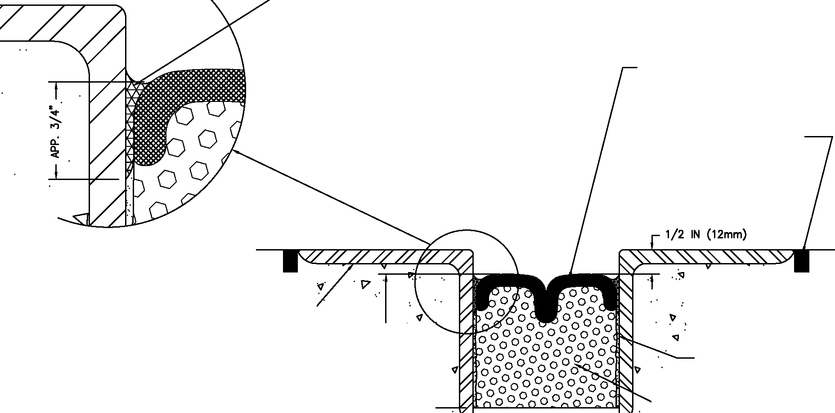FIELD-APPLIED SILICONE CORNER BEADS AND SILICONE BAND FORCED DOWN ALONG SIDE OF BEJS AS SHOWN - BOTH SIDES

FACTORY-APPLIED AND CURED TRAFFIC GRADE
SILICONE FACING. **

ROUT & SEAL BACK EDGES & JOINS BETWEEN UENGTHS OF METAL ANGLES TO PREVENT WATER BYPASSING JOINT SYSTEM BOTH SIDES - BY OTHERS

·t7 ·.. . <;] .
· ...
<;].

STEEL ANGUES-BY OTHERS I>
2 3/4 IN (70mm).

EPOXY ADHESIVE BOTH SIDES

.........__ BEJS IMPREGNATED FOAM

MOVEMENT: ±50%
+ 1 1/2 IN (40mm)
- 1 1/2 IN (40mm)

1-3 IN (75mm) -J

** WIDTHS UNDER 1-INCH (25mm) HAVE A CONVEX SINGLE-BEULOWS SURFACE. WIDTHS FROM 1-INCH (25mm) TO 4-INCHES (100mm) HAVE A DUAL-BELLOWS SURFACE.

EMSEAL BEJS - (BRIDGE EXPANSION JOINT SYSTEM)

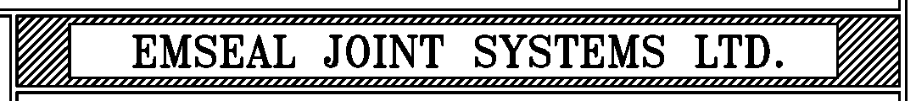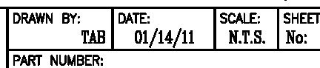THIS DOCUMENT CONTAINS lhfiJAW.liON OF A CONFIDENTW.
UN.WAII.ABI..E TO TilE PUBUC NG IS PRQPRIETARY 10 EMSEAL CORPORATION.
Nff UtwJTHORIZED USE WlL BE PROSECUTED. THIS DIIAWING IS PROTECTEO
BY aJPYRIGHT, TilE RIGHT TO REPRODUCE IN N« FORM BEING TIE EXCLUSM:
RICHT OF EMSFAI. CORPORA1'ION. N/'1 Um REPRODUCTION WHEI'HER
IN 1WO OR THREE DIIENSIONS 'MLL BE PROSEa/IED. BEJS 100-300-DD-003

I Or!

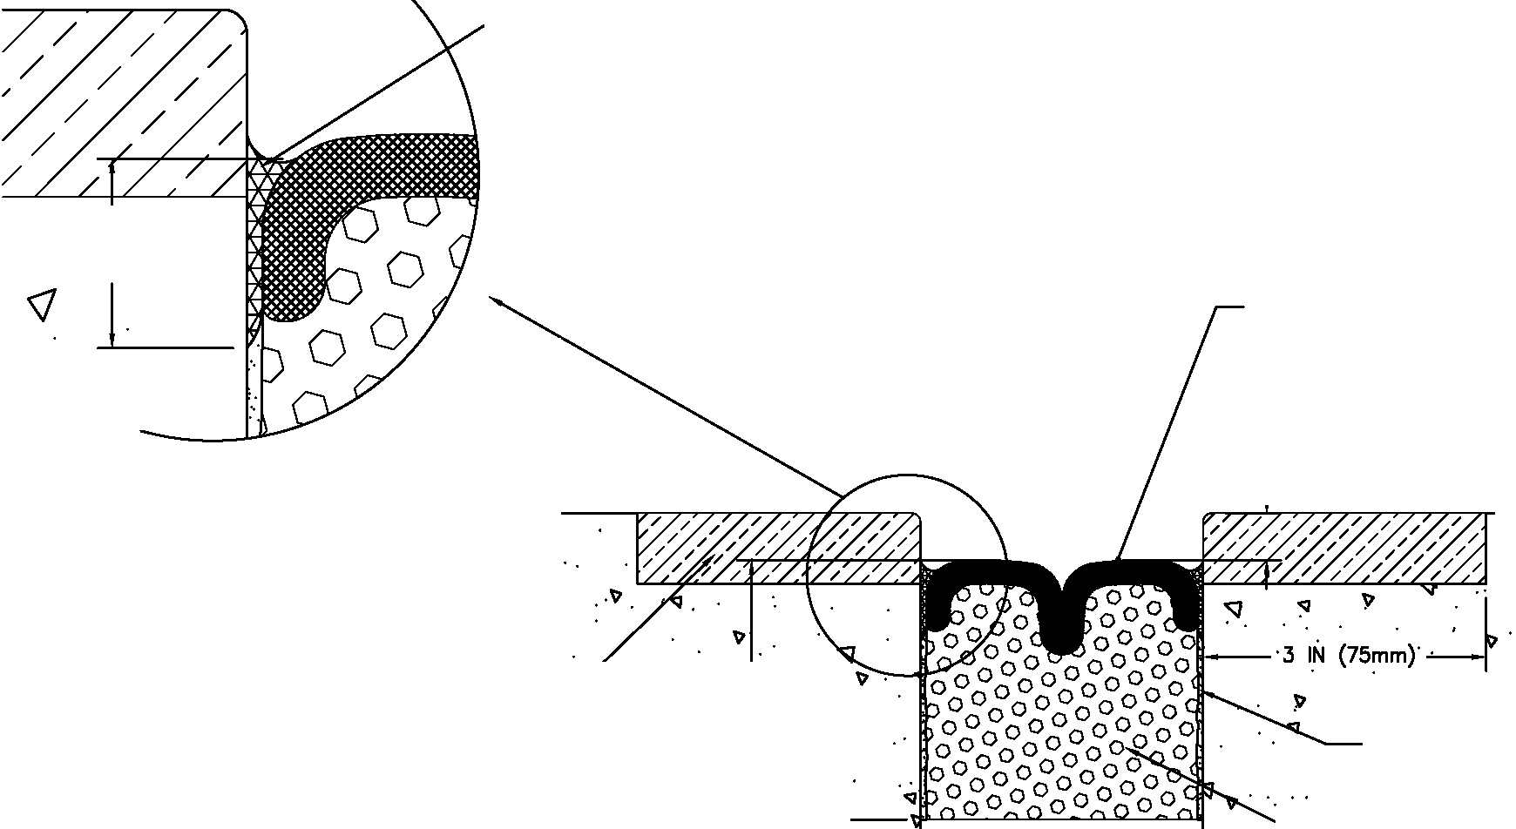FIELD-APPLIED SILICONE CORNER BEADS AND SILICONE BAND FORCED DOWN ALONG SIDE OF BEJS AS SHOWN - BOTH SIDES

APP. 3/4"

FACTORY-APPLIED AND CURED TRAFFIC GRADE
SILICONE FACING. **

1/2 IN (12mm)

. <I
)11
L+ LW &L - <1 -
3/4 IN

MOVEMENT: ±50%
+ 1 1/2 IN (40mm)
- 1 1/2 IN (40mm)
NOSING

. '<I '
2 3/4 IN (70mm)

-:J . .

'<) <I

1-3 IN (75mm) -J

EPOXY ADHESIVE BOTH SIDES

.<I...... BEJS IMPREGNATED FOAM

** WIDTHS UNDER 1-INCH (25mm) HAVE A CONVEX SINGLE-BELLOWS SURFACE. WIDTHS FROM 1-INCH (25mm) TO 4-INCHES (100mm) HAVE A DUAL-BELLOWS SURFACE.

EMSEAL BEJS - (BRIDGE EXPANSION JOINT SYSTEM)

THIS DOCUMENT CONTAINS lhfiJAW.liON OF A CONFIDENTW.
UN.WAII.ABI..E TO TilE PUBUC NG IS PRQPRIETARY 10 EMSEAL CORPORATION.
Nff UtwJTHORIZED USE WlL BE PROSECUTED. THIS DIIAWING IS PROTECTEO
BY aJPYRIGHT, TilE RIGHT TO REPRODUCE IN N« FORM BEING TIE EXCLUSM:
RICHT OF EMSFAI. CORPORA1'ION. N/'1 Um REPRODUCTION WHEI'HER IN 1WO OR THREE DIIENSIONS 'MUL BE PROSEa/IED.

BEJS 100-300-DD-002

I Or!

FIELD-APPLIED SILICONE CORNER BEADS AND SILICONE BAND FORCED DOWN ALONG SIDE OF BEJS AS SHOWN - BOTH SIDES

FACTORY-APPLIED AND CURED TRAFFIC GRADE
SILICONE FACING. **

IMPACT - ABSORBING NOSING MATERIAL

ASPHALT OR CONCRETE WEARING SURFACE
{BY OTHERS)

1/2 IN (12mm)
OPTIMZE REBAR SPACING & CONFIGURATION FOR SUPPORT OF HEADER (BY OTHERS)

.•. . .. '··. . .
• :,; :·
.

.·. . .
.
...

: ..
•• • "!! ."Q.
. . . . . . . "'
. : ... ..
•. . .... .
. ...

.-. • : "Q
. . . " ' . :

:. ... ··. . . ..
I I
3 IN {75mm)
•·"" . .
"" .

MOVEMENT: ±50%
+ 1 1/2 IN {40mm)
- 1 1/2 IN {40mm)
BEJS IMPREGNATED FOAM

CONCRETE
STRUCTURAL SLAB (BY OTHERS)
EPOXY ADHESIVE
BOTH SIDES DEPTH OF REBAR TO SUIT
(BY OTHERS)

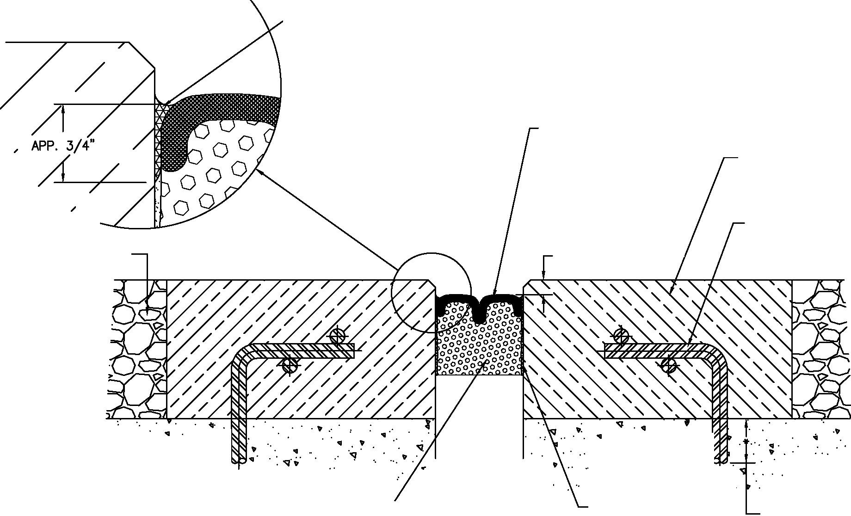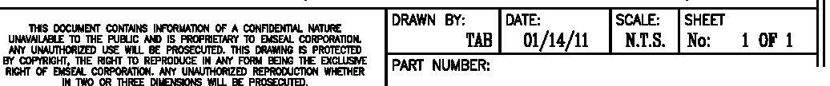•• WIDTHS UNDER 1-INCH {25mm) HAVE A CONVEX SINGLE-BELLOWS SURFACE. WIDTHS FROM 1-INCH {25mm) TO 4-INCHES {100mm) HAVE A DUAL-BELLOWS SURFACE.

EMSEAL BEJS - (BRIDGE EXPANSION JOINT SYSTEM)

BEJS 100-300-DD-004

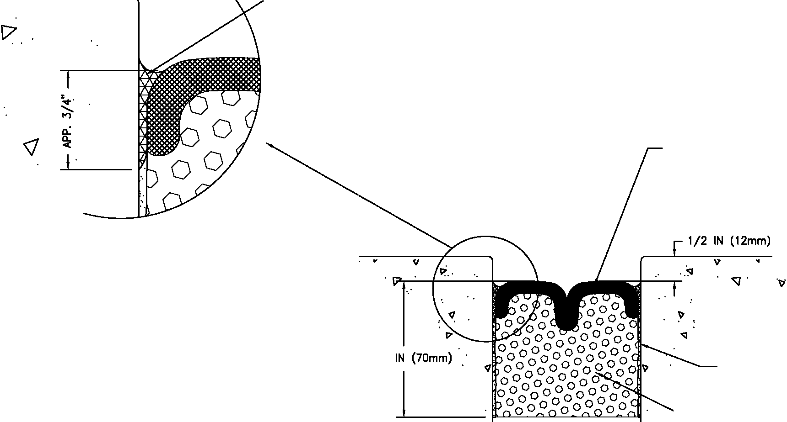FIELD-APPLIED SILICONE CORNER BEADS AND SILICONE BAND FORCED DOWN ALONG SIDE OF BEJS AS SHOWN - BOTH SIDES

FACTORY-APPLIED AND CURED TRAFFIC GRADE
SILICONE FACING. **

·I?' "' ·
-q'

2 J/4 IN (70mm) .·

EPOXY ADHESIVE BOTH SIDES

""--- BEJS IMPREGNATED FOAM

MOVEMENT: ±50%
+ 1 1/2 IN (40mm)
- 1 1/2 IN (40mm)

J- J IN (75mm) -J

** WIDTHS UNDER 1-INCH (25mm) HAVE A CONVEX SINGLE-BELLOWS SURFACE. WIDTHS FROM 1-INCH (25mm) TO 4-INCHES (100mm) HAVE A DUAL-BELLOWS SURFACE.

EMSEAL BEJS - (BRIDGE EXPANSION JOINT SYSTEM)

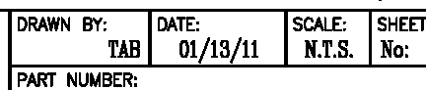THIS DOCUMENT CONTAINS lhfiJAW.liON OF A CONFIDENTW.
UN.WAII.ABI..E TO TilE PUBUC NG IS PRQPRIETARY 10 EMSEAL CORPORATION.
Nff UtwJTHORIZED USE WlL BE PROSECUTED. THIS DIIAWING IS PROTECTEO
BY aJPYRIGHT, TilE RIGHT TO REPRODUCE IN N« FORM BEING TIE EXCLUSM:
RICHT OF EMSFAI. CORPORA1'ION. N/'1 Um REPRODUCTION WHEI'HER
IN 1WO OR THREE DIIENSIONS 'MLL BE PROSEa/IED. BEJS 100-300-DD-001

I Or!

SPECIFICATION Sections 07 90 00 / 07 95 00

BEJS by EMSEAL

Preformed, Pre-Compressed, Self-Expanding, Sealant System with Silicone Pre-Coated Surface
Watertight, Traffic Durable, Primary Seal for Horizontal Joints in Bridges and Decks

PART 1 – GENERAL

1.01 Work Included

A. The work shall consist of furnishing and installing waterproof expansion joints in accordance with the details shown on the plans and the requirements of the specifications. Preformed sealant shall be silicone pre-coated, preformed, pre- compressed, self-expanding, sealant system.

B. Related Work
• Division 3 - Cast-in-Place Concrete
• Division 7 - Thermal & Moisture Protection
• Division 7 - Sealants, Caulking and Waterproofing

1.02 Submittals

A. General – Submit the following according to Division 1 Specification Section.

B. Standard Submittal Package – Submit typical expansion joint drawing(s) indicating pertinent dimensions, general construction, expansion joint opening dimensions and product information.

C. Sample of material is required at time of submittal.

D. All products must be certified by independent laboratory test report to be free in composition of any waxes or wax compounds using FTIR and DSC testing.

E. All products shall be certified in writing to be: a) capable of withstanding 150°F (65°C) for 3 hours while compressed down to the minimum of movement capability dimension of the basis of design product (-50% of nominal material size) without evidence of any bleeding of impregnation medium from the material; and b) that the same material after the heat stability test and after first being cooled to room temperature will subsequently self-expand to the maximum of movement capability dimension of the basis-of-design product (+50% of nominal material size) within 24 hours at room temperature 68°F (20°C).

1.03 Product Delivery, Storage and Handling

A. Deliver products to site in Manufacturer’s original, intact, labeled containers. Handle and protect as necessary to prevent damage or deterioration during shipment, handling and storage. Store in accordance with manufacturer’s installation instructions.

1.04 Basis of Design

A. All joints shall be designed to meet the specified performance criteria of the project as manufactured by: (USA & International) EMSEAL JOINT SYSTEMS, LTD 25 Bridle Lane,

1

Westborough, MA 01581-2603, Toll Free: 800-526-8365. (Canada) EMSEAL, LLC 120
Carrier Drive, Toronto, Ontario, Canada M9W 5R1 Toll Free: 800-526-8365. www.emseal.com

B. Alternate manufacturers must demonstrate that their products meet or exceed the design criteria and must submit certified performance test reports performed by nationally recognized independent laboratories as called for in section 1.02 Submittals. Submittal of alternates must be made three weeks prior to bid opening to allow proper evaluation time.

1.05 Quality Assurance

A. The General Contractor will conduct a pre-construction meeting with all parties and trades involved in the treatment of work at and around expansion joints including, but not limited to, concrete, mechanical, electrical, HVAC, landscaping, masonry, curtain wall, waterproofing, fire-stopping, caulking, flooring and other finish trade subcontractors as applicable. All superintendents and foremen with responsibility for oversight and setting of the joint gap must attend this meeting. The General Contractor is responsible to coordinate and schedule all trades and ensure that all subcontractors understand their responsibilities in relation to expansion joints and that their work cannot impede anticipated structural movement at the expansion joints, or compromise the achievement of watertightness and/or life safety at expansion joints in any way.

B. Warranty – Manufacturer’s standard warranty shall apply.

C. LEED Building Performance Requirements: The VOC of the silicone must not exceed 50 grams/liter.

PART 2 – PRODUCT

2.01 General

A. Provide traffic durable, watertight, expansion joint by EMSEAL Joint Systems for expansion joints and isolation joints in decks and bridges. Typical locations include, but are not limited to the following: bridge joints, bridge approach joints, applications for joints over occupied space, and structural expansion joints. System shall perform waterproofing, vehicular traffic bearing and movement-accommodation functions as the result of a single installation and without the addition of gutters, vapor barriers, bladders, or other devices suspended beneath or within the system in any way.

B. Provide BEJS as manufactured by EMSEAL JOINT SYSTEMS LTD and as indicated on drawings for horizontal-plane expansion joint locations.

C. Sealant system shall be comprised of three components: 1) cellular polyurethane foam impregnated with hydrophobic 100% acrylic, water-based emulsion, factory coated with highway-grade, fuel resistant silicone; 2) field-applied epoxy adhesive primer, 3) field-injected silicone sealant bands.

D. Material shall be capable as of movements of +50%, -50% (100% total) of nominal material size. Standard sizes from 1/2” (12mm) to 4” (150mm). Depth of seal as recommended by manufacturer.

E. Silicone coating to be highway-grade, low-modulus, jet-fuel resistant silicone applied to the impregnated foam sealant at a width greater than maximum allowable joint extension and which when cured and compressed will form a bellows.

2

F. BEJS to be installed into manufacturer’s standard field-applied epoxy adhesive.

G. BEJS is to be installed ½” recessed from the surface such that when the field-applied injection band of silicone is installed between the substrates and the foam-and- silicone-bellows.

H. Select the sealant system model appropriate to the movement and design requirements at each joint location that meet the project specification or as defined by the structural engineer of record.

I. Manufacturer’s Checklist must be completed and returned to manufacturer at time of ordering material.

2.02 Fabrication

A. BEJS by EMSEAL must be supplied precompressed to less than the joint size, packaged in shrink-wrapped lengths (sticks).

B. Directional changes and terminations into horizontal plane surfaces to be provided by factory-manufactured universal-90-degree single units containing minimum 12-inch long leg and 6-inch long leg or custom leg on each side of the direction change or through field fabrication in strict accordance with installation instructions.

PART 3 – EXECUTION

3.01 Installation

A. Preparation of the Work Area

1. The contractor shall provide properly formed and prepared expansion joint openings constructed to the exact dimensions and elevations shown on manufacturer’s standard system drawings or as shown on the contract drawings. Deviations from these dimensions will not be allowed without the written consent of the engineer of record.

2. The contractor shall clean the joint opening of all contaminants immediately prior to installation of expansion joint system. Repair spalled, irregular or unsound joint surfaces using accepted industry practices for repair of the substrates in question. Remove protruding roughness to ensure joint sides are smooth. Ensure that there is sufficient depth to receive the full depth of the size of the BEJS being installed. Refer to Manufacturers Installation Guide for detailed step-by-step instructions.

3. No drilling, or screwing, or fasteners of any type are permitted to anchor the sealant system into the substrate.

4. System to be installed by qualified sub-contractors only according to detailed published installation procedures and/or in accordance with job-specific installation instructions of manufacturer’s field technician.

3.02 Clean and Protect

A. Protect the system and its components during construction. Subsequent damage to the expansion joint system will be repaired at the general contractor’s expense. After work is complete, clean exposed surfaces with a suitable cleaner that will not harm or attack the finish.

END OF SECTION

3

www.emseal.com

BEJS SYSTEM
INSTALL DATA - BEJS SYSTEM APRIL 2012, PAGE 1 OF 6
INSTALL D
A

DO NOT OPEN ANY PACKAGES or install this material until all members of your crew have read and understand these instructions as well as all relevant MSDS sheets. If you do not understand any part of these instructions CALL EMSEAL : 800-526-8365 or 508-836-0280
T
This document does not purport to address all of the safety concerns, if any, associated with this product’s use. It is the responsibility of the user of this document to establish appropriate safety and health practices and to determine the applicability of regulatory limitations prior to use. The use of a dust mask, safety goggles and gloves is recommended. Keep out of reach of children.
A

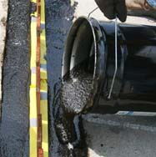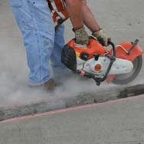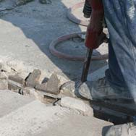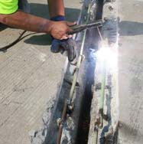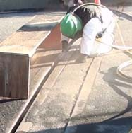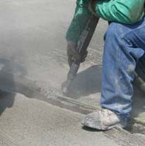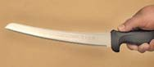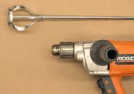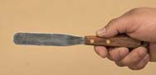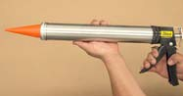IMPORTANT: This product cannot perform its intended function if not properly installed.

1 Equipment & Material Storage
In addition to safety equipment required to comply with applicable federal, state and local safety regulations, equipment to prepare and repair the joint-faces, as well as normal tools of the trade, the following are required:
Equipment Checklist:

 Duct Tape (2 ½ times the length of joint)--optional--if you care about masking the joint for drips.

 Tape measure

 Heavy duty electric, plug-in, low speed - high torque drill for mixing thick epoxy

 1 ½” diameter, paddle-type, epoxy
“jiffy mixers”
2 Repair Spalled Joint Faces/Refill Old Blockouts BEJS is only as good as the surrounding substrates. If the joint edges are badly spalled or cracked you’ve got to repair them.

Concrete:
• Remove loose particles and weak concrete to ensure sound concrete substrate.

Sawcut

• Spalls, chipped edges and uneven surfaces must be repaired using suitable patching material and proper patching geometry and techniques. Joint faces must be parallel.

 Sausage caulk guns to hold
20-oz silicone sausages

 Sausage-gun nozzles (cones)

 Long-bladed, serrated bread knife

 Spray bottle with water

• Reinforce as required per your Department’s normal practice or Engineer’s recommendations.

Chip

 Hacksaw

 Spatula to scrape epoxy from can

 Chemical-resistant gloves

 2-inch wide (50mm) margin trowels for applying epoxy adhesive on joint faces

 Caulk knives for tooling sealant bands

 Acetone* or effective alternative solvent for cleaning joint-faces, trowels and mixer tools

 Clean lint-free, 100% cotton rags
MATERIAL STORAGE:
Cold Days: Store material, off the floor, inside at above 68°F (20°C). It will recover slower when cold and faster when warm.

Very Hot Days: Keep material out of direct sun when the temperature is greater than 80°F (27°C) until immediately prior to installation.

• Clean Up: Remove epoxy and silicone sealant from equipment before it cures using acetone* or alternative solvent. Solvents are not effective after the epoxy or silicone has cured. Cured material may be removed by cutting it away with sharp tools or grinding.

(*Solvents are toxic and flammable. Observe solvent manufacturer’s precautions and refer to Material Safety Data Sheets as well as local and federal requirements for safe handling and use.)

Reinforce

• Remove all contaminants by sandblasting or grinding to ensure a thoroughly clean and sound substrate for the full sealant depth.

NOTE: DO NOT use a wire wheel--this will polish the substrate and cause bond-failure.

Blast

• Use a suitable patching material (EMSEAL’s EMCRETE works great), and proper patching geometry and techniques. Joint faces must be parallel.

Form and Pour
Metal:
• Sandblast or grind to rough, white metal and solvent-wipe immediately prior to applying BEJS epoxy.
IMPORTANT: Ensure that no oxidation (rusting) occurs before the epoxy is applied.
Other Substrates: Contact EMSEAL.

EMSEAL JOINT SYSTEMS LTD, 25 Bridle Lane, Westborough, MA 01581

Toll Free: 800.526.8365
PH: 508.836.0280 FX: 508.836.0281

EMSEAL LLC, 120 Carrier Drive, Toronto, ON, Canada M9W 5R1 PH: 416.740.2090 FX: 416.740.0233
Copyright © 2012, by EMSEAL Joint Systems Ltd, All Rights Reserved

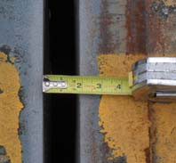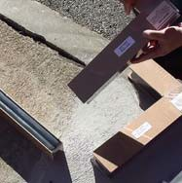INSTALL DATA - BEJS SYSTEM APRIL 2012, PAGE 2 OF 6
3 Size Matters!  • Make sure you have the right size material for the joint. If you don’t, it won’t work.  • Measure joint width at deck surface and below to ensure joint faces are parallel.  • Material has been supplied to suit your joint widths at mean temperature based on field-measured information you provided.  • Widths of material supplied are marked on each stick of material.  • Compare width of material supplied as marked on each stick against mean joint width.  • Actual width of material measured between the hardboard packag-  ing will be less than marked size because material is over-com- pressed to fit in the joint.  NOTE: If unsure of correct material selection, consult EMSEAL.  IMPORTANT: Do not remove outer plastic packaging until you have read and understand the rest of these instructions as material may expand prematurely. | 6 Start with Universal-90  Changes in plane, either up or down, are easily done with the use of factory- fabricated Universal-90’s from EMSEAL.  If you ordered factory-fabricated transitions start with these and then move on to connecting the straight lengths. (See Pages  5 and 6 for detailed instructions).  If you are just installing straight lengths, go to Step 7).
7 Mask Deck (Optional)

•OPTIONAL: IF you want it to look pretty, use duct tape to mask off the deck on both sides of the joint.
4 Temperature Matters! This step helps you plan your installation.  Temperature affects how fast or slow your BEJS foam expands.  This is not that lightweight, closed-cell, EVA foam--you don’t have to squeeze  it to get it in the joint.  BEJS is precompressed. When you take off the packaging, it will self expand.  To figure out how fast, cut a small piece off the end of one of your sticks and take off the hardboard and plastic packaging.  Measure it. Time how fast it grows to the width of the joint you just measured in Step 3.  You want the material to be as big or just slightly bigger than the  joint gap width when you put it in. This way it will sit snug at the right level and hold its own weight.  When it’s HOT (above 80oF, 27oC) it moves fast. You want to store it in the shade or in an air conditioned van or cab.  When it’s COLD (below 60oF, 15oC) you have time. Sometimes a lot of time. You want to store it in the sun or in a heated van or cab, AND you may want to open a few sticks ahead of installing the epoxy to get them moving. | 8 Mix Epoxy Adhesive  Mix Epoxy  • EMSEAL epoxy adhesive may be used in the 40°F (5°C) to 95°F (35°C) temperature range.  • Using a trowel, transfer the entire contents of Part B (hardener) into the contents of Part A (base) .  • Mix the material thoroughly (3 minutes) with a drill and mixing paddle. Scrape the walls and bottom of the container to ensure uniform and complete mixing.  • Ensure that a uniform gray color with no black or white streaks is obtained.  IMPORTANT: DO NOT thin the epoxy.  • BE SAFE! Wear chemical-resistant gloves and/or barrier hand cream when handling liquid sealant or epoxy. Remove promptly from skin with a commercial hand cleaner before eating or smoking. Avoid inhaling vapors.
9 Apply Epoxy to Substrate, and...

Ensure that the mixed epoxy adhesive is applied to the substrate before the pot life has expired (10 - 30 minutes depending
on the ambient temperature).
WARNING: Epoxy will harden more quickly when left in the pot. Apply it onto the joint face as soon as possible.

IMPORTANT: The epoxy must still be uncured when installing BEJS foam into the joint-gap.

If the epoxy cures before installing the BEJS foam then reapply new epoxy. If work is interrupted for more than 2 hours after initial cure then grind the old epoxy and apply new wet epoxy.

IMPORTANT: While one or more workers are applying epoxy to the joint faces, others must prepare the BEJS foam (see Step 10)
5 Solvent-Wipe Joint Faces

• Wipe joint faces with solvent-dampened, lint-free rags to remove all concrete dust and contaminants.

• Dry all wet surfaces. DO NOT use flame to dry substrate--this will leave carbon on the substrate and cause bond-failure.

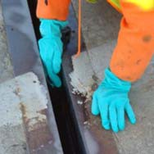EMSEAL JOINT SYSTEMS LTD, 25 Bridle Lane, Westborough, MA 01581

Toll Free: 800.526.8365

PH: 508.836.0280 FX: 508.836.0281

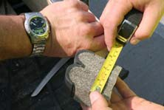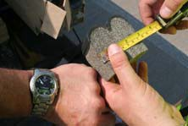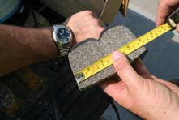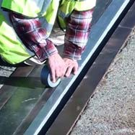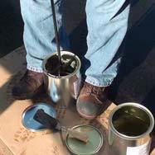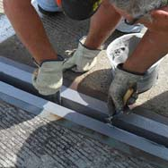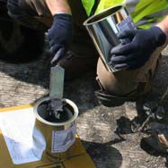EMSEAL LLC, 120 Carrier Drive, Toronto, ON, Canada M9W 5R1 PH: 416.740.2090 FX: 416.740.0233
Copyright © 2012, by EMSEAL Joint Systems Ltd, All Rights Reserved

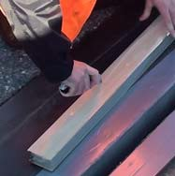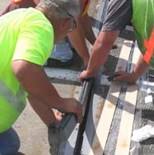INSTALL DATA - BEJS SYSTEM APRIL 2012, PAGE 3 OF 6
10 ... Unwrap BEJS  NOTE: Remember STEP 4? The BEJS is held in compression by shrinkwrap and hardboard. Based on what you learned in Step 4, you will either have decided to open several sticks to let them grow in cool weather, OR you will open them  immediately before you need them and work quickly in hot weather.  • Slit the plastic packing by cutting on the hardboard  DO NOT cut along the silicone bellows face! If you do you will destroy the seal.  • Remove the shrinkwrap, hardboard, and inner release liner. | 13 Install Next Length  • Work in one direction towards the previously installed length or end of joint. Do not stretch the material.  • Leave the end to be joined to the  previous length sticking proud of the joint-  -push the joining faces together.  Push, Don’t Pull  • Push Hard on the stick to compress  joins firmly together. Ensure there are no voids at joins.  • Once the full length is installed, push the protruding join into the joint and tool off the excess silicone.  Make the Join  Push the Join in Last 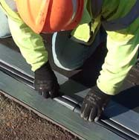  • Repeat this step for each new stick.
11 Install First BEJS Foam Length into Joint

• When installing the foam into the joint, ensure that the epoxy on the joint face has not cured.

• When installed, the BEJS must be recessed so that the top of the bellows is
1/2-inch (12mm) below the deck surface.

• Note: When material is correctly expanded for a snug fit it will support its own weight in the joint.

• Feed material into joint, starting from one end. The material should fit snugly and must be eased into the joint with steady, firm pressure.

• Leave the end to be joined to the next length sticking slightly proud of the joint.
14 Measure, Cut and Install “Closing” Piece

• The final piece needed is your “closing” piece. It may be needed between the last full length and the end of the bridge deck, OR, it may be needed to close the gap between the last full length and a factory transition installed earlier.

NOTE: Unused BEJS can be stored for later use by keeping it compressed between
the hardboard packaging using duct tape.

• Measure the length needed and
add an extra 3/8-inch
(10mm).
Measure

• Cut the length needed using your bread knife.

TIP: if knife is sticking, spray the blade with water from the spray bottle.
Cut

• Make sure you put your joining silicone on both joins (see Step 12).

• Install both ends first and push down working towards the middle. This will push the material outward making tight joins at each end.

Install Ends, Then Middle
12 Apply Joining Silicone to Bellows Face

• On the end of the next stick, using a sausage-gun and the sausages of silicone provided, apply the
liquid silicone to the exposed face of the silicone bellows.

NOTE: Avoid spreading silicone sealant on the foam face.

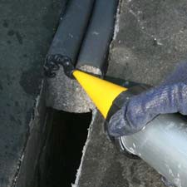EMSEAL JOINT SYSTEMS LTD, 25 Bridle Lane, Westborough, MA 01581

Toll Free: 800.526.8365

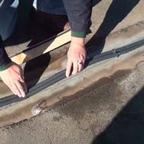PH: 508.836.0280 FX: 508.836.0281

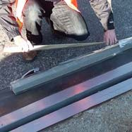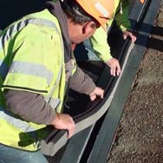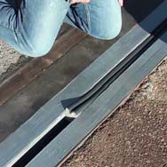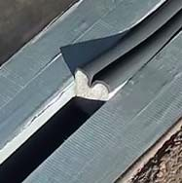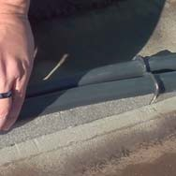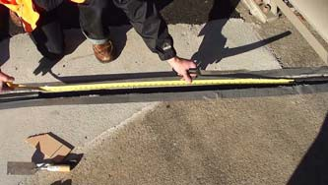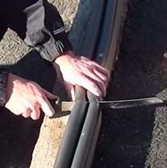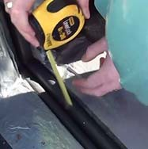EMSEAL LLC, 120 Carrier Drive, Toronto, ON, Canada M9W 5R1 PH: 416.740.2090 FX: 416.740.0233
Copyright © 2012, by EMSEAL Joint Systems Ltd, All Rights Reserved

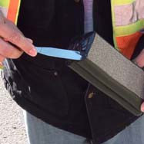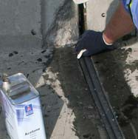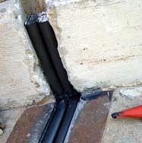INSTALL DATA - BEJS SYSTEM APRIL 2012, PAGE 4 OF 6
15 Wipe Silicone Facing at Joint Edge  • Using, clean, lint-free, cotton rags and solvent, thoroughly wipe the cured silicone facing and joint edge to remove excess epoxy and manufacturing release agent on silicone. | 19 Coat Any Exposed Foam Ends  • IMPORTANT: Any foam ends that will be exposed must be sealed with a light coating of silicone.  • You can do this before installing the piece that will be exposed or  after.
16 Inject Silicone Sealant Bands at Substrates
& Tool Excess Silicone

• Before the epoxy cures, force the tip of the silicone-gun cone between the substrate and the BEJS foam. Inject a 3/4-inch (20mm) deep silicone sealant band between the foam, cured silicone facing and the joint-face.
20 Remove Duct Tape

• IF, in Step 7, you chose to mask your joint edges with Duct Tape, remove the tape now.
-- INSTALLATION IS NOW COMPLETE --
Traffic can be allowed over the joints after normal cleanup of the jobsite is completed and traffic diversion equipment is removed -- usually within one hour of completing the installation.
17 Tool Excess Silicone into Cove-Bead  • Using a caulk knife, tool the freshly applied silicone firmly to blend with the substrates and cured bellows facing, and to ensure a proper bond and seamless appearance. | Addendum 1:  Transitions, Ends, and Special Conditions  Sequencing: Install factory-fabricated transition and/or termination pieces  first. Connect straight run material to U-90  in-place terminations and  transitions.  Note: If Cut closing piece 3/8"  installing very long and “arch” into joint.  long runs of material, to avoid having to  work at distant Then press down closing  ends of a joint piece flush to deck.  run and in order to prevent epoxy from fully  curing, the final  factory-fabricated Universal-90 termination can be installed as the second-to-last piece.  Cut closing pieces 3/8-inch (10mm) longer than the opening to be joined. Compress material longitudinally to fit.  UNIVERSAL-90 TRANSITIONS  Universal-90’s are factory-made transitions that make going up and down curbs, parapets and sidewalks easy.  Unlike straight-run lengths, BOTH sides of Universal-90’s are silicone coated with bellows so there is no top or bottom. They can be turned over to be used either as an upturn or a downturn.
18 Remove Excess Silicone from Bellows at
Joins

• Where BEJS foam meets at butt joins, use a caulk knife to remove excess sealant from between the bellows.

• Also tool excess silicone that squeezes out from the top of the join. Blend the sealant into the precured silicone bellows for a professional finish.

IMPORTANT: Silicone left between the wrinkles of the bellows could constrain movement -- using a caulk knife, remove excess sealant and blend what remains into the bellows.

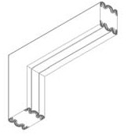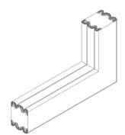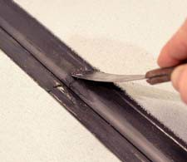EMSEAL JOINT SYSTEMS LTD, 25 Bridle Lane, Westborough, MA 01581

Toll Free: 800.526.8365
PH: 508.836.0280 FX: 508.836.0281

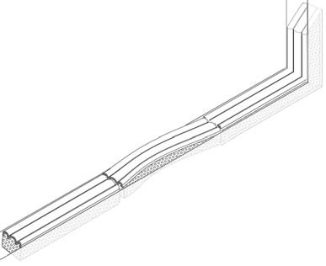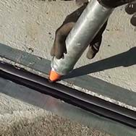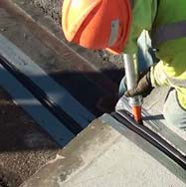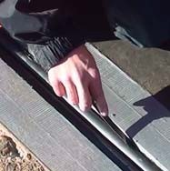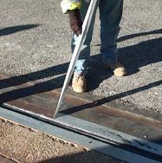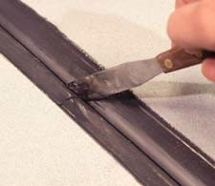E0M6-0S7-E20A11L 1L.0LC, 120 Carrier Drive, Toronto, ON, Canada M9W 5R1 PH: 416.740.2090 FX: 416.740.0233
Copyright © 2012, by EMSEAL Joint Systems Ltd, All Rights Reserved
10-24-2011 3.0

UNIVERSAL-90 Installation Sequence

UNIVERSAL-90 TERMINATIONS
INSTALL DATA - BEJS SYSTEM APRIL 2012, PAGE 5 OF 6

Arrange your U-90’s at the areas that need
them.

Measure the height of the curb and plan to join the lower and upper U-90 in the middle of the height of the curb.

Open and cut the vertical leg of the U-90 to
a length that will bring it to the middle of the height of the curb.

REMEMBER, the top of the BEJS will be recessed 1/2” (12mm) from the deck and sidewalk surface. Plan for this in your measurements.

Install the lower U-90 in accordance with the installation procedures in the rest of this instruction sheet.

Measure to make sure the top of the BEJS is recessed 1/2-inch (12mm) from the deck surface.

Measure the distance from the top of the upturn of the installed U-90.

Cut the next U-90 so that it will mate firmly with the already installed U-90. Remember to allow for the 1/2” (12mm) recess.
If you have decided to run the expansion joint material off the end of the deck instead of sealing vertically into or over a parapet, you should terminate the installation with a downturn termination.

If you decide to turn the joint up into a parapet without going over the top and down the parapet, you should terminate in the face of the parapet with an upturn termination.

As with Universal-90 transitions, install factory- fabricated upturn or downturn termination pieces first.
Connect straight run material to in-place terminations and transitions
(see Step 12).

KICK-OUT TERMINATION
EMSEAL’s BEJS “Kick-Out Termination” is an
alternative to the Universal-90 Terminations above.

The Kick-Out Termination is a factory fabricated termination piece with a built in
drip-edge that directs water runoff away from the bridge structure.

The Kick-Out Termination is installed at the edge of the deck with its downturn over the side of the bridge and the drip edge sticking out beyond the face of the slab.

Water that runs off the joint is directed away from the bridge and its bearing pads, columns etc. by the silicone-coated flared end of the kick-out.

Install the Kick-Out Termination first and connect the straight lengths to it starting with Step 12.

FIELD-CUT CORNERS
When NOT using U-90’s it is possible to make corners in the field.

Apply joining silicone along the edge of the silicone bellows.

Lower the upper U-90 into the wet epoxy on the joint faces.

Push the upper U-90 down to join firmly with the already installed U-90 upturn below.
Outside Corners -- “Notch and Bend”
• Notch the back of the foam only about 2/3 of the way through at a 40-degree angle.
• Bend the foam over keeping the silicone face intact.
Inside Corners -- “Notch and Miter”
• Cut the material for the horizontal joint longer than needed by an amount equal
to the depth of the material being installed.
• The inside corner must be joined by
cutting a keyway in the horizontal material with a matching miter in the vertical material.
• To cut the keyway, first make a template using a piece of the hardboard packaging and a hacksaw.

KEYWAY DIMENSIONS
Nominal Material Size Dim. “A”
Up to 3/4-in (20mm) 1/2-in (12mm) Over 1-in (25mm) 1-in (25mm)

Silicone Facing
Silicone Facing

Outside Corner
(Section)

Silicone Facing
A

Inside Corner
(Section)

Tool the silicone that squeezes out of the
join to make sure that there is no silicone in the groove in the middle. Blend the extra silicone into the bellows.

Continue installation of straight lengths starting with Step 12.

• Using the template and a water-sprayed bread knife, cut each piece of foam as shown.
• Install the horizontal section ensuring that the keyway is inserted
past the vertical face of the joint.
• Inject a bead of joining silicone into the face of the keyway and install the vertical miter into the wet silicone. Be sure of a tight fit with no voids. Tool excess silicone to allow bellows to move.

EMSEAL JOINT SYSTEMS LTD, 25 Bridle Lane, Westborough, MA 01581

Toll Free: 800.526.8365
PH: 508.836.0280 FX: 508.836.0281

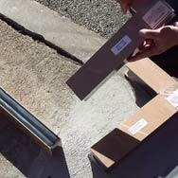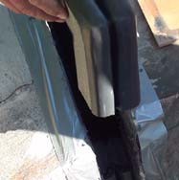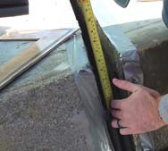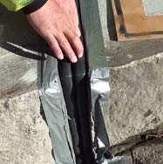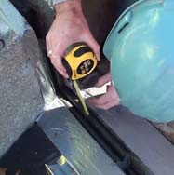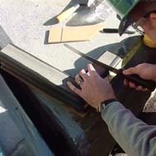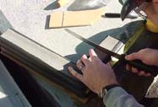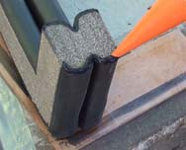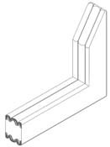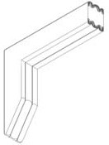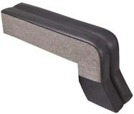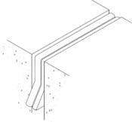EMSEAL LLC, 120 Carrier Drive, Toronto, ON, Canada M9W 5R1 PH: 416.740.2090 FX: 416.740.0233
Copyright © 2012, by EMSEAL Joint Systems Ltd, All Rights Reserved

INSTALL DATA - BEJS SYSTEM APRIL 2012, PAGE 6 OF 6

FLAT CORNERS:
• Work towards the corner so that the last two
Silicone Facing
pieces to install will join at the corner.
• Cut each piece to be joined 3/8-inch (10 mm) longer than needed.
• Install one piece so that it runs through the intersecting joint-gap. Firmly push and compress the extra length so that a tight fit
in the corner is achieved.
• Firmly butt intersecting piece(s) into side(s)
of placed material.
Silicone Facing

Do not epoxy at butt join**

Flat Corner Transition
(Plan View)

**IMPORTANT: Be sure that there is no epoxy on the sides or faces of the foam at a butt join.

• Using a caulk knife, remove any excess sealant and blend the liquid silicone into the bellows to preserve the bellow shape. NOTE: The extra length will make it a tight fit—this results in a compression fit.
• Inject a bead of liquid silicone where the silicone faces join and
where the silicone faces meet the substrate.

CROSSES AND TEES:
• Run one piece of material across the intersection. Coat silicone bellows end (only) of the intersecting material with silicone. Firmly butt intersecting pieces into sides of already placed material.
• Using a caulk knife, remove any excess sealant and blend the liquid silicone into the bellows to preserve the bellows shape.

Addendum2:
Patching with EMCRETE Elastomeric Concrete

Step 2 on page 1 refers to EMCRETE from EMSEAL as an ideal patching material option.

EMCRETE is a highly durable, elastomeric patching material.

It is perfect for:
• fixing spalled joint edges;
• filling blockouts
from old bolt- down systems;
• rebuilding joint edges
• resizing and rebuilding joint edges.

EMCRETE is shipped in a kit that contains Part A (5-gallon pail); Part B (gallon pail); Sand and Fiber Aggregate (3-gallon pail); and EMPRIME primer (quart can).

If you are using EMCRETE as part of your BEJS installation then you will have received the “EMCRETE Install Data” as part of your EMCRETE shipment.

You must read and understand and follow the complete
“EMCRETE Install Data” instructions.

Learn about BEJS

EMSEAL JOINT SYSTEMS LTD, 25 Bridle Lane, Westborough, MA 01581

Toll Free: 800.526.8365
PH: 508.836.0280 FX: 508.836.0281

EMSEAL LLC, 120 Carrier Drive, Toronto, ON, Canada M9W 5R1 PH: 416.740.2090 FX: 416.740.0233

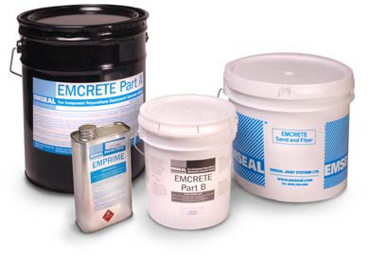04-13-2012 2.0
Copyright © 2012, by EMSEAL Joint Systems Ltd, All Rights Reserved

EMSEAL LLC
120 Carrier Drive
Toronto, ON M9W 5R1
PH : 416-740-2090, FX : 416-740-0233

www.emseal.com
Toll-Free: 800-526-8365
EMSEAL JOINT SYSTEMS, LTD
25 Bridle Lane
Westborough, MA 01581-1228
PH: 508-836-0280, FX: 508-836-0281

LEED INFORMATION

Product: Emseal BEJS

MR Credit 1: Building Reuse

Not applicable

MR Credit 3: Resource Reuse
Page 1 of 1

This product does not contain salvaged or refurbished materials. MR Credit 4: Recycled Content
Recycled Content (Post-consumer): 0% Recycled Content (Post-industrial): 0%
MR Credit 5.1: Regional Materials

Emseal’s manufacturing plant is located in Toronto, Ontario, Canada; please use this information to determine if the project falls within the required 500 mile radius.

MR Credit 6: Rapidly Renewable Materials
This product does not contain rapidly renewable materials. MR Credit 7: Certified Sustainably Harvested Wood

This product does not contain certified wood.

IEQ Credit 4: Low Emitting Materials (Adhesives and Sealants)

The VOC of the silicone used in EMSEAL BEJS is less than 50 grams / liter.

Preformed Sealants and Expansion Joints For:
• Parking, Plaza, Roadway, & Stadium Joints | • Interior Movement Joints | • Acoustic & Anti-Vibration Joints
• Façade, Wall, & Abutment Joints | • Masonry Joints | • Specialty Applications

SECTION 1: PRODUCT AND COMPANY IDENTIFICATION

Product Name: | BEJS
Manufacturer: Address: | EMSEAL CORPORATION  120 Carrier Dr Toronto, Ontario M9W 5R1 | Emergency P Fax: | hone: 416-740-2090  416-740-0233
SECTION 2: COMPOSITION

EMSEAL BEJS is composed of polyurethane foam impregnated with a cured acrylic pressure sensitive adhesive bonded to a fully cured silicone sealant.

SECTION 3: HAZARDS IDENTIFICATION

This product is not classified as hazardous when used as intended.

SECTION 4: FIRST AID MEASURES

EYES: Flush with water for at least 15 minutes, and call physician if problems persist.
SKIN: Product may leave a sticky residue, and mild irritation if prolonged exposure. Scrub with soapy water until adhesive is removed. INGESTION: Do not eat – call physician if ingested.

SECTION 5: FIRE-FIGHTING MEASURES

The material is flammable and can be ignited by open flame or by a source of smoldering ignition. The foam will also melt while burning, and it is possible for smoldering drips to cause the fire to spread.

FLASH POINT: Unknown.

AUTO-IGNITION TEMPERATURE: Unknown.

EXTINGUISHING MEDIA: Large volumes of water, or ABC chemical may be appropriate for initial control or small volumes of impregnated foam.

HAZARDOUS DECOMPOSITION PRODUCTS: Carbon di/mon oxides will be formed as well as other noxious and toxic fumes upon combustion – do not breath combustion products.

SECTION 6: ACCIDENTAL RELEASE MEASURES

ACCIDENTAL RELEASE MEASURES: If material is unusable pick up pieces and dispose of in accordance with local regulations; material and all components are non-toxic and normal landfill will most often be acceptable.

SECTION 7: HANDLING AND STORAGE

HANDLING AND STORAGE: Store in original packaging below 35oC. There are no special handling instructions.

PAGE 1 OF 1

SECTION 8: EXPOSURE CONTROLS/PERSONAL PROTECTION

RESPIRATORY PROTECTION: Not required

EYE PROTECTION: Not required

SKIN PROTECTION: gloves of any material are suitable if desired, but not required. No other protection is required.

SECTION 9: PHYSICAL AND CHEMICAL PROPERTIES
APPEARANCE: Dark grey / charcoal colored foam and colored silicone with product identifying packaging. ODOR: Slight characteristic odor. PERCENT SOLIDS BY WEIGHT: 100%
PHYSICAL STATE: Solid PERCENT VOLATILE: <1% wt/wt
Density: 0.4g/cm3 Decomposition: > 300oC SOLUBILITY IN WATER: None

SECTION 10: STABILITY AND REACTIVITY

STABILITY: Stable under normal conditions – avoid temperatures in excess of 300oC, strong acids and bases, and open flame.

SECTION 11: TOXICOLOGICAL INFORMATION

TOXICOLOGICAL INFORMATION: Unknown.

SECTION 12: ECOLOGICAL INFORMATION

ECOLOGICAL INFORMATION: Unknown.

SECTION 13: DISPOSAL CONSIDERATIONS

WASTE DISPOSAL METHOD: Usually may be disposed of in landfill; check with local regulations.

SECTION 14: TRANSPORT INFORMATION

Not hazardous – safe for non-hazardous shipping.

SECTION 15: REGULATORY INFORMATION

Unknown.

SECTION 16: OTHER INFORMATION

None.

PAGE 2 OF 2

Material Safety Data Sheet
Date last revised JANUARY, 2005
I. GENERAL INFORMATION
Chemical Name & Synonyms  SILICONE SEALANT NS | Trade Name & Synonyms  PECORA 301 Silicone Pavement Sealant
Chemical Family  POLYDIMETHYLSILOXANE MIXTURE | Formula  MIXTURE
Proper DOT Shipping  CAULKING COMPOUND | DOT Hazard Classification  NONE
Manufacturer  PECORA CORPORATION | Manufacturer’s Phone Number  215-723-6051
Manufacturer’s Address  165 Wambold Road, Harleysville, PA 19438 | Chemtrec Phone Number  800-424-9300
II. INGREDIENTS
Principal Hazardous Components  SILICONE DIOXIDE (CAS # 7631-86-9) |  | Percent  4% | Threshold Limit Value (Units)  10 Mg/M3 DUST
METHYL OXIMINO SILANE (CAS # 22984-54-9)  MINERAL SPIRITS (CAS # 64741-41-9) |  | 4 %  1 % | NONE ESTABLISHED
THIS PRODUCT DOES NOT CONTAIN ANY TOXIC
CHEMICALS SUBJECT TO THE REPORTING REQUIREMENTS OF SECTION 313 OF SARA.
HEALTH 1 FLAMMABILITY 0 |  |  | REACTIVITY 0
III. PHYSICAL DATA
Boiling Point (oF)  N/A | Specific Gravity (H20 = 1)  1.30
Vapor Pressure (mm Hg.)  UNKNOWN | Percent Volatile by Volume (%)  < 3%
Vapor Density (Air = 1)  HEAVIER | Evaporation Rate (ETHER= 1)  SLOWER
Solubility in Water  INSOLUBLE | pH  N/A
Appearance & Odor
SMOOTH PASTE – MILD, SLIGHTLY SOLVENT-LIKE
IV. FIRE & EXPLOSION HAZARD DATA
Flash Point (Test Method)  > 220o F. | Auto Ignition Temperature
Flammable Limits  UNKNOWN | LEL UEL  NOT DETERMINED NOT DETERMINED
Extinguishing Media :
DRY CHEMICAL, WATER SPRAY, FOAM, CARBON DIOXIDE
Special Fire Fighting Procedures: WEAR SELF-CONTAINED BREATHING APPARATUS WHEN FIGHTING FIRES THAT CONTAIN CHEMICALS.
Unusual Fire & Explosion Hazards:
UNDER FIRE CONDITIONS, IRRITATING OR TOXIC VAPORS MAY BE PRESENT.

PECORA 301 SILICONE PAVEMENT SEALANT PAGE 2 OF 2
V. Health Hazard Data
OSHA Permissible Exposure Limit  SEE SECTION II |  |  |  | ACGIH Threshold Limit Value  SEE SECTION II
Carcinogen – NTP Program  NO |  |  |  | Carcinogen – IARC Program  NO
Symptoms of Exposure: VAPORS EMITTED AS THE SEALANT CURES MAY IRRITATE THE EYES, NOSE AND THROAT PARTICULARY IN AN ENCLOSED OR POORLY VENTILATED AREA. DIRECT CONTACT WITH THE UNCURED PRODUCT MAY IRRITATE THE EYES AND MOUTH.

Medical Conditions Aggravated By Exposure: PRECLUDE FROM EXPOSURE THOSE INDIVIDUALS HAVING A HISTORY OF RESPIRATORY ILLNESS OR PRE-EXISTING EYE OR SKIN CONDITIONS.
Primary Route (s) of Entry:
INHALATION AND SKIN OR EYE CONTACT
Emergency First Aid: INHALATION: MOVE TO FRESH AIR. IF BREATHING IS DIFFICULT, GIVE OXYGEN. CALL A
PHYSICIAN. SKIN: REMOVE UNCURED MATERIAL AND WASH WITH SOAP AND WATER. EYES: FLUSH WITH RUNNING WATER 15 MINUTES. CONSULT A PHYSICIAN. INGESTION: CONSULT A PHYSICIAN IMMEDIATELY.
VI. REACTIVITY DATA
Stability |  | Unstable  Stable | Conditions to Avoid  WATER AND HIGH TEMPERATURES
 | x
Incompatibility |  |  | Materials to Avoid WATER AND STRONG ACID
Hazardous  Polymerization |  | May Occur  Will Not Occur | Conditions to Avoid  HIGH HUMIDITY AND HIGH TEMPERATURES
 | x
Hazardous Decomposition Products:
OXIDES OF CARBON, SILOXANE AND POSSIBLY OTHER FUMES WHICH MAY BE TOXIC.
VII. ENVIRONMENTAL PROTECTION PROCEDURES
Spill Response: COVER WITH DRY ABSORBENT MATERIAL SUCH AS SAND OR DIRT. PICK UP AND PLACE IN A
CONTAINER FOR DISPOSAL.
Waste Disposal Method: LAND FILL OR INCINERATE IN ACCORDANCE WITH FEDERAL, STATE OR LOCAL ENVIRONMENTAL CONTROL REGULATIONS.
VIII. SPECIAL PROTECTION INFORMATION
Eye Protection Skin Protection
NONE NORMALLY REQUIRED NONE NORMALLY REQUIRED
Respiratory Protection (Specific Type) Ventilation Recommended
ORGANIC VAPOR RESPIRATOR IN CONFINED AREAS LOCAL VENTILATION
Other Protection:
SAFETY GLASSES FOR OVERHEAD APPLICATIONS
IX. SPECIAL PRECAUTIONS
Hygienic Practices In Handling & Storage: TO PROLONG SHELF LIFE, STORE AT TEMPERATURES BELOW 80o F. WASH
HANDS AFTER USE. STORE IN DRY AREA FROM HEAT.
Precautions For Repair & Maintenance of Contaminated Equipment:
SEE SECTION V
Other Precautions:
FOR INDUSTRIAL USE ONLY
KEEP OUT OF REACH OF CHILDREN!!!!!

SECTION I: PRODUCT INFORMATION
PRODUCT: Sika® Epoxy 820 by Emseal PART A REVISION DATE: October 7, 2010
USAGE: HIGH-MODULUS, HIGH-STRENGTH, STRUCTURAL, EPOXY PASTE ADHESIVE MANUFACTURER: SIKA CANADA INC.
601, avenue Delmar Pointe Claire, QC H9R 4A9

EMERGENCY TELEPHONE NUMBER: CANUTEC (collect) (613) 996-6666

TDG CLASSIFICATION: Not Regulated WHMIS Classification: D2A
UN NUMBER: Not Established Class: Not Applicable
Packaging Group: Not Applicable
SECTION II: HAZARDOUS INGREDIENTS
Hazardous ingredients | % | T.L.V. | # CAS | LD50 (mg/kg) (Species, route) | LC50  (Species, route)
EPOXY RESIN | 30-60 | Not Available | 025085-99-8 | > 5000 (oral, rat) | Not Available
SILICA SAND | 30-60 | .1 mg/m3 | 14808-60-7 | Not available | Not Available
SECTION III: PHYSICAL CHARACTERISTICS
Physical State: Paste  Appearance and Odor: White paste with ether odor  Odor Threshold: Not Established Evaporation Rate: Not Applicable Vapor Density: Not Established Vapor Pressure: Not Established |  |  | Boiling Point: Not Established Freezing Point: Not Established Density: 1.7 g/ml  Water Solubility: Very low  pH: Not Established  % volatility: Not Applicable  Water/Oil Distribution: Not Established

PRODUCT: Sika® Epoxy 820 by Emseal PART A
SECTION IV: FIRE AND EXPLOSION HAZARDS
Flammability: No  If Yes, under what conditions:  Extinguishing methods: Foam, dry chemical products, CO2, water hose.  Special Methods: Fire fighters must wear usual protective clothing and respiratory equipment. A water hose may be used to cool the containers and dissipate the vapors. | TDG Flammability Class: Not Regulated Flammable upper limits (% vol.): Not Applicable Flammable lower limits (% vol.): Not Applicable Flash Point (method used): Not Applicable Auto-ignition temperature: Not Established Dangerous Combustion Products: Carbon Oxides,  phenol.  Protect from mechanical impact: No  Protect from static discharge: No
SECTION V: REACTIVITY
Chemical stability: Yes  If not, under what conditions: But excessive heat will degrade the resin.  Incompatibility with other material: Yes  If Yes, which ones: Strong acid, base, and oxidizer. | Dangerous decomposition products: Phenol, carbon oxides.  Polymerization Risks: May polymerize at very high temperatures.

PRODUCT: Sika® Epoxy 820 by Emseal PART A
SECTION VI: TOXIC PROPERTIES
ROUTE OF ENTRY / CONTACT  Eyes: May cause eye irritations.  Skin: May be irritating to the skin, may cause sensitization.  Inhalation: May irritate lungs, may cause an allergic reaction.  Ingestion: May cause irritation to the gastro- intestinal system. | Carcinogenicity: According to the IARC, the quartz silica is a probable cause of cancer.  Toxic effects  on reproduction: Not available  Teratogenicity: Not available Mutagenicity: Not available Product with synergistic  effects: Not known
An acute or chronic exposure will increase the toxic effects mentioned in this section and may aggravate respiratory problems.

PRODUCT: Sika® Epoxy 820 by Emseal PART A
SECTION VII: PREVENTIVE MEASURES
PERSONAL PROTECTIVE EQUIPMENT  Gloves: Chemical resistant gloves. Respiratory equipment: Not necessary under normal use. Eyes: Safety glasses  Shoes: Ordinary Clothing: Rubber Apron Other: No | OTHERS  Ventilation: Sufficient ventilation required  Procedure in case  of leaks: Absorb with sand or other absorbent material. Residue may be removed with steam or hot water and soap. All precautions should be taken when cleaning the spill with solvent.  Handling and Equipment  Methods: Avoid skin, eye and clothing contact  Warehouse  Requirements: Keep all containers closed in a cool, dry area. Keep away from heat and open flame  Special Shipping  Instructions: See TDG class  Waste Disposal: Dispose of sand and rinse water according to municipal, provincial or federal laws for disposal of chemicals.

PRODUCT: Sika® Epoxy 820 by Emseal PART A

SECTION VIII: FIRST AID

Skin: Remove and clean all contaminated clothing.
Wash immediately with plenty of soap and water. Consult a physician if required.

Eyes: Rinse with water for at least 15 minutes.
Consult a physician immediately.

Inhalation: In the case of overexposure, evacuate to fresh air.
Consult a physician if required.

Ingestion: Drink plenty of water. Do not induce vomiting.
Do not give anything by mouth to an unconscious person. See a physician immediately.

SECTION IX: PREPARATION INFORMATION

Prepared By: Steve Gosselin
Telephone #: (514) 697-2610
Fax #: (514) 694-2792

Notice To Reader
The information contained in this Material Safety Data Sheet applies only to the actual Sika Canada product identified and described herein. This information is not intended to address, nor does it address the use or application of the identified Sika product in combination with any other material, product or process. All of the information set forth herein is based on technical data regarding the identified product that Sika believes to be reliable as of the date hereof. Prior to each use of any Sika product, the user must always read and follow the warnings and instructions on the product's current Technical Data Sheet, product label and Material Safety Data Sheet for each Sika product, which are available at web site and/or telephone number listed in Section 1 of this MSDS.

SIKA MAKES NO WARRANTIES EXPRESS OR IMPLIED AND ASSUMES NO LIABILITY ARISING FROM THIS INFORMATION OR ITS USE. SIKA SHALL NOT BE LIABLE UNDER ANY LEGAL THEORY FOR SPECIAL OR CONSEQUENTIAL DAMAGES AND SHALL NOT BE RESPONSIBLE FOR THE USE OF THIS PRODUCT IN A MANNER TO INFRINGE ON ANY PATENT OR ANY OTHER INTELLECTUAL PROPERTY RIGHTS HELD BY OTHERS.

All sales of Sika products are subject to its current terms and conditions of sale available at www.sikacanada.com or 514-697-2610.

SECTION I: PRODUCT INFORMATION
PRODUCT: Sika® Epoxy 820 by Emseal PART B REVISION DATE: October 7, 2010
USAGE: HIGH-MODULUS, HIGH-STRENGTH, STRUCTURAL, EPOXY PASTE ADHESIVE MANUFACTURER: SIKA CANADA INC.
601, avenue Delmar Pointe Claire, QC H9R 4A9

EMERGENCY TELEPHONE NUMBER: CANUTEC (collect) (613) 996-6666

TDG CLASSIFICATION: Not Regulated WHMIS Classification: D2A, E
UN NUMBER: Not Established Class: Not Applicable
Packaging Group: Not Applicable
SECTION II: HAZARDOUS INGREDIENTS
Hazardous ingredients | % | T.L.V. | # CAS | LD50 (mg/kg) (Species, route) | LC50  (Species, route)
BENZYL ALCOHOL | 1-5 | Not Available. | 100-51-6 | 1230 (oral, rat) | 4000 mg/m3 (rat)
TRIDIMETHYLAMINO METHYL PHENOL 2,  4, 6 | 1-5 | Not Available. | 90-72-2 | 1635 (oral, rat) | .5 mg/L(rat)
ALIPHATIC AMINE AND EPOXY RESIN COPOLYMER | 5-10 | Not available | Not available | Not Available | Not Available
SILICA SAND | 40-70 | .1 mg/m3 | 14808-60-7 | Not available | Not Available
PETROLEUM DISTILLATE | 1-5 | Not available | 68477-31-6 | 2622 (oral, rat) | Not available
SECTION III: PHYSICAL CHARACTERISTICS
Physical State: Paste  Appearance and Odor: Light grey paste with amine odor  Odor Threshold: Not Established Evaporation Rate: Not Applicable Vapor Density: Not Established Vapor Pressure: Not Established |  |  | Boiling Point: Not Established Freezing Point: Not Established Density: 2.1 g/ml  Water Solubility: Partial  pH: Not Established  % volatility: 0  Water/Oil Distribution: Not Established

PRODUCT: Sika® Epoxy 820 by Emseal PART B
SECTION IV: FIRE AND EXPLOSION HAZARDS
Flammability: No  If Yes, under what conditions:  Extinguishing methods: Foam, dry chemical products, CO2, water hose.  Special Methods: Fire fighters must wear usual protective clothing and respiratory equipment. A water hose may be used to cool the containers and dissipate the vapors. | TDG Flammability Class: Not Regulated Flammable upper limits (% vol.): Not Established Flammable lower limits (% vol.): Not Established Flash Point (method used): > 96°C  Auto-ignition temperature: Not Established  Dangerous Combustion Products: Carbon oxides, nitrogen oxides, aldehyde, ketone.  Protect from mechanical impact: No  Protect from static discharge: No
SECTION V: REACTIVITY
Chemical stability: Yes  If not, under what conditions:  Incompatibility with other material: Yes  If Yes, which ones: Acid, strong oxidizer, organic halogen, aldehyde, ketone, nitrate, acrylate. | Dangerous decomposition products: Carbon oxides, nitrogen oxides, aldehyde, ketone.  Polymerization Risks: No

PRODUCT: Sika® Epoxy 820 by Emseal PART B
SECTION VI: TOXIC PROPERTIES
ROUTE OF ENTRY / CONTACT  Eyes: May cause eye irritations. May cause severe burns. May cause blindness.  Skin: May be irritating to the skin, may cause severe burns. May cause dermatitis, allergic reactions, and sensitization.  Inhalation: Vapors or mist of this product may cause irritation.  Ingestion: May cause severe burns to the mouth, throat and stomach. May cause vomiting, dizziness, diarrhea, damages to the lungs, troubles to the gastro-intestinal system, death.  An over-exposure may cause breathing difficulty, headaches, nausea, damages to the lungs, sensitization and dizziness.  May cause problems to the skin, eyes and lungs. May aggravate respiratory and allergic problems. | Carcinogenicity: According to the IARC, the quartz silica is a probable cause of cancer.  Toxic effects  on reproduction: Not available  Teratogenicity: Not available  Mutagenicity: Yes  Product with synergistic  effects: Not known
An acute or chronic exposure will increase the toxic effects mentioned in this section and may aggravate respiratory problems.

PRODUCT: Sika® Epoxy 820 by Emseal PART B
SECTION VII: PREVENTIVE MEASURES
PERSONAL PROTECTIVE EQUIPMENT  Gloves: Chemical resistant gloves. Respiratory equipment: Not necessary under normal use.  Eyes: Full face mask or safety glasses  Shoes: Leather Clothing: Rubber Apron Other: Eye wash station | OTHERS  Ventilation: Sufficient ventilation required  Procedure in case  Of leaks: Absorb with sand or other absorbent material.  Handling and Equipment  Methods: Avoid skin, eye and clothing contact  Warehouse  Requirements: Keep all containers closed in a cool, dry and well ventilated area. Keep away from heat and open flame  Special Shipping  Instructions: See TDG class  Waste Disposal: Dispose of sand and rinse water according to municipal, provincial or federal laws for disposal of chemicals.

PRODUCT: Sika® Epoxy 820 by Emseal PART B

SECTION VIII: FIRST AID

Skin: Remove contaminated clothing and shoes.
Wash immediately with plenty of soap and water. Throw away shoes that were soiled on the inside. Wash clothing before re-wearing.
Consult a physician if required.

Eyes: Rinse eyes immediately with plenty of water for several minutes, while holding eyelids wide open, to ensure a proper wash.
The eye rinse within the first minute is essential to ensure maximum protection.
Consult a physician immediately.

Inhalation: In the case of overexposure, evacuate to fresh air.
Consult a physician if required.

Ingestion: Drink plenty of water. Do not induce vomiting.
Do not give anything by mouth to an unconscious person. See a physician immediately.

SECTION IX: PREPARATION INFORMATION

Prepared By: Steve Gosselin
Telephone #: (514) 697-2610
Fax #: (514) 694-2792

Notice To Reader
The information contained in this Material Safety Data Sheet applies only to the actual Sika Canada product identified and described herein. This information is not intended to address, nor does it address the use or application of the identified Sika product in combination with any other material, product or process. All of the information set forth herein is based on technical data regarding the identified product that Sika believes to be reliable as of the date hereof. Prior to each use of any Sika product, the user must always read and follow the warnings and instructions on the product's current Technical Data Sheet, product label and Material Safety Data Sheet for each Sika product, which are available at web site and/or telephone number listed in Section 1 of this MSDS.

SIKA MAKES NO WARRANTIES EXPRESS OR IMPLIED AND ASSUMES NO LIABILITY ARISING FROM THIS INFORMATION OR ITS USE. SIKA SHALL NOT BE LIABLE UNDER ANY LEGAL THEORY FOR SPECIAL OR CONSEQUENTIAL DAMAGES AND SHALL NOT BE RESPONSIBLE FOR THE USE OF THIS PRODUCT IN A MANNER TO INFRINGE ON ANY PATENT OR ANY OTHER INTELLECTUAL PROPERTY RIGHTS HELD BY OTHERS.

All sales of Sika products are subject to its current terms and conditions of sale available at www.sikacanada.com or 514-697-2610.

®

www.emseal.com

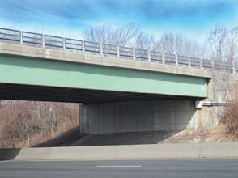BEJS Bridge Expansion Joint System One Install Does It All

Watertight, Traffic Durable, Joint-Face-Adhered,
Primary Seal for Retrofit and New Expansion Joints

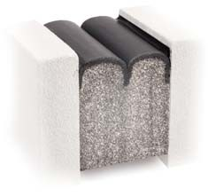The BEJS System is a traffic-durable bridge and roadway expansion joint which fills expansion gaps and provides a primary watertight seal. It is designed to handle harsh environmental conditions with greater movement capability, better low temperature flexibility and higher temperature stability. The single unit non-invasive anchoring system provides for quick installation and repairs, and will help and/or decrease maintenance costs to deteriorating bridge bearing pads and support structures.
Uses
Manufactured for the D.O.T./Infrastructure market, it is ideal for new construction and retrofit of old or failed bridge expansion joint systems in:
• Concrete-to-concrete substrates
• Rebuilt joint faces
• Existing embedded metal angles
• As a lasting replacement for all failed liquid-sealant joints
• Buried joint applications

Product Description
BEJS is a 100% acrylic, preformed, precompressed, factory cured and silicone coated impregnated cellular foam. It is installed into field applied epoxy adhesive and a silicone band is inserted along the sides. Traffic-grade Pecora 301 silicone is used for its superb fuel resistant properties (see Fig. 1).
The BEJS System features a patent-pending acrylic adhesive which is infused into the cellular foam base material incorporating hydrophobic microspheres. This outperforms the sealing performance of all other acrylic impregnated products. It is odorless, clean handling, UV stable, non-staining, and features low temperature flexibility.
The BEJS System functions well in thermal shock conditions (rapid opening /closing joints during large temperature swings) where asphalt and wax-based products are not recommended. BEJS is compressed “to fit” at high temperature ranges in
order to ensure watertight success at colder temperatures.

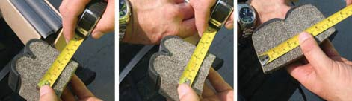
BEJS precompressed foam expands to fill the expansion gap completing the watertight seal. The picture above demonstrates the expansion of a sample section cut from a stick of BEJS.
RESIZE, REBUILD, RESEAL - The EMSEAL Approach to Bridge Expansion Joint Retrofit.

RESIZE:
Joint failure is frequently the result of not matching the move- ment capability of the expansion joint to the movement expectations of the structure as a product of its length and temperature range for its geographical location. Recalculat- ing these factors may be necessary to ensure the correct size is used on the retrofit.

REBUILD:
Traffic, freeze-thaw cycles and rebar corrosion can crack or deteriorate the concrete or asphalt at joint edges. By removing the failed concrete or asphalt and replacing it with EMSEAL’s impact-resistant, fast curing, nosing material, the joint edge will be repaired and reformed to accept the expected movement handled by the BEJS SYSTEM.

RESEAL:
Installation of the BEJS SYSTEM is fast, can be staged while preserving partial traffic flow, can be done day or night, and can be installed in a wide temperature range.
Continuity of seal is critical. Not only the joint in traffic surfaces must be watertight but also the joints through all changes in plane and direction. To achieve this, the joints in the parapets and sidewalks must be sized the same as the roadway joint and the system sealing the roadway must transition through all the elevation changes ensuring watertightness across the entire bridge.
Expansion joints are not drains. A major cause of structural deterioration of piers, columns and beams on bridges is the leaking of joints that are used as drains. Water laced with de-icing salts and atmospheric contaminants directed through expansion joints shed directly onto the most critical structural elements of bridges. Corrosion and expansion of rebar and subsequent spalling require the expensive reconstruction of beams, piers, columns and wing walls. Unless the joint system above these structural elements is watertight, and the pitch of the bridge drains water away from the joints to a less critical discharge point or to purposed-designed drains, structural deterioration will continue and accelerate.

EMSEAL JOINT SYSTEMS LTD. 25 Bridle Lane, Westborough, MA USA 01581 PH: 508.836-0280 FX: 508.836.0281

EMSEAL, LLC 120 Carrier Drive, Toronto, Ontario, Canada M9W 5R1
TOLL FREE: 800.526.8365
PH: 416.740.2090 FX: 416.740.0233

Copyright © 2011 EMSEAL Joint Systems Ltd. All rights reserved.

BEJS

Bridge Expansion Joint System

Fig.1: BEJS SYSTEM in Typical Installation--New or Retrofit
Fig.3: BEJS SYSTEM in New or Rebuilt Joint Edges with EMSEAL Nosing Material

FIELD-INJECTED
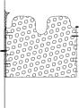SILICONE SEALANT BANDS (Silicone supplied by EMSEAL)

FACTORY-APPLIED AND CURED SILICONE BELLOWS FACING
0.5-inch (12mm)

FIELD-APPLIED SILICONE CORNER BEADS AND SILICONE BAND FORCED DOWN ALONG SIDE OF BEJS AS SHOWN – BOTH SIDES

EPOXY ADHESIVE FOR JOINT FACES
(Epoxy supplied by EMSEAL)
BEJS MODIFIED ACRYLIC IMPREGNATED FOAM

Fig.2: BEJS SYSTEM in Existing Steel Angles--Retrofit

ASPHALT OR CONCRETE
WEARING
SURFACE (BY OTHERS)

FACTORY-APPLIED AND CURED SILICONE
BELLOWS FACING

0.5-inch (12mm)

EMSEAL IMPACT – ABSORBING NOSING MATERIAL

OPTIMIZE REBAR SPACING
& CONFIGURATION FOR SUPPORT OF HEADERS (BY OTHERS)

0.5-inch (12mm)

EXISTING STEEL ANGLES WHERE REMOVAL IS NOT FEASIBLE
DAMAGED CONCRETE AT BACK EDGES OF EMBEDDED ANGLES ROUTED AND SEALED (BY OTHERS)

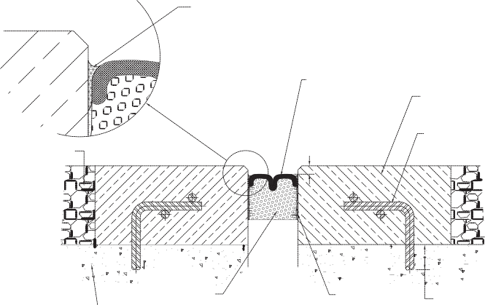CONCRETE

BEJS
IMPREGNATED

EPOXY
ADHESIVE

DEPTH OF REBAR TO SUIT (BY

STRUCTURAL SLAB FOAM (BY OTHERS)
BOTH SIDES OF
JOINT FACE
OTHERS)

Features

Note: For joint sizes less than 1" (25mm) a smooth, convex, single bellows is supplied.

Performance

Watertight — the tensionless silicone bellows is installed just below the deck surface ensuring watertightness of the deck. Unlike liquid-applied sealants, compression seals, and closed- cell EVA foam, the BEJS SYSTEM does not rely on adhesion in tension and is not wedged into the joint gap. Instead the mate- rial is factory-precompressed, ensuring that the spring energy of compression is always pushing back on the substrate.

Non-Invasive Anchoring — there are no hard metal-to-concrete connections in the system. The system is locked to the joint faces by means of the 1) backpressure of the foam; 2) the epoxy adhesive, and 3) the injected silicone sealant band at the joint face to foam and silicone bellows interface.

Joint-Size Variation — uniform bellows appearance, and the ability to handle variations in joint size through size-switching, are among other system features.

Factory-Fabricated Transitions — to ensure continuity of seal through changes in plane, EMSEAL offers Universal-90 factory-fabricated transitions and terminations. These BEJS single-unit pieces can be turned and joined horizontally or verti- cally to complete a run or transition to straight sticks of BEJS. These eliminate the need for cutting and creating corners in the field as well as ensuring continuity of seal through their mono-
lithic design. BEJS also of fer s Kick-Out Terminations, a factory-fabricated piece with a built in drip-edge that directs water runoff away from the bridge structure. The Kick-Out Termination is installed at the edge of the deck with its down- turn over the side of the bridge and the drip edge sticking out beyond the face of the slab. Water that runs off the joint is directed away from the bridge and its bearing pads, columns etc. by the silicone-coated flared end of the kick-out.
Capable of movements of +50%, -50% (100% total) of nominal material size.

Standard sizes from 1/2" (12mm) to 4" (100mm). Other sizes available on review of application - consult EMSEAL.

Composition
Differing from closed-cell EVA foam, BEJS is produced by coating an impregnated cellular foam with Pecora 301 highway-grade silicone.
The expanding foam is cellular polyurethane foam impregnated with a water-based acrylic containing a high performance micro- cellular additive.
The silicone external facing is factory applied to the foam at a width greater than maximum joint extension and is cured before final compression.
Silicone application and curing takes place in a factory-controlled environment. In contrast to field applied liquid sealant and backer rod installations, no movement takes place during curing that can cause deformation or stresses in the material.
Then compressed, a bellows is created in the coating*. As joint movement occurs the bellows simply folds and unfolds free of tension on the bond line, and virtually free of tensile stresses in the silicone material.
The foam provides a resilient backing to the silicone coating, allowing the system to resist reasonable transient point loads
BEJ S SYSTEM is supplied in shrink-wrapped lengths of precompressed sticks maunufactured to less than the joint size for easy insertion. After removal from the shrink-wrap and hard board restraining packaging, it expands gradually.

*BEJS is manufactured with a dual-bellows surface for nominal gap widths of 1" (25mm) to 4" (100mm). Widths of 1/2" (12mm), 5/8" (15mm) and
3/4" (20mm) are manufactured with a convex single-bellows surface.

EMSEAL JOINT SYSTEMS LTD. 25 Bridle Lane, Westborough, MA USA 01581 PH: 508.836-0280 FX: 508.836.0281

EMSEAL, LLC 120 Carrier Drive, Toronto, Ontario, Canada M9W 5R1
TOLL FREE: 800.526.8365
PH: 416.740.2090 FX: 416.740.0233

Copyright © 2011 EMSEAL Joint Systems Ltd. All rights reserved.
04-13-2012

BEJS SYSTEM TECH DATA
www.emseal.com APRIL 2011, PAGE 1 OF 2

®

BEJS SYSTEM
Watertight Joint System for Road Bridges

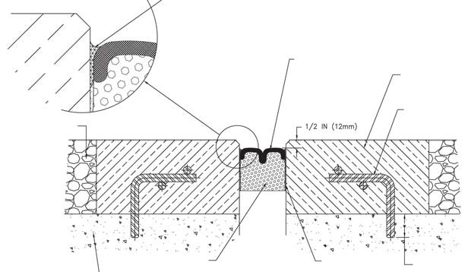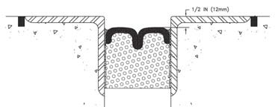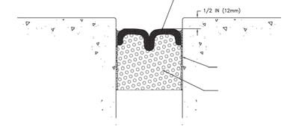TECHD A T A

Product Description
The BEJS SYSTEM, Bridge Expansion Joint System, builds on a track record of over 30 years of sealing horizontal plane joints with impregnated foam sealants and is an evolution of EMSEAL's DSH SYSTEM.

The system is comprised of:
1) Precompressed, silicone-and- impregnated-foam hybrid installed into
2) field-applied epoxy adhesive on the joint faces; with the silicone bellows
Uses
• Watertight, traffic durable, joint-face-adhered, precompressed, primary seal for retrofit and new expansion joints in road bridges, wing walls,
abutments, jersey barriers, longitudinal joints, etc.
• Ideal for new construction and retrofit of old or failed joint systems in concrete or rebuilt joint edges. Suitable for use in embedded metal angles where demolition or removal of the metal angles is not feasible and where the existing joint opening is suited to the movement capability of the BEJS.
• Ideal for lasting replacement of failed caulk joints.

Fig.1: BEJS SYSTEM in Typical Installation--New or Retrofit
FACTORY-APPLIED AND CURED

locked to the joint faces with 3) a silicone sealant band (see Figure 1).

The BEJS SYSTEM features an innovation in sealant technology in the form of a patent-pending acrylic adhesive infused into the cellular foam base material. This new chemistry incorporates a hydrophobic microsphere component
3) FIELD-INJECTED
SILICONE SEALANT BANDS
SILICONE BELLOWS FACING

2) EPOXY ADHESIVE FOR JOINT FACES

1) BEJS MODIFIED ACRYLIC IMPREGNATED FOAM

never before available in a sealant formulation.

The material features sealing performance significantly greater than
Fig.2: BEJS SYSTEM in Existing Steel Angles--Retrofit

any acrylic impregnated predecessor. In addition, it is odorless, clean handling, UV stable, non-staining, and features low temperature
EXISTING STEEL ANGLES WHERE REMOVAL IS NOT FEASIBLE
DAMAGED CONCRETE AT BACK EDGES
OF EMBEDDED ANGLES ROUTED AND SEALED (BY OTHERS)

flexibility not previously available in asphalt, wax, or isobutylene-based predecessors or competitors.

The result is extension of the usability of the product to applications where asphalt and wax-based predecessors did not work well under conditions of thermal shock (rapid opening and closing of joints during large temperature swings).
Fig.3: BEJS SYSTEM in New or Rebuilt Joint Edges with EMSEAL Nosing Material
FIELD-APPLIED SILICONE CORNER BEADS AND SILICONE BAND FORCED DOWN ALONG SIDE OF BEJS AS SHOWN – BOTH SIDES
FACTORY-APPLIED AND CURED SILICONE BELLOWS FACING
EMSEAL IMPACT – ABSORBING NOSING MATERIAL

OPTIMIZE REBAR SPACING & CONFIGURATION FOR SUPPORT

These applications include joint-face
adhered installations on bridge decks wing walls, abutments, jersey barriers, etc.

Suitability is further extended to applications in colder geographical regions to which asphalt and wax-based predecessors have not previously been recommended.

Features
Watertight—the tensionless silicone
ASPHALT OR CONCRETE
WEARING SURFACE (BY OTHERS)

CONCRETE STRUCTURAL SLAB (BY OTHERS)

BEJS
IMPREGNATED FOAM

EPOXY ADHESIVE BOTH SIDES OF JOINT FACE
OF HEADERS (BY OTHERS)

DEPTH OF REBAR
TO SUIT (BY OTHERS)

bellows are installed just below the deck
Note: For joint sizes less than 1" (25mm) a smooth, convex, single bellows is supplied.

surface. This ensures watertightness is achieved at the deck surface.

Non-Invasive Anchoring—there are no hard metal-to-concrete connections with the BEJS SYSTEM. This includes embedded pins, anchors, screws, bolts or tracks, trays or rails. The system is locked to the joint faces by means of the
1) backpressure of the foam; 2) the epoxy adhesive, and 3) the injected silicone sealant band at the joint face to foam and silicone bellows interface.
Continuity of Seal—as in all EMSEAL
expansion joint systems, continuity of seal through changes in plane and direction is an essential performance differentiator. Details for watertight, field-fabricated transitions from deck to wall, at curbs, sidewalks, parapets, tees, and crosses are available from EMSEAL. “Universal 90’s” are factory fabricated transition pieces that are coated on both sides. This means that they can be installed in inside corners and outside corners as needed. “Universal 90’s” are
warranted by EMSEAL to be watertight through the entire movement capability of the product.
Movement Capability
+50% and -50% (Total 100%) of nominal material size.

Aesthetics & Versatility—Standard color is black. Uniform bellows appearance, double sealing, fuel resistance, and an enhanced ability to handle variations in joint size are among other system features.

EMSEAL JOINT SYSTEMS, LTD 25 Bridle Lane, Westborough, MA 01581
EMSEAL, LLC 120 Carrier Drive, Toronto, ON, Canada M9W 5R1

Toll Free: 1-800-526-8365
PH: 508.836.0280 FX: 508.836.0281
PH: 416.740.2090 FX: 416.740.0233

Copyright © 2011 by EMSEAL JOINT SYSTEMS, LTD. All Rights Reserved

www.emseal.com

Performance
• Substrates must be parallel, plumb and capable of resisting approx. 2.5 psi backpressure from the foam.
• Standard sizes from 1/2" (12mm) to 4" (100mm). Other sizes available subject to review of application: consult EMSEAL.
• Fuel Resistance: Silicone sealant is not degraded by contact with fuel. Some swelling of the silicone material will normally occur, but it will return to its original shape upon evaporation of the fuel.
Composition
• BEJS is produced by coating an impregnated cellular foam with highway-grade silicone.
• The silicone external facing is factory applied to the foam at a width greater than maximum joint extension and is cured before final compression.
• Silicone application and curing takes place in a factory-controlled environment. In contrast to field applied liquid sealant and backer rod installations, no movement takes place during curing that can cause deformation or stresses in the material.
• When compressed, a bellows is created in the coating. As joint movement occurs the bellows simply folds and
Table 1: Typical Physical Properties of BEJS Foam
Property Value Test Method
BASE MATERIAL  Impregnation  TEMPERATURE SERVICE RANGE  HIGH  LOW  UV RESISTANCE  (Accelerated Weatherometer)  RESISTANCE TO AGING | CELLULAR, HIGH DENSITY, POLYURETHANE FOAM  Proprietary, modified, water-based, acrylic  185°F (85°C)  -40°F (-40°C)  NO CHANGES--2000 HOURS  NO CHANGES--2000 HOURS |  | N/A  N/A  ASTM C711  ASTM G155-00A  ASTM G155-00A
Bleeding:  -40°F to 180°F (-40°C to 85°C)  COMPRESSION SET | No bleeding when compressed to minimum of claimed movement i.e. -50% of nominal size and when simultaneously heated to 180°F (85°C) FOR 3 HOURS  MATERIAL RECOVERS TO +50% OF NOMINAL SIZE WITHIN 24 HOURS OF COMPRES-  SION TO -50% AND SIMULTANEOUS HEATING TO 180°F (85°C) FOR 3 HOURS
Table 2: Typical Physical Properties of Silicone Coating
Property Value
COLOR  Percent Solids (minimum)  SPECIFIC GRAVITY  Following tests conducted on Sealant Cured after 21 days at  25°C (77°F) and 50% RH:  ELONGATION PERCENT MINIMUM  Joint Modulus at 50 percent Elongation, psi (kPa) maximum  JOINT MODULUS AT 100 PERCENT ELONGATION, PSI (KPA) MAXIMUM  Joint Modulus at 150 percent Elongation, psi (kPa) maximum  ADHESION TO CONCRETE, MINIMUM PERCENT ELONGATION Adhesion to Asphalt, minimum percent Elongation JOINT MOVEMENT CAPABILITY, +100/-50 PERCENT, 10 CYCLES Weatherability  FLEXIBILITY |  | BLACK  96  1.26 - 1.34  1400  7(48)  8(55)  9(62)  +600  +600  NO FAILURE  Unaffected by climatic extremes  CURED SEALANT STAYS RUBBERY FROM -45 TO  149°C (-50 TO 300°F)
Table 3: Approximate Volume Change of Silicone Coating after Exposure to Fluids:
Percent Volume Swell - Visual
Fluid Silicone Joint Sealant
JP-4 5-20 PERCENT
Skydrol B None
50/50 GLYCOL/H2O NONE
Hydraulic Fluid None AFTER DRYING, ALL SAMPLES PASSED +100/-50% MOVEMENT TESTING.

unfolds free of tension on the bondline, and virtually free of tensile stresses in the silicone material.
• The foam provides a resilient backing to the silicone coating, making the system capable of resisting reasonable transient point loads.
• BEJS SYSTEM is supplied in 6.56 LF (2m) shrink-wrapped lengths (sticks). It is precompressed to less than the joint size for easy insertion. After removal from the shrink-wrap and hard board restraining packaging, it expands gradually.

Installation
IMPORTANT: The following instructions are a summary. Refer to "BEJS SYSTEM Install Data" and job-specific instructions of an EMSEAL technician for complete procedures.
• Store indoors at room temperature. Expansion is quicker when warm, slower when cold.
• Ensure material nominal size matches joint size.
• Mix epoxy and trowel a thin layer onto the joint faces to at least the depth of the BEJS foam
• Apply a thin layer of epoxy to both sides of the joint face.
BEJS SYSTEM TECH DATA APRIL 2011, PAGE 2 OF 2

• Remove shrink-wrap packaging, hardboard. If necessary, heat using torch to expand material to a snug fit in the joint.
• Insert material into joint with a
1/2" (12mm) recess.
• Join lengths by pushing silicone coated ends firmly together.
• Wipe silicone facing using clean,
lint-free rag made damp with solvent.
• Before the epoxy cures, force the tip of the sealant tube between the foam and the substrate and inject a silicone sealant band. Tool overflow sealant into a cove bead between the top of the silicone bellows and the substrate. Tool silicone between joined lengths so that bellows is not restrained by excess silicone.

Warranty
Standard or project-specific warranties are available from EMSEAL on request.
CAD Details & Guide Specs
Guide specifications and CAD details are available at www.emseal.com.
Availability & Price
BEJS SYSTEM is available for shipment internationally. Prices are available from local representatives and/or directly from the manufacturer. The product range is continually being updated, and accordingly EMSEAL® reserves the right to modify or withdraw any product without prior notice.

Table 4: BEJS SYSTEM Sizing
(see “Performance” for movement capabilities & limitations)
Nominal Material Size  (Joint Size at Mean T°F) | Depth of Seal | Min. Joint  (closes to) | Max. Joint  (opens to)
1/2"  (12mm) | 1 1/2"  (40mm) | 1/4"  (6mm) | 3/4"  (20mm)
3/4"  (20mm) | 1-1/2"  (40mm) | 3/8"  (10mm) | 1-1/8"  (28mm)
1"  (25mm) | 2"  (50mm) | 1/2"  (12mm) | 1-1/2"  (40mm)
1-1/4"  (30mm) | 2"  (50mm) | 5/8"  (15mm) | 1-7/8"  (47mm)
1-1/2"  (40mm) | 2 1/2"  (65mm) | 3/4"  (20mm) | 2-1/4"  (55mm)
1-3/4"  (45mm) | 2-1/2"  (65m) | 7/8"  (22mm) | 2-5/8"  (68mm)
2"  (50mm) | 2-1/2"  (65mm) | 1"  (25mm) | 3"  (75mm)
2-1/4"  (55mm) | 2-1/2"  (65mm) | 1-1/8"  (28mm) | 3-3/4"  (95mm)
2-1/2"  (65mm) | 2-3/4"  (70mm) | 1-1/4"  (30mm) | 3-3/4"  (95mm)
2-3/4"  (70mm) | 2-3/4"  (70mm) | 1-3/8"  (35mm) | 4-1/8"  (105mm)
3"  (75mm) | 2-3/4"  (70mm) | 1-1/2"  (40mm) | 4-1/2"  (115mm)
3-1/4"  (85mm) | 3-1/2"  (90mm) | 1-5/8"  (42mm) | 4-7/8"  (120mm)
3-1/2"  (90mm) | 3-1/2"  (90mm) | 1-3/4"  (45mm) | 5-1/4"  (135mm)
3-3/4"  (95mm) | 3-1/2"  (90mm) | 1-7/8"  (47mm) | 5-5/8"  (140mm)
4"  (100mm) | 3-1/2"  (90mm) | 2"  (50mm) | 6"  (150mm)
• For sizes not shown consult EMSEAL.
• Select nominal material size to correspond to joint-gap size at mean temperature.
• Material supplied in shrink-wrapped sticks of 6.56 ft. (2 M).

EMSEAL JOINT SYSTEMS, LTD 25 Bridle Lane, Westborough, MA 01581
EMSEAL, LLC 120 Carrier Drive, Toronto, ON, Canada M9W 5R1

Toll Free: 1-800-526-8365
PH: 508.836.0280 FX: 508.836.0281
PH: 416.740.2090 FX: 416.740.0233

EMSEAL_BEJS_TD_4_05_2011_w
Copyright © 2011 by EMSEAL JOINT SYSTEMS, LTD. All Rights Reserved

