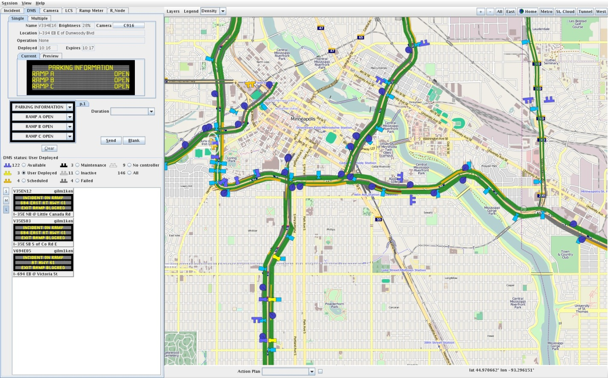
MnDOT Intelligent Roadway Information System Example
- The Release Notes gives a basic overview of the major activities in enhancing and fixing IRIS. Note that the first entry on the reverse chronological list was made last week on April 26th.
-The Installation Instructions is intended to assist software staff in the installation process. This was made simpler as we worked with Caltrans and UC Davis AHMCT.
- Mercurial repositories is the method that the software people use to track and report activities to changes in the various modules.
- Run IRIS is initiating running IRIS after it has been installed.

Intelligent Roadway System Webpage

