®

[*www.emseal.com*](http://www.emseal.com/)



*BEJS Bridge Expansion Joint System One Install Does It All*

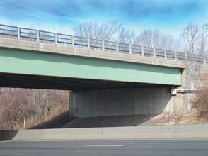

Watertight, Traffic Durable, Joint-Face-Adhered,

Primary Seal for Retrofit and New Expansion Joints

The BEJS System is a traffic-durable bridge and roadway expansion joint which fills expansion gaps and provides a primary watertight seal. It is designed to handle harsh environmental conditions with greater movement capability, better low temperature flexibility and higher temperature stability. The single unit non-invasive anchoring system provides for quick installation and repairs, and will help and/or decrease maintenance costs to deteriorating bridge bearing pads and support structures.

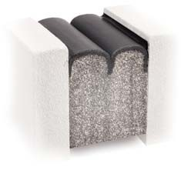

Uses

Manufactured for the D.O.T./Infrastructure market, it is ideal for new construction and retrofit of old or failed bridge expansion joint systems in:

• Concrete-to-concrete substrates

• Rebuilt joint faces

• Existing embedded metal angles

• As a lasting replacement for all failed liquid-sealant joints

• Buried joint applications

Product Description

BEJS is a 100% acrylic, preformed, precompressed, factory cured and silicone coated impregnated cellular foam. It is installed into field applied epoxy adhesive and a silicone band is inserted along the sides. Traffic-grade Pecora 301 silicone is used for its superb fuel resistant properties (see Fig. 1).

The BEJS System features a patent-pending acrylic adhesive which is infused into the cellular foam base material incorporating hydrophobic microspheres. This outperforms the sealing performance of all other acrylic impregnated products. It is odorless, clean handling, UV stable, non-staining, and features low temperature flexibility.

The BEJS System functions well in thermal shock conditions (rapid opening /closing joints during large temperature swings) where asphalt and wax-based products are not recommended. BEJS is compressed “to fit” at high temperature ranges in

order to ensure watertight success at colder temperatures.



*BEJS precompressed foam expands to fill the expansion gap completing the watertight seal. The picture above demonstrates the expansion of a sample section cut from a stick of BEJS.*

RESIZE, REBUILD, RESEAL - The EMSEAL Approach to Bridge Expansion Joint Retrofit.

RESIZE:

Joint failure is frequently the result of not matching the move- ment capability of the expansion joint to the movement expectations of the structure as a product of its length and temperature range for its geographical location. Recalculat- ing these factors may be necessary to ensure the correct size is used on the retrofit.

REBUILD:

Traffic, freeze-thaw cycles and rebar corrosion can crack or deteriorate the concrete or asphalt at joint edges. By removing the failed concrete or asphalt and replacing it with EMSEAL’s impact-resistant, fast curing, nosing material, the joint edge will be repaired and reformed to accept the expected movement handled by the BEJS SYSTEM.

RESEAL:

Installation of the BEJS SYSTEM is fast, can be staged while preserving partial traffic flow, can be done day or night, and can be installed in a wide temperature range.

*Continuity of seal is critical*. Not only the joint in traffic surfaces must be watertight but also the joints through all changes in plane and direction. To achieve this, the joints in the parapets and sidewalks must be sized the same as the roadway joint and the system sealing the roadway must transition through all the elevation changes ensuring watertightness across the entire bridge.

*Expansion joints are not drains.* A major cause of structural deterioration of piers, columns and beams on bridges is the leaking of joints that are used as drains. Water laced with de-icing salts and atmospheric contaminants directed through expansion joints shed directly onto the most critical structural elements of bridges. Corrosion and expansion of rebar and subsequent spalling require the expensive reconstruction of beams, piers, columns and wing walls. Unless the joint system above these structural elements is watertight, and the pitch of the bridge drains water away from the joints to a less critical discharge point or to purposed-designed drains, structural deterioration will continue and accelerate.

*BEJS*

*Bridge Expansion Joint System*

Fig.1: BEJS SYSTEM in Typical Installation--New or Retrofit

Fig.3: BEJS SYSTEM in New or Rebuilt Joint Edges with EMSEAL Nosing Material

FIELD-INJECTED

SILICONE SEALANT BANDS (Silicone supplied by EMSEAL)

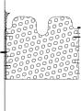

FACTORY-APPLIED AND CURED SILICONE BELLOWS FACING

0.5-inch (12mm)

FIELD-APPLIED SILICONE CORNER BEADS AND SILICONE BAND FORCED DOWN ALONG SIDE OF BEJS AS SHOWN – BOTH SIDES

EPOXY ADHESIVE FOR JOINT FACES

(Epoxy supplied by EMSEAL)

BEJS MODIFIED ACRYLIC IMPREGNATED FOAM

Fig.2: BEJS SYSTEM in Existing Steel Angles--Retrofit

ASPHALT OR CONCRETE

WEARING

SURFACE (BY OTHERS)

FACTORY-APPLIED AND CURED SILICONE

BELLOWS FACING

0.5-inch (12mm)

EMSEAL IMPACT – ABSORBING NOSING MATERIAL

OPTIMIZE REBAR SPACING

& CONFIGURATION FOR SUPPORT OF HEADERS (BY OTHERS)

0.5-inch (12mm)



EXISTING STEEL ANGLES WHERE REMOVAL IS NOT FEASIBLE

DAMAGED CONCRETE AT BACK EDGES OF EMBEDDED ANGLES ROUTED AND SEALED (BY OTHERS)

CONCRETE

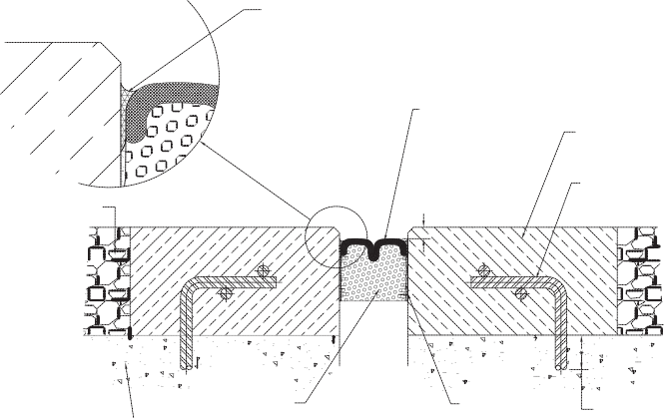

BEJS

IMPREGNATED

EPOXY

ADHESIVE

DEPTH OF REBAR TO SUIT (BY

STRUCTURAL SLAB FOAM (BY OTHERS)

BOTH SIDES OF

JOINT FACE

OTHERS)

Features

**Note: For joint sizes less than 1" (25mm) a smooth, convex, single bellows is supplied.**

Performance

Watertight — the tensionless silicone bellows is installed just below the deck surface ensuring watertightness of the deck. Unlike liquid-applied sealants, compression seals, and closed- cell EVA foam, the BEJS SYSTEM does not rely on adhesion in tension and is not wedged into the joint gap. Instead the mate- rial is factory-precompressed, ensuring that the spring energy of compression is always pushing back on the substrate.

Non-Invasive Anchoring — there are no hard metal-to-concrete connections in the system. The system is locked to the joint faces by means of the 1) backpressure of the foam; 2) the epoxy adhesive, and 3) the injected silicone sealant band at the joint face to foam and silicone bellows interface.

Joint-Size Variation — uniform bellows appearance, and the ability to handle variations in joint size through size-switching, are among other system features.

Factory-Fabricated Transitions — to ensure continuity of seal through changes in plane, EMSEAL offers *Universal-90* factory-fabricated transitions and terminations. These BEJS single-unit pieces can be turned and joined horizontally or verti- cally to complete a run or transition to straight sticks of BEJS. These eliminate the need for cutting and creating corners in the field as well as ensuring continuity of seal through their mono-

lithic design. BEJS also of fer s *Kick-Out Terminations*, a factory-fabricated piece with a built in drip-edge that directs water runoff away from the bridge structure. The *Kick-Out Termination* is installed at the edge of the deck with its down- turn over the side of the bridge and the drip edge sticking out beyond the face of the slab. Water that runs off the joint is directed away from the bridge and its bearing pads, columns etc. by the silicone-coated flared end of the kick-out.

Capable of movements of +50%, -50% (100% total) of nominal material size.

Standard sizes from 1/2" (12mm) to 4" (100mm). Other sizes available on review of application - consult EMSEAL.

Composition

Differing from closed-cell EVA foam, BEJS is produced by coating an impregnated cellular foam with Pecora 301 highway-grade silicone.

The expanding foam is cellular polyurethane foam impregnated with a water-based acrylic containing a high performance micro- cellular additive.

The silicone external facing is factory applied to the foam at a width greater than maximum joint extension and is cured before final compression.

Silicone application and curing takes place in a factory-controlled environment. In contrast to field applied liquid sealant and backer rod installations, no movement takes place during curing that can cause deformation or stresses in the material.

Then compressed, a bellows is created in the coating*. As joint movement occurs the bellows simply folds and unfolds free of tension on the bond line, and virtually free of tensile stresses in the silicone material.

The foam provides a resilient backing to the silicone coating, allowing the system to resist reasonable transient point loads

BEJ S SYSTEM is supplied in shrink-wrapped lengths of precompressed sticks maunufactured to less than the joint size for easy insertion. After removal from the shrink-wrap and hard board restraining packaging, it expands gradually.



*BEJS is manufactured with a dual-bellows surface for nominal gap widths of 1" (25mm) to 4" (100mm). Widths of 1/2" (12mm), 5/8" (15mm) and

3/4" (20mm) are manufactured with a convex single-bellows surface.