Sponsor | Nominations must be submitted by an AASHTO member DOT willing to help promote the technology | - Sponsoring DOT (State): Idaho
 |  | - Name and Title: Tony Ernest, Traveler Services Coordinator
 |  | Organization: Idaho Transportation Department (ITD)
 |  | Street Address: 3311 W. State Street
 |  | City: Boise | State: ID | Zipcode: 83703-5879
 |  | E-mail: tony.ernest@itd.idaho.gov | Phone: 208-334-8836 | Fax:
3. Is the sponsoring State DOT willing to promote this technology to other states by participating
on a Lead States Team supported by the AASHTO Innovation Initiative? Yes or No:
Yes

Technology Description (10 points) | The term “technology” may include processes, products, techniques, procedures, and practices. | - Name of Technology:  RWIS Automated Hazardous Travel Condition Warnings on Traveler Information Website
- Please describe the technology.
Idaho’s Automated 511 Reporting System uses Road Weather Information System (RWIS) sensor data to identify hazardous travel conditions, and automatically update the 511 Traveler Information website. The automated updates provide information describing the hazardous conditions and include current camera views of the road surface.
The system automatically updates Idaho’s 511 website every 15 minutes (96 times per day).
ITD has approximately 120 RWIS stations evenly distributed across its state highway system. Along with more conventional atmospheric sensors, most are equipped with Dynamic Surface Condition (DSC) sensors capable of independently measuring surface water, ice, and snow layers. The system uses this data to calculate the current “grip” surface friction value of the pavement, and determines when travel conditions have become unsafe.
The system generates warnings for slick or very slick roadways (based on grip value), snow or ice on the roadway, poor visibility, or high winds. The warnings appear on the 511 website map as red weather-station alert icons.
Holding a computer curser over an icon on the 511 website will highlight an area around the RWIS site where travelers may expect to encounter those adverse conditions.
Clicking on an icon will open a window displaying weather-sensor readings describing the hazardous conditions generating the alert, along with two or more current camera views from the site, and any winter road condition reports recently sent in by maintenance crews.

6. If appropriate, please attach photographs, diagrams, or other images illustrating the appearance or functionality of the technology. (If electronic, please provide a separate file.) Please list your attachments here.
Hazardous_Condition_Alert_Examples.docx
State of Development  (30 points) | Technologies must be successfully deployed in at least one State DOT. The AII selection process will favor technologies that have advanced beyond the research stage, at least to the pilot deployment stage, and preferably into routine use. | - Briefly describe the history of its development.  Because of Idaho’s rugged terrain and high elevation, hazardous weather conditions create major safety issues for drivers. The previous method of reporting hazardous road conditions to the 511 database required maintenance staff to communicate road conditions to the State Communications Center via radio. The Communications Center staff then manually entered the data to the 511 database.  The frequency of reports varied from one to two times per day, or as conditions changed. This process was hit or miss depending on the storm-response activities of the maintenance staff, so the reporting was sometimes incomplete or outdated.  That is why the Idaho Transportation Department developed a unique system that automatically updates the 511 website every 15 minutes (96 times per day). This provides drivers with up-to-date information on hazardous-driving conditions they may encounter on the road.  The system accesses data from an extensive network of Road Weather Information System (RWIS) sensors, and automatically posts alerts on the 511 webpage for locations that measure hazardous driving conditions such as slick roads (low grip), limited visibility, or high winds.  Idaho’s RWIS network (approximately 105 locations) covers a majority of the State Highway System and most of the road segments that commonly experience hazardous driving conditions. ITD will continue to add RWIS sites in the future to broaden the automated coverage and further reduce the need for manual reporting in areas that do not have RWIS sensors.  The automated 511 reporting system leverages the department’s investments in RWIS and the 511 system to provide the public with more accurate, reliable, and timely road-condition information. This online service significantly improves safety, mobility, and economic opportunity, which are ITD’s core strategic goals.  Idaho has displayed RWIS weather sensor information on its Traveler Information websites since 2009. Over the last few years, in conjunction with ITD’s winter performance measures program, many new sites have been constructed, and older RWIS stations have been upgraded to include DSC sensors.  Early in 2014, ITD capitalized these existing capabilities to deploy RWIS Automated Hazardous Travel Condition Warnings on the high-bandwidth version of its Traveler Information website.
- For how long and in approximately how many applications has your State DOT used this technology?
ITD implemented the RWIS Automated Hazardous Travel Condition Warnings in January of 2014. It is currently only available on the high bandwidth version of ITD’s 511 Traveler Information website.
The department is currently developing the same capabilities for the low-bandwidth version of the 511 website, and for ITD’s 511 smartphone application.

- What additional development is necessary to enable routine deployment of the technology?
The technology is already fully implemented on the high-bandwidth version of Idaho’s Traveler Information website, on a statewide basis. Other Traveler Information platforms require software upgrades to display the information. Deployment of additional RWIS sites will increase coverage.
- Have other organizations used this technology? Yes or No: If so, please list organization names and contacts.
No
 |  | Organization | Name | Phone | E-mail
Potential Payoff  (30 points) | Payoff is defined as the combination of broad applicability and significant benefit or advantage over other currently available technologies. | - How does the technology meet customer or stakeholder needs in your State DOT or other organizations that have used it?  ITD’s Automated 511 Reporting System provides the public with critical road-condition information that is updated 96 times per day, without human intervention. The system allows drivers to make informed decisions on trip routing and scheduling.  Drivers now have up-to-date information and photographs of roadways at their fingertips telling them if the route they plan to take is slick with snow or ice; has limited visibility due to snow, fog, or dust; or has high winds. This has a positive impact on safety during times of hazardous-driving conditions.  ITD’s Automated 511 Reporting System may be the first of its kind in the nation. It provides a model that can be used by other states that have RWIS networks, allowing them to provide the public with up-to-date information on hazardous driving conditions. The safest drivers are those who are most informed.  Automatically posting hazardous travel condition warnings on ITD’s 511 Traveler Information Website greatly improves the availability of roadway safety information during inclement weather events.  The automatic updates improve the timeliness, accuracy, and scope of safety information available to drivers. Warnings can be generated 24 hours per day, 365 days per year.  One example of the safety benefits of the system is that truck drivers in Idaho can now get real-time information regarding dangerous high-wind conditions across key canyon bridges in the state. Strong winds on these high bridges are extremely dangerous for high-profile vehicles, especially when traveling empty.
12. What type and scale of benefits has your DOT realized from using this technology? Include cost savings, safety improvements, transportation efficiency or effectiveness, environmental benefits, or any other advantages over other existing technologies.
The primary benefit is the greatly improved quality and timeliness of safety information provided to the traveling public during inclement weather events.
The resulting drop in accident rates will reduce the associated societal costs and accident-response costs.
- Please describe the potential extent of implementation in terms of geography, organization type (including other branches of government and private industry) and size, or other relevant factors. How broadly might the technology be deployed?
The technology can be deployed in any state that experiences inclement weather. Surface condition sensors can detect loss of traction due to hydroplaning conditions as easily as they do surface ice.
Environmental sensors can detect loss of visibility or high winds, which can occur virtually anywhere.
The technology could be implemented by any organization that has both roadside weather stations and a map-based webpage. In theory, the technology could be generalized for implementation on mobile, vehicle-mounted roadway and atmospheric sensor arrays.
Market Readiness (30 points) | The AII selection process will favor technologies that can be adopted with a reasonable amount of effort and cost, commensurate with the payoff potential. | - What actions would another organization need to take to adopt this technology?  Assuming the organization already has access to live sensor information from RWIS stations (or other roadside weather stations) and already has a map-based traveler information website:  - The live sensor data would need to be made available to the database driving the website.  - The online map would need to be modified to display the location of each RWIS station, and display the live sensor data.  - Software modifications would be needed to analyze sensor data and assess when thresholds are crossed into unsafe driving conditions.  - When unsafe conditions are detected, the system must be made capable of generating an alert icon, or modifying an existing icon to indicate that an alert is active. The site sensor data display should highlight the values showing unsafe conditions.  Camera views from the RWIS site are not strictly necessary for display, but greatly enhance the impact of the hazardous driving condition report, and show drivers exactly what current conditions look like on the road surface.
- What is the estimated cost, effort, and length of time required to deploy the technology in another organization?
Assuming the organization already has access to live sensor information from RWIS stations, and already has a map-based traveler information website, all that is required is some additional website development.
In Idaho, the initial budget to import and display RWIS stations on ITD’s 511 traveler information webpage, completed in 2009, cost $100,000 and required 11 months to implement.
In 2014, the additional enhancement to the website creating the automated alerts cost $45,000 and required seven months to implement.
- What resources—such as technical specifications, training materials, and user guides—are already available to assist deployment?
None. Specific details would depend on the specifications of existing RWIS sites and the traveler information website involved.
- What organizations currently supply and provide technical support for the technology?
In Idaho, Vaisala is the RWIS contractor, providing RWIS installation, maintenance, and data flow. Idaho’s traveler information system is supplied by Castle Rock Associates.
- Please describe any legal, environmental, social, intellectual property, or other barriers that might affect ease of implementation.
No known barriers.
Images |  | Examples of Hazardous Condition  Alerts on ITD’s Automated 511 Website  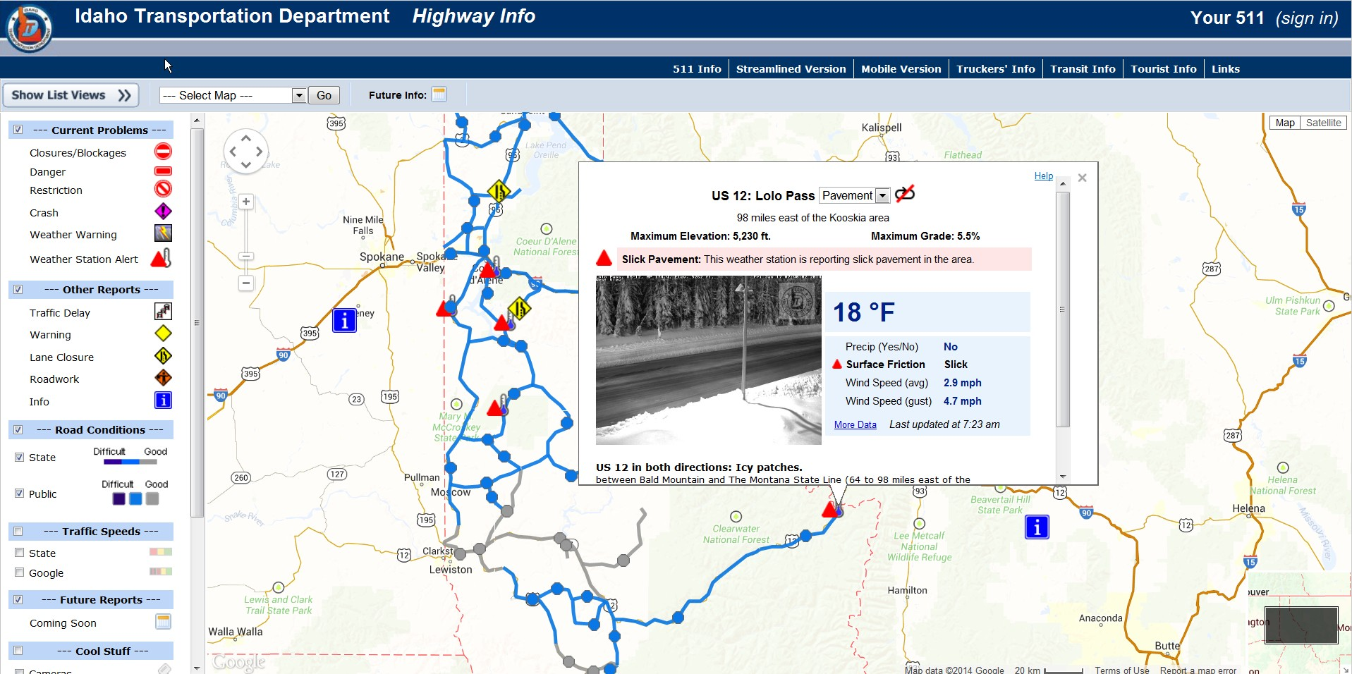  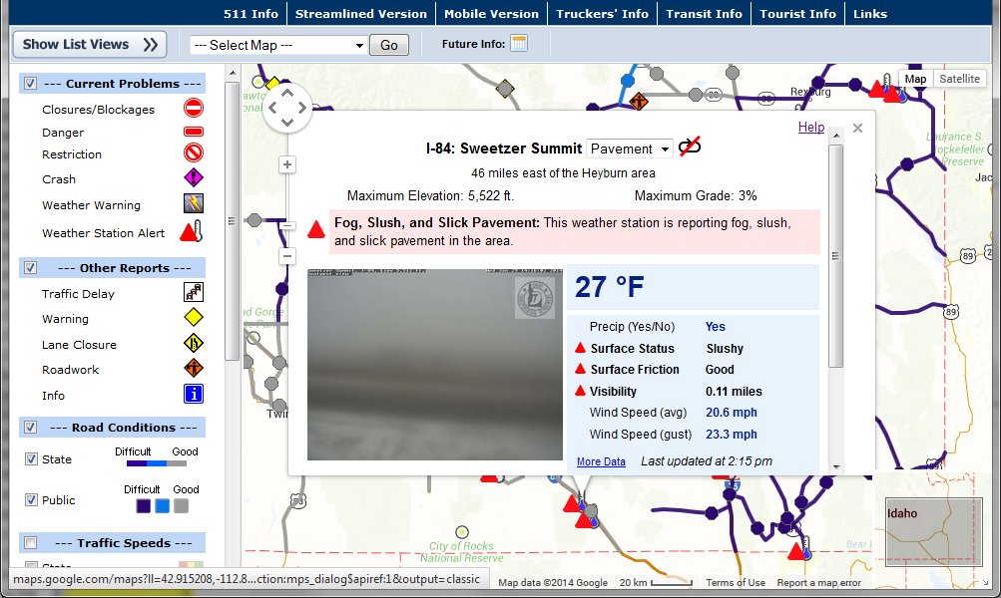
Submit Completed form to |  | http://web.transportation.org/tig_solicitation/Submit.aspx

