AASHTO Technology Implementation Group

Nomination of Technology Ready for Implementation

2007 Missouri Department of Transportation Nomination Attachments

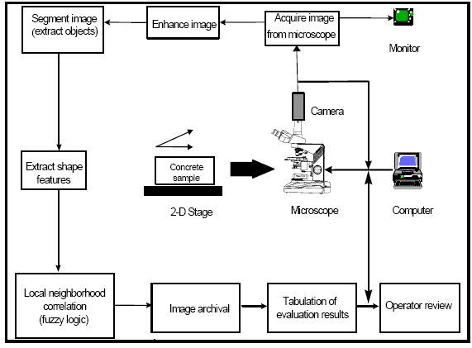

Visual overview of the ACE system operation.

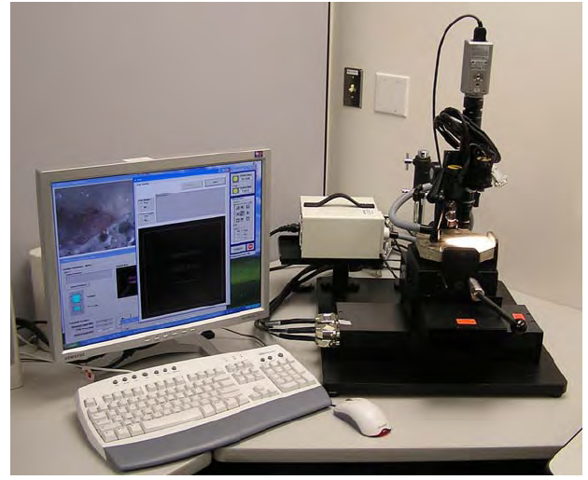

NG-ACE configuration showing the computer, computer-controlled stage, sample mount, digital camera, and lighting (bridge mount not shown).

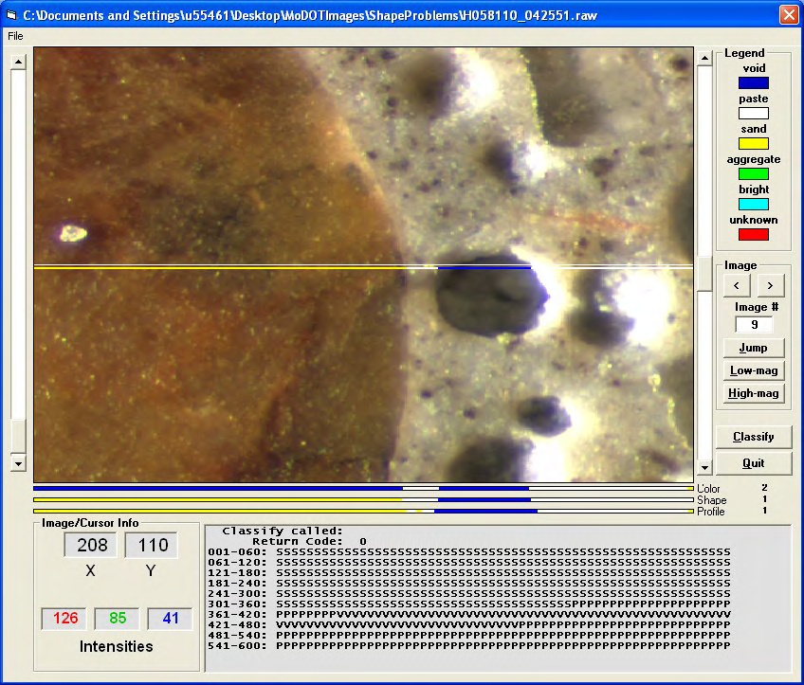

An example screen capture of the test specimen

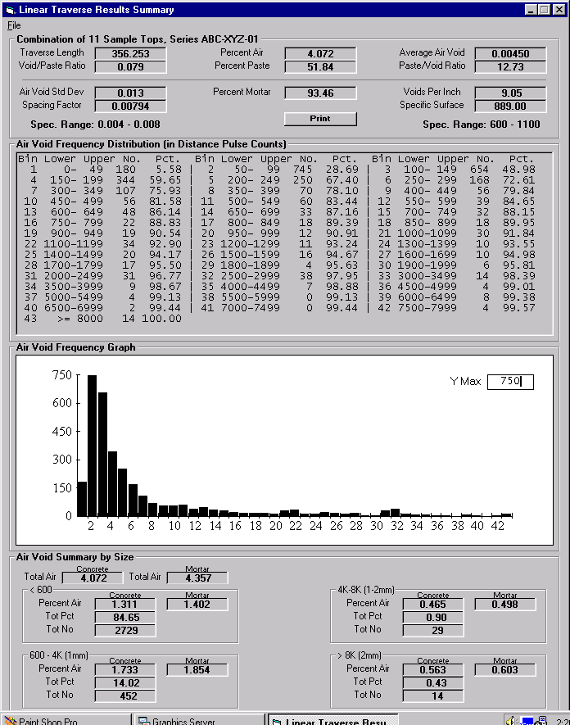

Example of a Final Report from a Test Sample

