Sponsor | Nominations must be submitted by an AASHTO member DOT willing to help promote the technology | - Sponsoring DOT (State): Pooled fund study TPF-5(242), Traffic and Data Preparation for AASHTO MEPDG Analysis and Design
 |  | - Name and Title: Harold Paul, Sponsor contact, Director
 |  | Organization: LTRC/LADOTD
 |  | Street Address: 4101 Gourrier Ave.
 |  | City: Baton Rouge |  | State: LA |  |  | Zipcode: 70808
 |  | E-mail: doc.zhang@la.gov |  | Phone: 225-767-9162 |  |  | Fax: 225-767-9108
 |  | - Date Submitted: 27 Dec 2013
 |  | 4. Is the sponsoring State DOT willing to promote this technology to other states by participating on a Lead States Team supported by the AASHTO Technology Implementation Group? Yes or No: yes
Technology Description (10 points) | The term “technology” may include processes, products, techniques, procedures, and practices. | 5. Name of Technology:  Prep-ME Software for the Implementation of Pavement ME Design
6. Please describe the technology.
Prep-ME is a full production software program to store and process climate, traffic, and materials data required for the AASHTO Pavement ME Design. This software complies with FHWA Traffic Monitoring Guide (TMG) and TMAS for quality assurance and quality control (QA/QC). State highway agencies’ experience has been built into the QA/QC of traffic data collection. The software has the following basic functions with more specific features requested by individual states.
(1) Imports an agency’s WIM traffic data complying with FHWA Traffic Monitoring Guide (TMG) file formats, and store the data in SQL server Local database with exceptional computation efficiency.
(2) Conduct TMAS 2.0 data check and generate TMAS check error log for each imported raw file.
(3) Perform automatic quality control checks by direction and lane of a WIM station for both classification and weight data following algorithms defined in TMG.
(4) Provide user friendly interfaces to review monthly, weekly and daily traffic data, and investigate the WIM data that is incomplete or fails the automatic QC check through various manual, sampling, and analyzing operations.
(5) Conduct field quality check for portable WIM data collection.
(6) Generate three levels of traffic inputs: Level 1 site specific, Level 2 clustering average, Level 3 state average, and LTPP TPF-5(004) defaults.
(7) Clustering methods developed by North Carolina and Michigan DOTs, the Truck Traffic Classification (TTC) method, and the simplified TTC approach are fully implemented, offering state agencies with the flexibility of generating Level 2 loading spectra inputs for Pavement ME Design based on the availability of traffic data.
(8) Generate input files in the file formats that can be directly imported into MEPDG and Pavement ME Design software.
7. If appropriate, please attach photographs, diagrams, or other images illustrating the appearance or functionality of the technology. (If electronic, please provide a separate file.) Please list your attachments here.
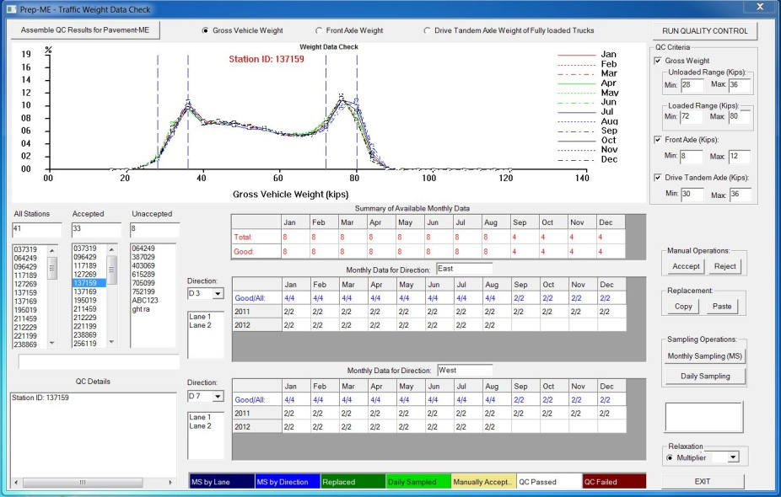
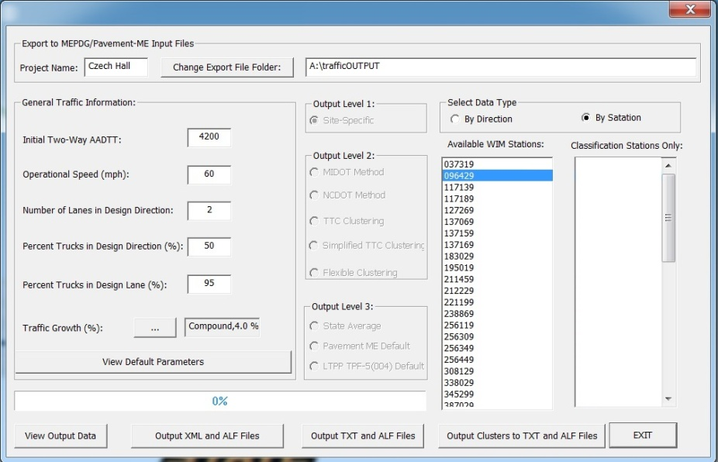
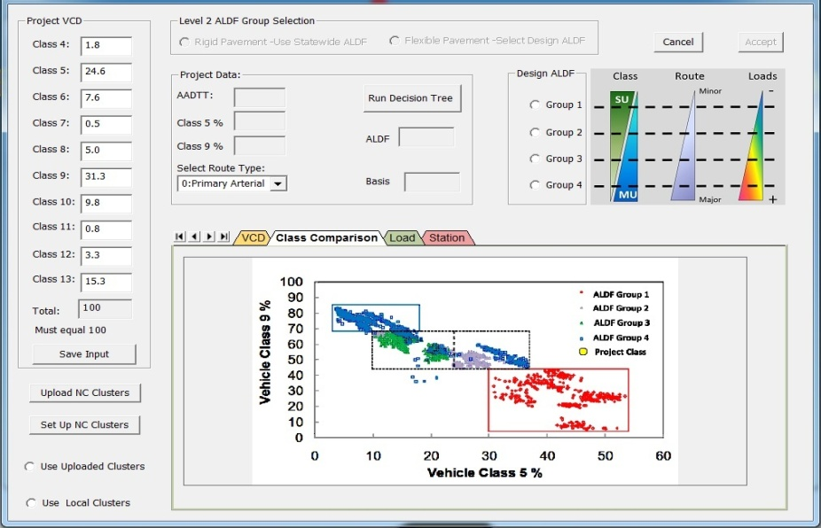

State of Development  (30 points) | Technologies must be successfully deployed in at least one State DOT. The TIG selection process will favor technologies that have advanced beyond the research stage, at least to the pilot deployment stage, and preferably into routine use. | 8. Briefly describe the history of its development.  - Lead state: LADOTD  - Sign up states: HI, KY, LA, MD, NC, NH, WI, MI, and FHWA  - Contract period: Sep. 1, 2011 – Aug. 31, 2014  - Commitment: $50,000/State total for three years  - Sponsor contact: Harold Paul / Doc Zhang harold.paul@la.gov  - FHWA contact: Gary Crawford, Gary.Crawford@dot.gov
9. For how long and in approximately how many applications has your State DOT used this technology?

Eight state highway agencies, including HI, KY, LA, MD, NC, NH, WI, and MI, are in the process of implementing this software in their daily production activities.
10. What additional development is necessary to enable routine deployment of the technology?

Future developments and enhancement of Prep-ME will be based on the needs of individual states with more specific features requested by individual states. Technical support and training are needed for other states to enable routine deployment of the software.

 |  | 11. Have other organizations used this technology? Yes or No: yes If so, please list organization names and contacts.
 |  | Organization | Name |  | Phone | E-mail
 |  | NC DOT | Kent L Taylor |  | (919) 212-4550 | kltaylor@ncdot.gov
 |  | MI DOT | Michael Eacker |  | (517) 322-3474 | eackerm@michigan.gov
 |  | KY Transportation Cabinet | Paul Looney |  | (502) 782-4897 | paul.looney@ky.gov
 |  | Wi DOT | Laura Fenley |  | (608) 246-5455 | laura.fenley@dot.wi.gov
Potential Payoff  (30 points) | Payoff is defined as the combination of broad applicability and significant benefit or advantage over other currently available technologies. | 12. How does the technology meet customer or stakeholder needs in your State DOT or other organizations that have used it?  - Help state traffic data collection engineers to conduct an effective QA/QC check on traffic data collected for all kinds of applications, such as pavement design, HPMS, traffic planning, bridge design etc.  - Help state pavement design engineers to analyze the traffic loading data collected through the Weight-in-Motion (WIM) technology and select the best load spectra for pavement design purpose among WIMs, national, and local defaults.  - Improve the productivities of above tasks operation tremendously.
13. What type and scale of benefits has your DOT realized from using this technology? Include cost savings, safety improvements, transportation efficiency or effectiveness, environmental benefits, or any other advantages over other existing technologies.

Provide quality traffic data for all types of applications and help the implementation of AASHTO Pavement ME design guide.
14. Please describe the potential extent of implementation in terms of geography, organization type (including other branches of government and private industry) and size, or other relevant factors. How broadly might the technology be deployed?

Prep-ME software and technology can be used by all state highway agencies for the QA/QC of traffic data collected, analysis of truck loading data, and preparation of input for AASHTO Pavement ME software.
Market Readiness (30 points) | The TIG selection process will favor technologies that can be adopted with a reasonable amount of effort and cost, commensurate with the payoff potential. | 15. What actions would another organization need to take to adopt this technology?  Install the software, get the training on how to use it, provide feedback to software developer, and make necessary changes to meet the state’s specific needs.
16. What is the estimated cost, effort, and length of time required to deploy the technology in another organization?

$15,000 per state for implementation for one year that include training and technical support.
17. What resources—such as technical specifications, training materials, and user guides—are already available to assist deployment?

Prep-Me software, user manual, training documents, etc.
18. What organizations currently supply and provide technical support for the technology?

Oklahoma State University
19. Please describe any legal, environmental, social, intellectual property, or other barriers that might affect ease of implementation.

None
Submit Completed form to |  | http://transportation1.org/tig_solicitation/Submit.aspx

