Opening page of the WRR application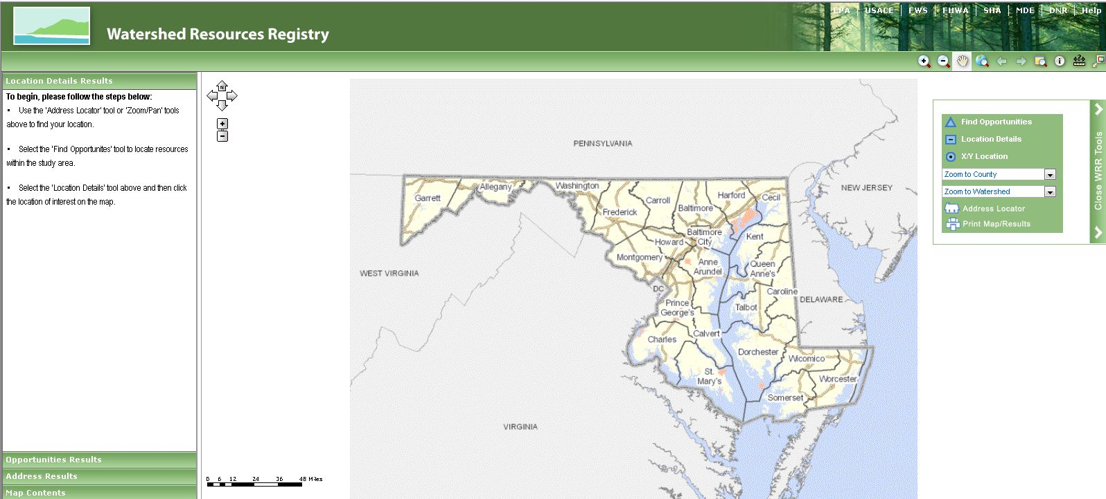

Using the Find Opportunities tool to locate potential projects for upland preservation 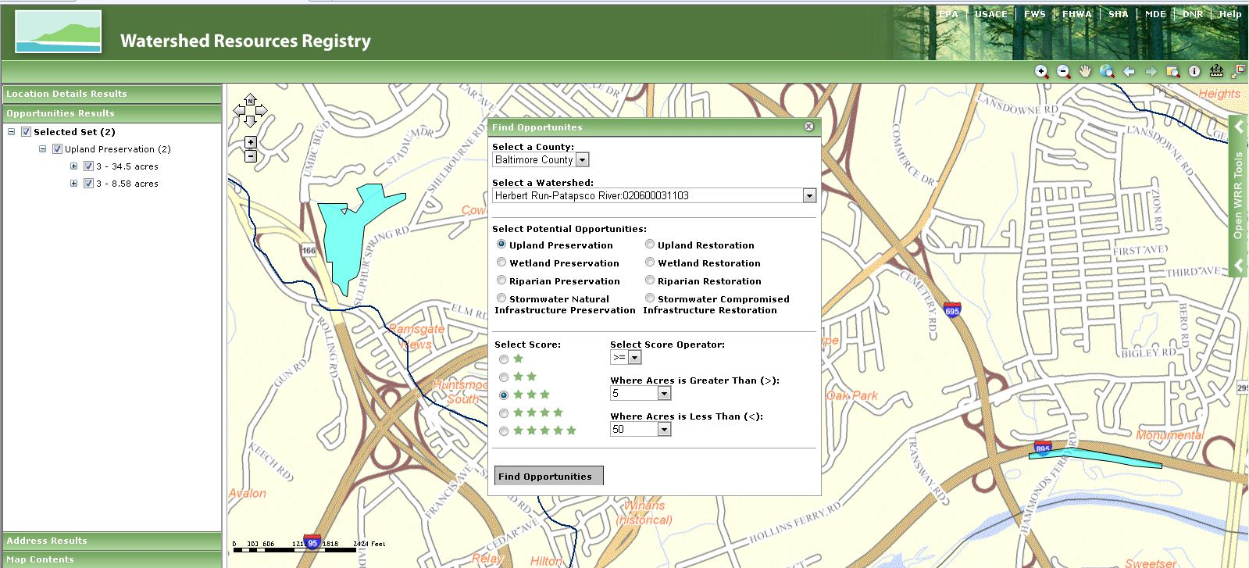

Adding resource data layers to customize your view 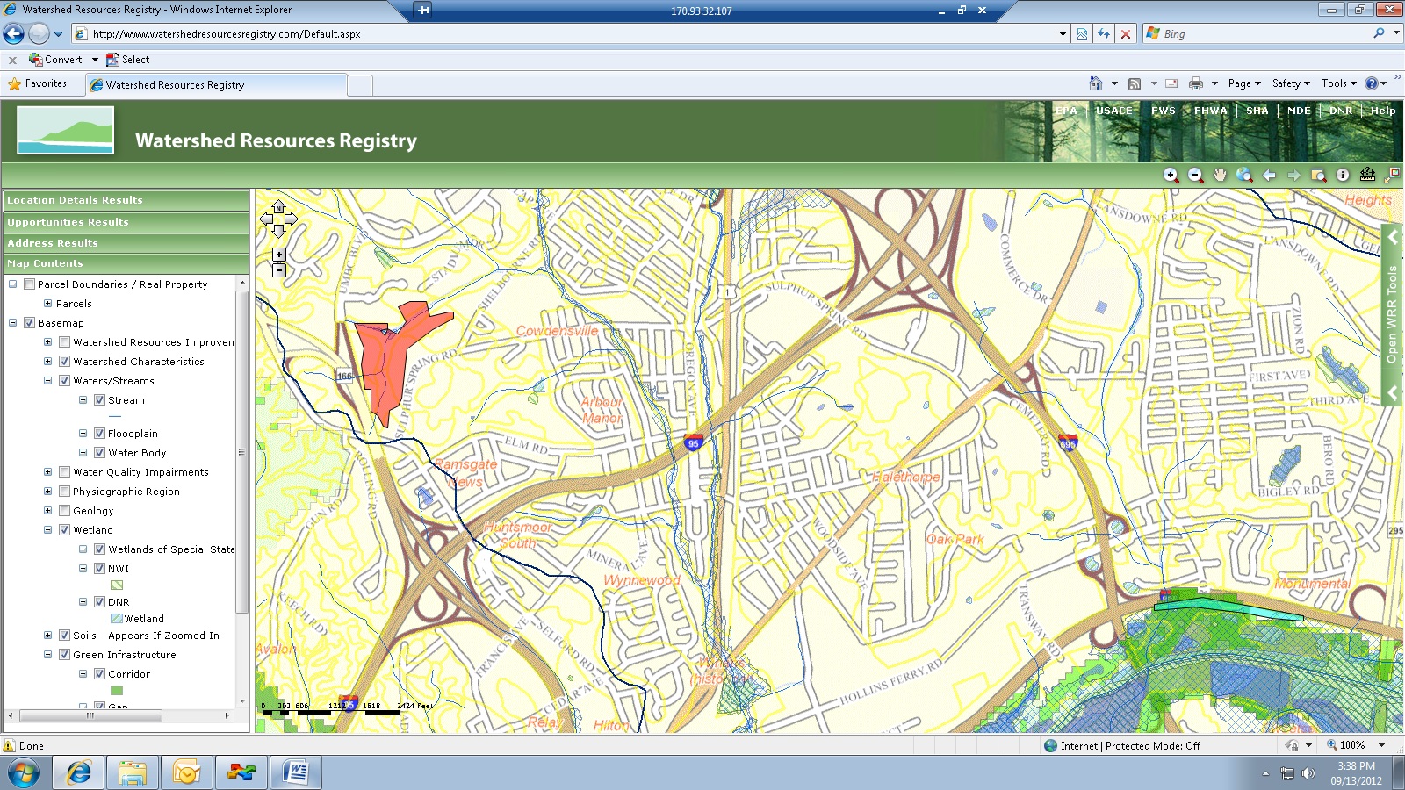

Revealing opportunity details

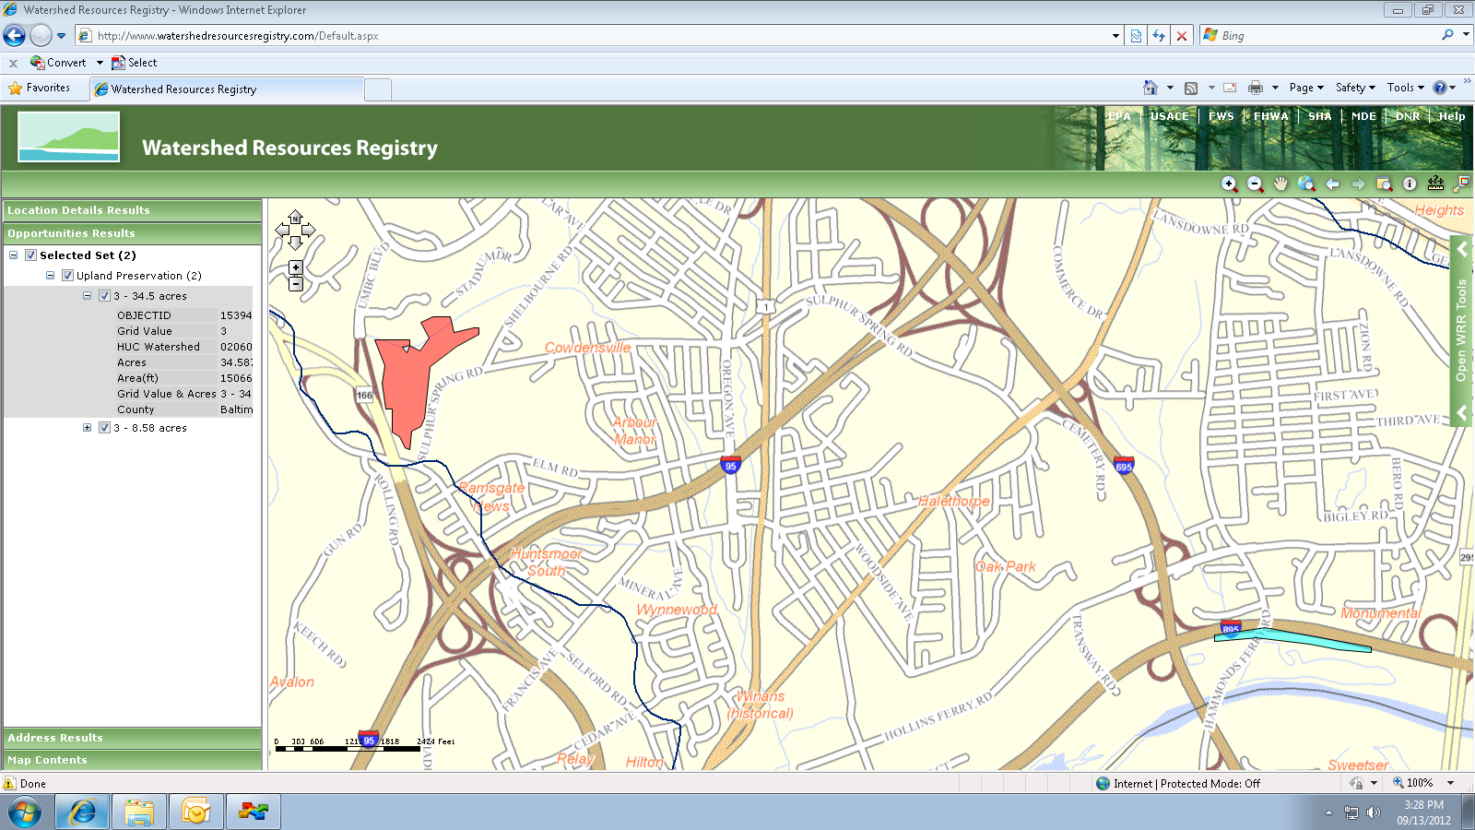

Opening page of WRR outreach website