Sponsor | Nominations must be submitted by an AASHTO member DOT willing to help promote the technology | - Sponsoring DOT (State): Massachusetts Department of Transportation
 |  | - Name and Title: Lorenzo Parra Director Highway Operations Center
 |  | Organization: MassDOT-Highway Division
 |  | Street Address: 50 Massport Haul Rd
 |  | City: Boston |  | State: MA |  |  | Zipcode: 02210
 |  | E-mail: Lorenzo.parra@state.ma.us |  | Phone: 617-946-3029 |  |  | Fax:
 |  | 3. Is the sponsoring State DOT willing to promote this technology to other states by participating on a Lead States Team supported by the AASHTO Innovation Initiative? Yes or No:
Technology Description (10 points) | The term “technology” may include processes, products, techniques, procedures, and practices. | 4. Name of Technology:  Go-Time / Real Time Traffic Management (RTTM) system
- Please describe the technology.
- Background
In 2012 MassDOT initiated an operational test of a Bluetooth based real time traveler information system called the Real Time Traffic Management (RTTM) system. The system calculates travel time between two or more points along the roadway by using time stamps collected from anonymous wireless devices, and displays these live travel times on roadside portable variable message signs. RTTM uses new technology; a Bluetooth sensor, wireless communications, and solar powered sensors.

RTTM is multi-purpose. Real-time data can be used for Planning, Operations, and for real time performance measurement. The technology primarily is a traveler information tool used to keep drivers informed of the distance and number of minutes it will likely take to travel from the message sign they are reading to destinations 5 to 10 miles down the highway. This provides motorists with a sense of how long their commute will take, and an ability to plan ahead when traffic is worse than expected. These signs are placed at key interchanges or decision points across the highway network to facilitate a greater degree of route or mode diversion. Drivers can also get this information pre-trip on the MassDOT website, or RideWISE phone app.

- Statewide Expansion
RTTM began as a pilot program in 2012, and based on positive customer feedback, is currently under development as a statewide expansion, with a “Go-Live” date of July 2015. This will also include transferring the current RTTM pilot routes into the statewide system. When completed, the RTTM will be the largest single deployment of a Bluetooth based travel time system, encompassing over 700 miles of highway, in a state. It will extend to the NH border on I-93 and I-95, Rhode Island border on I-95, and New York border on I-90. When fully deployed, it is estimated that over 2.2 million motorists will view the Travel Time Message Signs on a daily basis.

As part of the statewide expansion, MassDOT will transition from using portable variable message signs (figure 2) to installing new static travel time signs consistent with MUTCD. These signs, shown in Figure 3, will pose significant advantages over using PVMS to display travel times. The signs can accommodate up to 3 destinations and provide drivers with more information. The signs will represent a significant increase in customer service as the signs will be dedicated to travel time information, may reduce driver distraction, and will add additional PVMS to MassDOT’s inventory.

- Open Data Initiative
The statewide RTTM deployment will include a MassDOT owned “back office” that is scalable to expand to other highways, arterials or special routes, as needed. Unlike many other DOTs that buy their travel time data from third-party vendors, MassDOT will own and operate the statewide system. This business model will mean that travel time data is owned and archived by MassDOT, thus ensuring accuracy, accountability and reliability. This innovative strategy also allows MassDOT to make this data freely available in real time through the Internet to third party developers (http://www.massdot.state.ma.us/DevelopersData.aspx).

This open data strategy encourages the development of innovative third-party Smartphone applications by using data provided in a standard XML format open to anyone. Developers can also combine this data with other MassDOT data for transit, construction, and incidents, or third party data for parking, weather, and special events to create customized information for users in real time. MassDOT has a forward thinking strategy; it leverages the developing trend of public-private partnerships along with the growth in ITS technology to deliver on the public’s expectation for access to personalized and up to date travel information.

6. If appropriate, please attach photographs, diagrams, or other images illustrating the appearance or functionality of the technology. (If electronic, please provide a separate file.) Please list your attachments here.
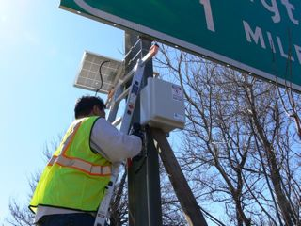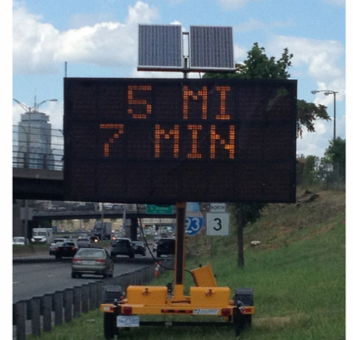
(Figure 1: Bluetoad sensor installed) (Figure 2: Portable vms for travel time display)
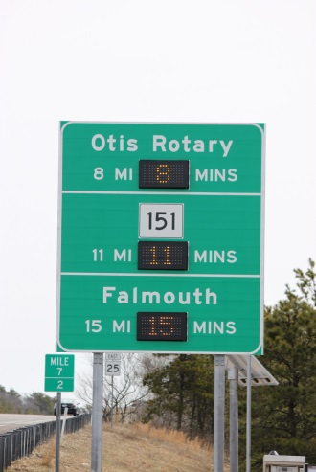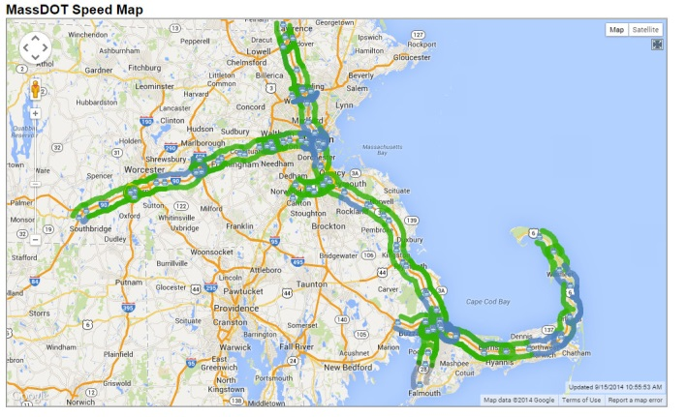
(Figure 3: Static travel time board) (Figure 4: Graphical user interface for travel time display)

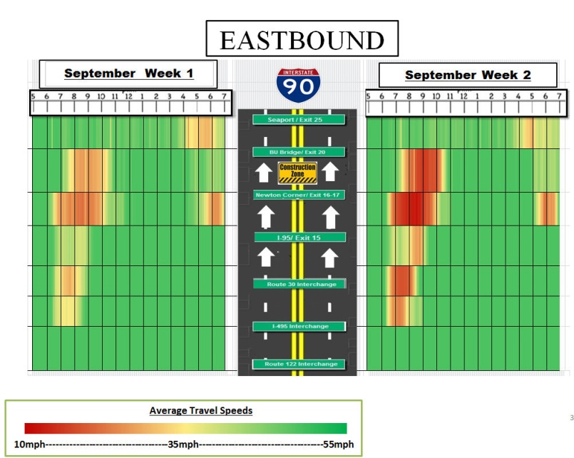
(Figure 5: Congestion contour map produced using RTTM data)
State of Development  (30 points) | Technologies must be successfully deployed in at least one State DOT. The AII selection process will favor technologies that have advanced beyond the research stage, at least to the pilot deployment stage, and preferably into routine use. | - Briefly describe the history of its development.  The project was launched as a pilot along the Interstate 93 corridor in 2012 from the New Hampshire border in the north to the town of Canton, MA in the south. The program was expanded Memorial Day weekend in 2013 to include Interstate 90 from Boston to Sturbridge, MA and Route 3 south of Boston to Cape Cod’s Sagamore Bridge. In April 2014, MassDOT announced the expansion of the program as a statewide initiative, starting with deployment of the system along Cape Cod with fixed signs and LED travel time inserts.  This pilot approach has led to key “lessons learned” for MassDOT over the course of two years. Each expansion presents its own set of unique challenges to overcome, and has prepared MassDOT for a successful statewide program.
- For how long and in approximately how many applications has your State DOT used this technology?

MassDOT has been using this technology since the initial pilot program on I-93 in 2012. The RTTM system is now in routine use on I-93, I-90 to Sturbridge, MA, Route 3 south and Route 6 to Cape Cod. Figure 4 shows the extent of current deployment.

MassDOT has utilized the Go-Time/RTTM system in a number of applications, including operations, performance management and ITS. In addition to providing real time traveler information, the RTTM is a robust source of performance management tools that allow MassDOT to measure congestion. The system’s current data warehouse allows users to produce segment comparisons by day, month and year. Data is exportable and can be used to produce periodic reports on congestion. Figure 5 shows a report created at MassDOT using raw RTTM data.

The RTTM system also enhances operations by displaying travel time data on a Graphical User Interface (GUI) posted to the RTTM website (93rttm.com). This provides a “snap-shot” of live traffic conditions across the entire roadway network. Operators in the Highway Operations Center use this GUI to proactively search for anomalies in roadway performance. In some cases, unexpected spikes in travel time can alert operators to an incident on the roadway.

Finally, this technology will form the centerpiece for compliance with new Federal Highway regulations requiring the collection and availability of real-time traffic information in metropolitan areas (23 CFR 511). RTTM has exceeded the accuracy, availability and timeliness requirements specified in the RTSMIP requirements. RTTM will also support compliance with highway performance measurement requirements established in MAP-21.

- What additional development is necessary to enable routine deployment of the technology?

MassDOT is currently reviewing proposals for the “back-office” portion of the Go-Time/RTTM statewide expansion. The selected vendor will be the integrator of all Bluetooth devices and travel time signs, as well as managing the travel time algorithm and data warehouse. All devices and travel time signs are being procured through a separate construction contract. (Note: the initial RTTM pilots were “turn-key” solutions. Based on lessons learned of 2+ years, MassDOT is bidding two separate contracts in order to see greater cost savings). It is expected that by July 2015, MassDOT will be in routine operations with a statewide travel time system that covers over 700 miles of roadway statewide.

 |  | - Have other organizations used this technology? Yes or No: Yes If so, please list organization names and contacts.
 |  | Organization | Name |  | Phone | E-mail
 |  | Illinois DOT | Jeff Galas
 |  | Cobb County, Atlanta
 |  | Fulton County, Atlanta
Potential Payoff  (30 points) | Payoff is defined as the combination of broad applicability and significant benefit or advantage over other currently available technologies. | - How does the technology meet customer or stakeholder needs in your State DOT or other organizations that have used it?  Go-Time/RTTM is first and foremost a customer service tool. It keeps drivers informed, both pre-trip and en-route, of how long it will take to get to their destination. It provides motorists with a sense of how long their commute will take, an ability to plan ahead when traffic is worse than expected, or even change their route, mode or time of travel. To the extent that the RTTM affects driver behavior, it is also an active traffic management (ATM) tool for managing congestion and increasing the efficiency of the highway network as a whole.  The most unique aspect of MassDOT’s strategy with RTTM is the dissemination of real-time data in a free XML feed to the MassDOT developer’s page (http://www.massdot.state.ma.us/DevelopersData.aspx). This open data strategy encourages the development of innovative Smartphone applications that can also be combined with other MassDOT data for transit, construction, and incidents, or third party data for parking, weather, and special events to create customized information for users in real time. MassDOT expects that this app development will help support an Integrated Corridor Management strategy that would use real-time data to encourage mode shift from car to commuter rail.  RTTM/GO-time has been important to meeting the needs of MassDOT stakeholders and MassDOT senior staff, especially in Planning and performance management. Significant benefits are realized by having a state- owned and archived data set: Data analysis can be performed in-house and as issues are identified, MassDOT staff has better access to raw data, and senior staff can more easily (and more quickly) gain insights into congestion issues.
12. What type and scale of benefits has your DOT realized from using this technology? Include cost savings, safety improvements, transportation efficiency or effectiveness, environmental benefits, or any other advantages over other existing technologies.

As stated previously, unlike most other DOTs that purchase travel time data from private
companies such as HERE and INRIX, MassDOT owns and operates its own travel time system.
Thus MassDOT is not restricted by any data usage agreements, and can provide its data free of
charge to the developer community.

Bluetooth technology is superior to other means of collecting travel time information: radar, loops, GPS, cellular. Bluetooth is low cost, non-intrusive, mobile, solar and wireless. Bluetooth can reliably be used to estimate origin and destination patterns, unlike other technologies. Once the RTTM system is fully deployed, MassDOT will see large cost savings over purchasing this data directly from a private provider.

- Please describe the potential extent of implementation in terms of geography, organization type (including other branches of government and private industry) and size, or other relevant factors. How broadly might the technology be deployed?

This technology can be deployed in any size transportation organization, from a state DOT to a small authority managing a few roads. Private industries would be able to utilize this technology, as long as it adhered to regional right of way laws.
Market Readiness (30 points) | The AII selection process will favor technologies that can be adopted with a reasonable amount of effort and cost, commensurate with the payoff potential. | - What actions would another organization need to take to adopt this technology?  Any jurisdiction interested in adopting this technology would presumably utilize the systems engineering process to identify needs, goals and objectives, and to identify specific corridors that would benefit from the deployment. A concept of operations completed would then drive the rest of the project to system validation and deployment. An investment in a pilot program or an extended program would need to be considered. The program at MassDOT was narrowly tailored around specific needs and policy decisions made by senior leadership to improve the transportation experience for users of our roadway system. Making the data a free public facing attribute of the program requires a policy decision based on the notion that the public and private sector can work together to bring meaningful multi-modal information to the public that informs decision making.
- What is the estimated cost, effort, and length of time required to deploy the technology in another organization?
Depending on the scope and size of the project, the costs will vary. As the MassDOT program is still in development, it is difficult to provide an irrefutable price. The process involves consultant support, community support, and technology deployments through the systems engineering process. Different models may be chosen over this process. The technology is available to be modular and scalable; in principle the innovation rests in the policy decision to bring this information to the public through different media and to allow the private sector to use the data in partnership with MassDOT to enhance the number and customized applications available to the public. MassDOT anticipates a cost to deploy the technology statewide at approximately 2 million dollars. The construction and deployment of fixed message boards has yet to be determined.
- What resources—such as technical specifications, training materials, and user guides—are already available to assist deployment?
Technical specifications for the statewide program are currently completed. Training and user guides for the current I93/I90, Route 3 program in place are also available. It is anticipated that these documents would be made available to other jurisdictions upon completion of the statewide program.

- What organizations currently supply and provide technical support for the technology?

KCUS, INC. Jacobs Engineering, TrafficCast
- Please describe any legal, environmental, social, intellectual property, or other barriers that might affect ease of implementation.

One barrier to implementation is that most travel time systems rely on a proprietary algorithm to perform calculations. It would be difficult to produce these algorithms in-house. Instead, an agency can opt for a “turn-key” solution, or pay a fee to use an algorithm from an established company.

Privacy concerns may be an issue in some communities, as the travel time system works by collected unique MAC addresses from Bluetooth enabled devices. However, the systems anonymize this data and delete the records after creating a match.

Submit Completed form to |  | http://web.transportation.org/tig_solicitation/Submit.aspx

